Republic of Maldives

PREQUALIFICATION DOCUMENT

Supply, Install, Commission, Operate & Transfer of Battery Energy Storage Systems (BESS) on Selected Islands in Maldives
RFB No.: MV-MEE-224266-CW-RFB
Accelerating Renewable Energy Integration and Sustainable Energy (ARISE)
Project ID: P172788

Ministry of Environment, Climate Change and Technology
Republic of Maldives

Issued on: June 10, 2021
Issued by: National Tender
Ministry of Finance
Republic of Maldives

Table of Contents

PART 1 – Prequalification Procedures 3
Section I - Instructions to Applicants 5
Section II - Prequalification Data Sheet (PDS) 23
Section III - Qualification Criteria and Requirements 27
Section IV - Application Forms 37
Section VI - Fraud and Corruption 57
PART 2 – Project Requirements 59
Section VII - Scope of Project 61

PART 1 – Prequalification Procedures

Section I - Instructions to Applicants
Contents
A. General 7
1. Scope of Application 7
2. Source of Funds 7
3. Fraud and Corruption 7
4. Eligible Applicants 8
5. Eligibility 10
B. Contents of the Prequalification Document 11
6. Sections of Prequalification Document 11
7. Clarification of Prequalification Document and Pre-Application Meeting 11
8. Amendment of Prequalification Document 12
C. Preparation of Applications 12
9. Cost of Applications 12
10. Language of Application 12
11. Documents Comprising the Application 13
12. Application Submission Letter 13
13. Documents Establishing the Eligibility of the Applicant 13
14. Documents Establishing the Qualifications of the Applicant 13
15. Signing of the Application and Number of Copies 13
D. Submission of Applications 14
16. Sealing and Marking of Applications 14
17. Deadline for Submission of Applications 14
18. Late Applications 14
19. Opening of Applications 14
E. Procedures for Evaluation of Applications 15
20. Confidentiality 15
21. Clarification of Applications 15
22. Responsiveness of Applications 15
23. Margin of Preference 15
24. Subcontractors 16
F. Evaluation of Applications and Prequalification of Applicants 16
25. Evaluation of Applications 16
26. Employer’s Right to Accept or Reject Applications 19
27. Prequalification of Applicants 19
28. Notification of Prequalification 19
29. Request for Bids 19
30. Changes in Qualifications of Applicants 20
31. Procurement Related Complaint 21

Section I - Instructions to Applicants

A. General
1. Scope of Application | 1.1 In connection with the invitation for Prequalification indicated in Section II (Prequalification Data Sheet) (PDS), the Employer, as defined in the PDS, issues this Prequalification Document (“Prequalification Document”) to prospective applicants (“Applicants”) interested in submitting applications (“Applications”) for prequalification to bid for the Works described in Section VII (Scope of Project). In case the Works are to be bid as individual contracts (i.e., the slice and package procedure), these are listed in the PDS. The Request for Bids (RFB) number corresponding to this prequalification is also provided in the PDS.
2. Source of Funds | - The Borrower or Recipient (hereinafter called “Borrower”) indicated in the PDS has applied for or received financing (hereinafter called “funds”) from the International Bank for Reconstruction and Development or the International Development Association (hereinafter called “the Bank”) in an amount specified in the PDS, towards the cost of the project named in the PDS. The Borrower intends to apply a portion of the funds to eligible payments under the contract(s) resulting from the bidding for which this prequalification is conducted.  - Payment by the Bank will be made only at the request of the Borrower and upon approval by the Bank, and will be subject, in all respects, to the terms and conditions of the Loan (or other financing) Agreement. The Loan (or other financing) Agreement prohibits a withdrawal from the loan (or credit) account for the purpose of any payment to persons or entities, or for any import of goods, equipment, plant or materials, or services if such payment or import, to the knowledge of the Bank, is prohibited by a decision of the United Nations Security Council taken under Chapter VII of the Charter of the United Nations. No party other than the Borrower shall derive any rights from the Loan (or other financing) Agreement or have any claim to the proceeds of the loan (or credit).
3. Fraud and Corruption | - The Bank requires compliance with the Bank’s Anti-Corruption Guidelines and its prevailing sanctions policies and procedures as set forth in the WBG’s Sanctions Framework, as set forth in Section VI, Fraud and Corruption.  - In further pursuance of this policy, Applicants shall permit and shall cause their agents (where declared or not), subcontractors, subconsultants, service providers, suppliers, and personnel, to permit the Bank to inspect all accounts, records and other documents relating to any initial selection process, prequalification process, bid submission (in case prequalified), proposal submission, and contract performance (in the case of award), and to have them audited by auditors appointed by the Bank.
4. Eligible Applicants | 4.1 Applicants shall meet the eligibility criteria as per this ITA and ITA 5.1 and 5.2.  4.2 An Applicant may be a firm that is a private entity, a state-owned enterprise or institution subject to ITA 4.8 or any combination of such entities in the form of a joint venture (“JV”) under an existing agreement or with the intent to enter into such an agreement supported by a letter of intent. In the case of a joint venture, all members shall be jointly and severally liable for the execution of the entire Contract in accordance with the Contract terms. The JV shall nominate a Representative who shall have the authority to conduct all business for and on behalf of any and all the members of the JV during the prequalification process, bidding (in the event the JV submits a Bid) and during contract execution (in the event the JV is awarded the Contract). Unless specified in the PDS, there is no limit on the number of members in a JV.
4.3 A firm may apply for prequalification both individually, and as part of a joint venture, or participate as a subcontractor. If prequalified, it will not be permitted to bid for the same contract both as an individual firm and as a part of the joint venture or as a subcontractor. However, a firm may participate as a subcontractor in more than one Bid, but only in that capacity. Bids submitted in violation of this procedure will be rejected.
4.4 A firm and any of its affiliates (that directly or indirectly control, are controlled by or are under common control with that firm) may submit its application for prequalification either individually, as joint venture or as a subcontractor among them for the same contract. However, if prequalified, only one prequalified Applicant will be allowed to bid for the same contract. All Bids submitted in violation of this procedure will be rejected.
 | 4.5 An Applicant may have the nationality of any country, subject to the restrictions pursuant to ITA 5.1 and 5.2. An Applicant shall be deemed to have the nationality of a country if the Applicant is constituted, incorporated or registered in and operates in conformity with the provisions of the laws of that country, as evidenced by its articles of incorporation (or equivalent documents of constitution or association) and its registration documents, as the case may be. This criterion also shall apply to the determination of the nationality of proposed specialized sub-contractors or suppliers for any part of the Contract including related Services.
 | 4.6 Applicants shall not have a conflict of interest. Applicants shall be considered to have a conflict of interest, if they, or any of their affiliates, participated as a consultant in the preparation of the design or technical specifications or have been hired or proposed to be hired by the Employer or Borrower as Engineer for contract implementation of the Works that are the subject of this prequalification. In addition, Applicants may be considered to have a conflict of interest if they have a close business or family relationship with a professional staff of the Borrower (or of the project implementing agency, or of a recipient of a part of the loan) who: (i) are directly or indirectly involved in the preparation of the prequalification Document or Request for Bids (RFB) Document or specifications of the Contract, and/or the Bid evaluation process of such Contract; or (ii) would be involved in the implementation or supervision of such Contract, unless the conflict stemming from such relationship has been resolved in a manner acceptable to the Bank throughout the prequalification, RFB process and execution of the Contract.
 | 4.7 An Applicant that has been sanctioned by the Bank, pursuant to the Bank’s Anti-Corruption Guidelines, and in accordance with its prevailing sanctions policies and procedures as set forth in the WBG’s Sanctions Framework, as described in Section VI, paragraph 2.2 d. shall be ineligible to be prequalified for, initially selected for, bid for, propose for, or be awarded a Bank-financed contract or benefit from a Bank-financed contract, financially or otherwise, during such period of time as the Bank shall have determined. The list of debarred firms and individuals is available at the electronic address specified in the PDS.
 | 4.8 Applicants that are state-owned enterprise or institutions in the Employer’s Country may be eligible to prequalify, compete and be awarded a Contract(s) only if they can establish, in a manner acceptable to the Bank, that they (i) are legally and financially autonomous (ii) operate under commercial law, and (iii) are not under supervision of the Employer.
 | 4.9 An Applicant shall not be under suspension from bidding by the Employer as the result of the execution of a Bid/Proposal–Securing Declaration.
 | 4.10 An Applicant shall provide such documentary evidence of eligibility satisfactory to the Employer, as the Employer shall reasonably request.
 | 4.11 A firm that is under a sanction of debarment by the Borrower from being awarded a contract is eligible to participate in this procurement, unless the Bank, at the Borrower’s request, is satisfied that the debarment; (a) relates to fraud or corruption, and (b) followed a judicial or administrative proceeding that afforded the firm adequate due process.
5. Eligibility | - Firms and individuals may be ineligible if they are nationals of ineligible countries as indicated in Section V. The countries, persons or entities are ineligible if:  - as a matter of law or official regulations, the Borrower’s country prohibits commercial relations with that country, provided that the Bank is satisfied that such exclusion does not preclude effective competition for the supply of goods or the contracting of works or services required; or  - by an act of compliance with a decision of the United Nations Security Council taken under Chapter VII of the Charter of the United Nations, the Borrower’s country prohibits any import of goods or contracting of works or services from that country, or any payments to any country, person, or entity in that country.  - When the Works are implemented across jurisdictional boundaries (and more than one country is a Borrower, and is involved in the procurement), then exclusion of a firm or individual on the basis of ITA 5.1(a) above by any country may be applied to that procurement across other countries involved, if the Bank and the Borrowers involved in the procurement agree.
 | B. Contents of the Prequalification Document
6. Sections of Prequalification Document | 6.1 This Prequalification Document consists of parts 1 and 2 which comprise all the sections indicated below, and which should be read in conjunction with any Addendum issued in accordance with ITA 8.
PART 1 Prequalification Procedures
- Section I - Instructions to Applicants (ITA)
- Section II - Prequalification Data Sheet (PDS)
- Section III - Qualification Criteria and Requirements
- Section IV - Application Forms
- Section V – Eligible Countries
- Section VI – Fraud and Corruption

PART 2 Works Requirements
- Section VII - Scope of Project
 | 6.2 Unless obtained directly from the Employer, the Employer accepts no responsibility for the completeness of the document, responses to requests for clarification, the minutes of the pre-Application meeting (if any), or Addenda to the Prequalification Document in accordance with ITA 8. In case of any discrepancies, documents issued directly by the Employer shall prevail.
 | 6.3 The Applicant is expected to examine all instructions, forms, and terms in the Prequalification Document and to furnish with its Application all information or documentation as is required by the Prequalification Document.
7. Clarification of Prequalification Document and Pre-Application Meeting | 7.1 An Applicant requiring any clarification of the Prequalification Document shall contact the Employer in writing at the Employer’s address indicated in the PDS. The Employer will respond in writing to any request for clarification provided that such request is received no later than fourteen (14) days prior to the deadline for submission of the applications. The Employer shall forward a copy of its response to all prospective Applicants who have obtained the Prequalification Document directly from the Employer, including a description of the inquiry but without identifying its source. If so indicated in the PDS, the Employer shall also promptly publish its response at the web page identified in the PDS. Should the Employer deem it necessary to amend the Prequalification Document as a result of a clarification, it shall do so following the procedure under ITA 8. and in accordance with the provisions of ITA 17.2.  7.2 If indicated in the PDS, the Applicant’s designated representative is invited at the Applicant’s cost to attend a pre-Application meeting at the place, date and time mentioned in the PDS. During this pre-Application meeting, prospective Applicants may request clarification of the project requirement, the criteria for qualifications or any other aspects of the Prequalification Document.  7.3 Minutes of the pre-Application meeting, if applicable, including the text of the questions asked by Applicants, including those during the meeting (without identifying the source) and the responses given, together with any responses prepared after the meeting will be transmitted promptly to all prospective Applicants who have obtained the Prequalification Document. Any modification to the Prequalification Document that may become necessary as a result of the pre-Application meeting shall be made by the Employer exclusively through the use of an Addendum pursuant to ITA 8. Non-attendance at the pre-Application meeting will not be a cause for disqualification of an Applicant.
8. Amendment of Prequalification Document | 8.1 At any time prior to the deadline for submission of Applications, the Employer may amend the Prequalification Document by issuing an Addendum.
 | 8.2 Any Addendum issued shall be part of the Prequalification Document and shall be communicated in writing to all Applicants who have obtained the Prequalification Document from the Employer. The Employer shall promptly publish the Addendum at the Employer’s web page identified in the PDS.
 | 8.3 To give Applicants reasonable time to take an Addendum into account in preparing their Applications, the Employer may, at its discretion, extend the deadline for the submission of Applications in accordance with ITA 17.2.
 | C. Preparation of Applications
9. Cost of Applications | 9.1 The Applicant shall bear all costs associated with the preparation and submission of its Application. The Employer will in no case be responsible or liable for those costs, regardless of the conduct or outcome of the prequalification process.
10. Language of Application | 10.1 The Application as well as all correspondence and documents relating to the prequalification exchanged by the Applicant and the Employer, shall be written in the language specified in the PDS. Supporting documents and printed literature that are part of the Application may be in another language, provided they are accompanied by an accurate translation of the relevant passages in the language specified in the PDS, in which case, for purposes of interpretation of the Application, the translation shall govern.
11. Documents Comprising the Application | 11.1 The Application shall comprise the following:  (a) Application Submission Letter, in accordance with ITA 12.1;  (b) Eligibility: documentary evidence establishing the Applicant’s eligibility, in accordance with ITA 13.1;  (c) Qualifications: documentary evidence establishing the Applicant’s qualifications, in accordance with ITA 14; and  (d) any other document required as specified in the PDS.  11.2 The Applicant shall furnish information on commissions and gratuities, if any, paid or to be paid to agents or any other party relating to this Application
12. Application Submission Letter | 12.1 The Applicant shall complete an Application Submission Letter as provided in Section IV (Application Forms). This Letter must be completed without any alteration to its format.
13. Documents Establishing the Eligibility of the Applicant | 13.1 To establish its eligibility in accordance with ITA 4, the Applicant shall complete the eligibility declarations in the Application Submission Letter and Forms ELI (eligibility) 1.1 and 1.2, included in Section IV (Application Forms).
14. Documents Establishing the Qualifications of the Applicant | 14.1 To establish its qualifications to perform the contract(s) in accordance with Section III, Qualification Criteria and Requirements, the Applicant shall provide the information requested in the corresponding Information Sheets included in Section IV (Application Forms).  14.2 Wherever an Application Form requires an Applicant to state a monetary amount, Applicants should indicate the USD equivalent using the rate of exchange determined as follows:  - For construction turnover or financial data required for each year - Exchange rate prevailing on the last day of the respective calendar year (in which the amounts for that year is to be converted).  - Value of single contract - Exchange rate prevailing on the date of the contract.  Exchange rates shall be taken from the publicly available source identified in the PDS. Any error in determining the exchange rates in the Application may be corrected by the Employer.
15. Signing of the Application and Number of Copies | 15.1 The Applicant shall prepare one original of the documents comprising the Application as described in ITA 11 and clearly mark it “ORIGINAL”. The original of the Application shall be typed or written in indelible ink and shall be signed by a person duly authorized to sign on behalf of the Applicant. In case the Applicant is a JV, the Application shall be signed by an authorized representative of the JV on behalf of the JV and so as to be legally binding on all the members as evidenced by a power of attorney signed by their legally authorized signatories.  15.2 The Applicant shall submit copies of the signed original Application, in the number specified in the PDS, and clearly mark them “COPY”. In the event of any discrepancy between the original and the copies, the original shall prevail.
 | D. Submission of Applications
16. Sealing and Marking of Applications | 16.1 The Applicant shall enclose the original and the copies of the Application in a sealed envelope that shall:  (a) bear the name and address of the Applicant;  (b) be addressed to the Employer, in accordance with ITA 17.1; and  (c) bear the specific identification of this prequalification process indicated in the PDS 1.1.
 | 16.2 The Employer will accept no responsibility for not processing any envelope that was not identified as required in ITA 16.1 above.
17. Deadline for Submission of Applications | 17.1 Applicants may either submit their Applications by mail or by hand. Applications shall be received by the Employer at the address and no later than the deadline indicated in the PDS. When so specified in the PDS, Applicants have the option of submitting their Applications electronically, in accordance with electronic Application submission procedures specified in the PDS.
 | 17.2 The Employer may, at its discretion, extend the deadline for the submission of Applications by amending the Prequalification Document in accordance with ITA 8, in which case all rights and obligations of the Employer and the Applicants subject to the previous deadline shall thereafter be subject to the deadline as extended.
18. Late Applications | 18.1 The Employer reserves the right to accept applications received after the deadline for submission of applications, unless otherwise specified in the PDS.
19. Opening of Applications | 19.1 The Employer shall open all Applications at the date, time and place specified in the PDS. Late Applications shall be treated in accordance with ITA 18.1.  19.2 Applications submitted electronically (if permitted pursuant to ITA 17.1) shall be opened in accordance with the procedures specified in the PDS.  19.3 The Employer shall prepare a record of the opening of Applications to include, as a minimum, the name of the Applicants. A copy of the record shall be distributed to all Applicants.
 | E. Procedures for Evaluation of Applications
20. Confidentiality | 20.1 Information relating to the Applications, their evaluation and results of the prequalification shall not be disclosed to Applicants or any other persons not officially concerned with the prequalification process until the notification of prequalification results is made to all Applicants in accordance with ITA 28.
 | 20.2 From the deadline for submission of Applications to the time of notification of the results of the prequalification in accordance with ITA 28. any Applicant that wishes to contact the Employer on any matter related to the prequalification process may do so only in writing.
21. Clarification of Applications | 21.1 To assist in the evaluation of Applications, the Employer may, at its discretion, ask an Applicant for a clarification (including missing documents) of its Application, to be submitted within a stated reasonable period of time. Any request for clarification from the Employer and all clarifications from the Applicant shall be in writing.
 | 21.2 If an Applicant does not provide clarifications and/or documents requested by the date and time set in the Employer’s request for clarification, its Application shall be evaluated based on the information and documents available at the time of evaluation of the Application.
22. Responsiveness of Applications | 22.1 The Employer may reject any Application which is not responsive to the requirements of the Prequalification Document. In case the information furnished by the Applicant is incomplete or otherwise requires clarification as per ITA 21.1, and the Applicant fails to provide satisfactory clarification and/or missing information, it may result in disqualification of the Applicant.
23. Margin of Preference | 23.1 Unless otherwise specified in the PDS, a margin of preference for domestic bidders shall not apply in the bidding process resulting from this prequalification.
24. Subcontractors | 24.1 Unless otherwise stated in the PDS, the Employer does not intend to execute any specific elements of the Works by sub-contractors selected in advance by the Employer (so-called “Nominated Subcontractors”).  24.2 The Applicant shall not propose to subcontract the whole of the Works. The Employer, in ITA 25.2, may permit the Applicant to propose subcontractors for certain specialized parts of the work as indicated therein as (“Specialized Subcontractors”). Applicants planning to use such Specialized Subcontractors shall specify, in the Application Submission Letter, the activity(ies) or parts of the Works proposed to be subcontracted along with details of the proposed subcontractors including their qualification and experience.
 | F. Evaluation of Applications and Prequalification of Applicants
25. Evaluation of Applications | 25.1 The Employer shall use the factors, methods, criteria, and requirements defined in Section III, Qualification Criteria and Requirements, to evaluate the qualifications of the Applicants, and no other methods, criteria, or requirements shall be used. The Employer reserves the right to waive minor deviations from the qualification criteria if they do not materially affect the technical capability and financial resources of an Applicant to perform the Contract.
 | 25.2 Subcontractors proposed by the Applicant shall be fully qualified for their parts of the Works. The subcontractor’s qualifications shall not be used by the Applicant to qualify for the Works unless their parts of the Works were previously designated by the Employer in the PDS as can be met by Specialized Subcontractors, in which case, the qualifications of the Specialized Subcontractor proposed by the Applicant may be added to the qualifications of the Applicant for the purpose of the evaluation.
25.3 In case of multiple contracts, Applicants should indicate in their Applications the individual contract or combination of contracts in which they are interested. The Employer shall prequalify each Applicant for the maximum combination of contracts for which the Applicant has thereby indicated its interest and for which the Applicant meets the appropriate aggregate requirements. The qualification criteria and requirements are specified in Section III.
25.4 However, with respect to the specific experience under item Section III (Qualification Criteria and Requirements), 4.2 (a) , the Employer will select any one or more of the options as identified below:
N is the minimum number of contracts
V is the minimum value of a single contract.
(a) Prequalification for one Contract:
Option 1: (i) N contracts, each of minimum value V;
Or
Option 2: (i) N contracts, each of minimum value V,
Or
(ii) Less than or equal to N contracts, each of minimum value V, but with total value of all contracts equal or more than N x V
(b) Prequalification for Multiple Contracts
Option 1: (i) Minimum requirements for combined contract(s) shall be the aggregate requirements for each contract for which the Applicant has applied for as follows, and N1, N2, N3, etc. shall be different contracts:
Lot 1: N1 contracts, each of minimum value V1;
Lot 2: N2 contracts, each of minimum value V2;
Lot 3: N3 contracts, each of minimum value V3; ----etc.
Or
Option 2: (i) Minimum requirements for combined contract(s) shall be the aggregate requirements for each contract for which the Applicant has applied for as follows, and N1, N2, N3, etc. shall be different contracts:
Lot 1: N1 contracts, each of minimum value V1;
Lot 2: N2 contracts, each of minimum value V2;
Lot 3: N3 contracts, each of minimum value V3; ----etc,
Or
(ii) Lot 1: N1 contracts, each of minimum value V1; or number of contracts less than or equal to N1, each of minimum value V1, but with total value of all contracts equal or more than N1 x V1
Lot 2: N2 contracts, each of minimum value V2; or number of contracts less than or equal to N2, each of minimum value V2, but with total value of all contracts equal or more than N2 x V2
Lot 3: N3 contracts, each of minimum value V3; or number of contracts less than or equal to N3, each of minimum value V3, but with total value of all contracts equal or more than N3 x V3 ----etc.
Or
Option 3: (i) Minimum requirements for combined contract(s) shall be the aggregate requirements for each contract for which the Applicant has applied for as follows, and N1, N2 ,N3, etc. shall be different contracts:
Lot 1: N1 contracts, each of minimum value V1;
Lot 2: N2 contracts, each of minimum value V2;
Lot 3: N3 contracts, each of minimum value V3; ----etc,
Or
(ii) Lot 1: N1 contracts, each of minimum value V1; or number of contracts less than or equal to N1, each of minimum value V1, but with total value of all contracts equal or more than N1 x V1
Lot 2: N2 contracts, each of minimum value V2; or number of contracts less than or equal to N2, each of minimum value V2, but with total value of all contracts equal or more than N2 x V2
Lot 3: N3 contracts, each of minimum value V3; or number of contracts less than or equal to N3, each of minimum value V3, but with total value of all contracts equal or more than N3 x V3 ----etc,
Or
(iii) Subject to compliance as per (ii) above with respect to minimum value of single contract for each lot, total number of contracts is equal or less than N1 + N2 + N3 +--but the total value of all such contracts is equal or more than N1 x V1 + N2 x V2 + N3 x V3 +---.
25.5 Only the qualifications of the Applicant shall be considered. The qualifications of other firms, including the Applicant’s subsidiaries, parent entities, affiliates, subcontractors (other than Specialized Subcontractors in accordance with ITA 25.2 above) or any other firm(s) different from the Applicant shall not be considered.
26. Employer’s Right to Accept or Reject Applications | 26.1 The Employer reserves the right to accept or reject any Application, and to annul the prequalification process and reject all Applications at any time, without thereby incurring any liability to the Applicants.
27. Prequalification of Applicants | 27.1 All Applicants whose Applications substantially meet or exceed the specified qualification requirements will be prequalified by the Employer.  27.2 An Applicant may be “conditionally prequalified,” that is, qualified subject to the Applicant submitting or correcting certain specified nonmaterial documents or deficiencies to the satisfaction of the Employer.  27.3 Applicants that are conditionally prequalified will be so informed along with the statement of the condition(s) which must be met to the satisfaction of the Employer before or at the time of submitting their Bids.
28. Notification of Prequalification | 28.1 The Employer shall notify all Applicants in writing of the names of those Applicants who have been prequalified or conditionally prequalified. In addition, those Applicants who have been disqualified will be informed separately.  28.2 Applicants that have not been prequalified may write to the Employer to request, in writing, the grounds on which they were disqualified.
29. Request for Bids | 29.1 Promptly after the notification of the results of the prequalification, the Employer shall invite Bids from all the Applicants that have been prequalified or conditionally prequalified.
29.2 Bidders may be required to provide a Bid Security or a Bid-Securing Declaration acceptable to the Employer in the form and an amount to be specified in the bidding document.
29.3 The successful Bidder shall be required to provide a Performance Security as specified in the bidding document.
29.4 If applicable, the successful Bidder shall be required to provide a separate Environmental and Social (ES) Performance Security.
29.5 Bidders shall be required to provide a Code of Conduct which will apply to their and subcontractors’ personnel that includes the minimum requirements specified in the bidding document.
29.6 Bidders shall be required to submit management strategies and implementation plans that address key Environmental and Social (ES) risks (including Sexual Exploitation and Abuse (SEA) and Sexual Harassment (SH)) requirements.
29.7 If required in the bidding document, the successful Bidder shall provide additional information about its beneficial ownership using the Beneficial Ownership Disclosure Form included in the bidding document.
29.8 If specified in the PDS, Bidders shall be required to submit a Sexual Exploitation and Abuse (SEA) and/or Sexual Harassment (SH) Declaration, using the Sexual Exploitation and Abuse (SEA), and/or Sexual Harassment (SH) declaration form included in the bidding documents.
29.9 Prior to Contract award, the Employer will verify that the successful Bidder (including each member of a JV) is not disqualified by the Bank due to noncompliance with contractual SEA/SH prevention and response obligations. The Employer will conduct the same verification for each subcontractor proposed by the successful Bidder. If any proposed subcontractor does not meet the requirement, the Employer will require the Bidder to propose a replacement subcontractor.
30. Changes in Qualifications of Applicants | 30.1 Any change in the structure or formation of an Applicant after being prequalified in accordance with ITA 27 and invited to bid (including, in the case of a JV, any change in the structure or formation of any member and also including any change in any specialized subcontractor whose qualifications were considered to prequalify the Applicant) shall be subject to the written approval of the Employer prior to the deadline for submission of Bids. Such approval shall be denied if (i) a prequalified applicant proposes to associate with a disqualified applicant or in case of a disqualified joint venture, any of its members; (ii) as a consequence of the change, the Applicant no longer substantially meets the qualification criteria set forth in Section III (Qualification Criteria and Requirements); or (iii) in the opinion of the Employer, the change may result in a substantial reduction in competition. Any such change should be submitted to the Employer not later than fourteen (14) days after the date of the Request for Bids.
31. Procurement Related Complaint | 31.1 The procedures for making a Procurement-related Complaint are as specified in the PDS.

Section II - Prequalification Data Sheet (PDS)
A. General
ITA 1.1 |  | The identification of the Invitation for Prequalification is:  (IUL)13-K/13/2021/168  MV-MEE-224266-CW-RFB-PQ  The Employer is:  Mr. Ajwad Mustafa  Permanent Secretary  Ministry of Environment, Climate Change and Technology,  Green Building, Handhuvaree Hingun,  Maafannu, Male', 20392,  Republic of Maldives  The list of contracts is:  Supply, Install, Commission, Operate & Transfer of Battery Energy Storage Systems (BESS) on Selected Islands in Maldives  LOT ONE:  Supply, Install, Commission, Operate & Transfer of 24MWh Battery Energy Storage Systems (BESS) on locations at Addu Mainland, S. Hulhudhoo-Meedhoo, Gn. Fuvahmulah, GDh. Thinadhoo, HDh. Kulhudhuffushi, B. Eydhafushi and Lh. Hinnavaru.  LOT TWO:  Supply, Install, Commission, Operate & Transfer of 16MWh Battery Energy Storage Systems (BESS) on locations at L. Atoll Islands (Fonadhoo, Gan, Dhanbidhoo, Isdhoo-Kalaidhoo, Maabaidhoo, Maamendhoo, Kunahandhoo-Hithadhoo and Maavah), Lh. Naifaru, Dh. Kudahuvadhoo, GA. Villingili and Sh. Funadhoo.  RFB name and number are:  Supply, Install, Commission, Operate & Transfer of Battery Energy Storage Systems (BESS) on Selected Islands in Maldives  MV-MEE-224266-CW-RFB  TES/2021/G-010
ITA 2.1 |  | The Borrower is:  Government of the Republic of Maldives
ITA 2.1 |  | Loan or Financing Agreement amount: USD 23 Million
ITA 2.1 |  | The name of the Project is:  Accelerating Renewable Energy Integration and Sustainable Energy (ARISE) Project
ITA 4.2 |  | Maximum number of members in the JV shall be:  3 (Three)
ITA 4.7 |  | A list of debarred firms and individuals is available on the Bank’s external website: http://www.worldbank.org/debarr.
B. Contents of the Prequalification Document
ITA 7.1 |  | For clarification purposes, the Employer's address is:  National Tender  Ministry of Finance  Ameenee Magu, Maafannu,  Male’, 20379  Republic of Maldives  Tel: (+960) 3349102  E-Mail: ibrahim.aflah@finance.gov.mv  Copy to: tender@finance.gov.mv  Requests for clarification should be received by the Employer no later than:  Date: July 15, 2021  Time: 01:00 PM Male’ Time
ITA 7.1 & 8.2 |  | Web page :  www.finance.gov.mv
ITA 7.2 |  | Pre-Application Meeting will be held:  Yes  Employer will organize an Online Video Conference Meeting for the Pre-Application meeting.  Date: July 08, 2021  Time: 10:00 AM Male’ Time  Duration: 2 Hours Maximum  Applicant must send by email clarifications they intend to ask in the Pre-Application meeting by July 01, 2021 01:00 PM Male’ Time.  All registered applicants will receive an email with the link to join the meeting 3 calendar days before the meeting. Only 1 representative from each applicant shall join the meeting. Failure to participate in the meeting will not disqualify the applicant from submitting the application for the prequalification.  The Employer shall not be responsible for any interruptions or disconnections during the Online Video Conference Meeting.  A site visit conducted by the Employer shall not be organized.
C. Preparation of Applications
ITA 10.1 | This Prequalification document has been issued in the English language.  All correspondence exchange shall be in English language.  The Application as well as all correspondence shall be submitted in English language.  Language for translation of supporting documents and printed literature is English language.
ITA 11.1 (d) | The Applicant shall submit with its Application, the following additional documents:  None
ITA 14.2 | The source for determining exchange rates is:  Maldives Monetary Authority www.mma.gov.mv
ITA 15.2 | In addition to the original, the number of copies to be submitted with the Application is:  One (1) digital copy on a DVD or CD. The type of optical disk that should be used is DVD-R or CD-R.  Any discrepancies between the hard copies and the DVD/CD, the original-hardcopy shall prevail.
D. Submission of Applications
ITA 17.1 | The deadline for Application submission is:  Date: September 02, 2021  Time: 01:00 PM Male’ Time  For Application submission purposes only, the Employer's address is:  National Tender  Ministry of Finance  Ameenee Magu, Maafannu,  Male’, 20379  Republic of Maldives  Tel: (+960) 3349102  E-Mail: ibrahim.aflah@finance.gov.mv  Copy to: tender@finance.gov.mv  Applicants shall not have the option of submitting their Applications electronically.
ITA 18.1 | Late Applications will be returned unopened to the Applicants.
ITA 19.1 | The opening of the Applications shall be at:  National Tender  Ministry of Finance  Ameenee Magu, Maafannu,  Male’, 20379  Republic of Maldives  Date: September 02, 2021  Time: 01:00 PM Male’ Time
ITA 19.2 | N/A
E. Procedures for Evaluation of Applications
ITA 23.1 | A margin of domestic preference shall not apply.
ITA 24.1 | At this time the Employer does not intend to execute certain specific parts of the Works by sub-contractors selected in advance.
ITA 25.2 | N/A
ITA 29.8 | The Employer does not intend to require Bidders to submit Sexual Exploitation and Abuse (SEA) and/or Sexual Harassment (SH) Declaration.
ITA 31.1 | The procedures for making a Procurement-related Complaint are detailed in the “Procurement Regulations for IPF Borrowers (Annex III).” If an Applicant wishes to make a Procurement-related Complaint, the Applicant shall submit its complaint following these procedures, in writing (by the quickest means available, that is either by email or fax), to:  National Tender  Ministry of Finance  Ameenee Magu, Maafannu,  Male’, 20379  Republic of Maldives  Tel: (+960) 3349102  E-Mail: ibrahim.aflah@finance.gov.mv  Copy to: tender@finance.gov.mv  In summary, at this stage, a Procurement-related Complaint may challenge any of the following:  - the terms of the Prequalification Documents; and  - the Employer’s decision not to prequalify an Applicant.

Section III - Qualification Criteria and Requirements
This section contains all the methods, criteria, and requirements that the Employer shall use to evaluate Applications. The information to be provided in relation to each requirement and the definitions of the corresponding terms are included in the respective Application Forms.
Contents

1. Eligibility 28
2. Historical Contract Non-Performance 28
3. Financial Situation and Performance 30
4. Experience 32

Eligibility and Qualification Criteria |  |  |  | Compliance Requirements |  |  |  |  | Document/  Form
No. | Subject | Requirement |  | Single Entity | Joint Venture (existing or intended) |  |  |  | Submission Requirement
 |  |  |  |  | All Members Combined | Each Member | One Member
1. Eligibility
1.1 | Nationality | Nationality in accordance with ITA 4.5 |  | Must meet requirement | Must meet requirement | Must meet requirement | N/A | Forms ELI – 1.1 and 1.2, with attachments
1.2 | Conflict of Interest | No conflicts of interest in accordance with ITA 4.6 |  | Must meet requirement | Must meet requirement | Must meet requirement | N/A | Application Submission Letter
1.3 | Bank Eligibility | Not having been declared ineligible by the Bank, as described in ITA 4.7 and 5.1 |  | Must meet requirement | Must meet requirement | Must meet requirement | N/A | Application Submission Letter
1.4 | State-owned Entity of the Borrower Country | Applicant required to meet conditions of ITA 4.8 |  | Must meet requirement | Must meet requirement | Must meet requirement | N / A | Forms ELI -1.1 and 1.2, with attachments
1.5 | United Nations resolution or Borrower’s country law | Not having been excluded as a result of prohibition in the Borrower’s country laws or official regulations against commercial relations with the Applicant’s country, or by an act of compliance with UN Security Council resolution, both in accordance with ITA 5.1 and 5.2 and Section V. |  | Must meet requirement | Must meet requirement | Must meet requirement | N/A | Forms ELI – 1.1 and 1.2, with attachments
2. Historical Contract Non-Performance
2.1 | History of Non-Performing Contracts |  | Non-performance of a contract did not occur as a result of contractor’s default since 1st January 2016. | Must meet requirement1 | Must meet requirements | Must meet requirement | N/A | Form CON-2
2.2 | Suspension Based on Execution of Bid/Proposal Securing Declaration by the Employer |  | Not under suspension based on execution of a Bid/Proposal Securing Declaration pursuant to ITA 4.9. | Must meet requirement | Must meet requirement | Must meet requirement | N/A | Application Submission Letter
2.3 | Pending Litigation |  | Applicant’s financial position and prospective long-term profitability still sound according to criteria established in 3.1 below and assuming that all pending litigation will be resolved against the Applicant | Must meet requirement | N/A | Must meet requirement | N/A | Form CON – 2
2.4 | Litigation History |  | No consistent history of court/arbitral award decisions against the Applicant since 1st January 2016. | Must meet requirement | Must meet requirement | Must meet requirement | N/A | Form CON – 2
2.5 | Declaration: Environmental, and Social (ES) past performance |  | Declare any civil work contracts that have been suspended or terminated and/or performance security called by an employer for reasons related to the non-compliance of any environmental, or social (including Sexual Exploitation and Abuse) contractual obligations in the past five years. | Must make the declaration. Where there are Specialized Sub-contractor/s, the Specialized Sub-contractor/s must also make the declaration | N/A | Each must make the declaration. Where there are Specialized Sub-contractor/s, the Specialized Sub-contractor/s must also make the declaration. | N/A | Form CON-3 ES Performance Declaration
2.6 | Bank’s SEA and/or SH Disqualification |  | - At the time of Contract Award, not subject to disqualification by the Bank for non-compliance with SEA/ SH obligations  - If the Applicant had been subject to disqualification by the Bank for non-compliance with SEA/ SH obligations, the Applicant shall either (i) provide evidence of an arbitral award on the disqualification made in its favour; or (ii) demonstrate that it has adequate capacity and commitment to comply with SEA/SH prevention and response obligations; or (iii) provide evidence that it has already demonstrated such capacity and commitment for another Bank financed works contract | Must meet requirement  (including each subcontractor) | N/A | Must meet requirement (including each subcontractor proposed by the Applicant) | N/A | Application Submission Letter, Form CON-4
3. Financial Situation and Performance
3.1 | Financial Capabilities |  | (i) The Applicant shall demonstrate that it has access to, or has available, liquid assets, unencumbered real assets, lines of credit, and other financial means (independent of any contractual advance payment) sufficient to meet the cash flow requirements estimated as follows for the subject contract(s) net of the Applicants other commitments.  Lot One: USD 5 Million  Lot Two: USD 3 Million | Must meet requirement | Must meet requirement | At least 20% of the requirement | At least 50% of the requirement  (Such Member will be called as Lead Member / Partner) | Form FIN – 3.1, with attachments  Only the qualifications of the Applicant shall be considered. The qualifications of other firms, including the Applicant’s subsidiaries, parent entities, affiliates, subcontractors or any other firm(s) different from the Applicant shall not be considered.  Consolidated Financial Statements will not be accepted.
 |  |  | (ii) The audited balance sheets or, if not required by the laws of the Applicant’s country, other financial statements acceptable to the Employer, for the last 3 (three) years shall be submitted and must demonstrate the current soundness of the Applicant’s financial position and indicate its prospective long-term profitability.  Note: For this purpose, the most recent year of business operation shall be the most recent financial year defined by the regulatory agency of the respective country of business registration of the Bidder. | Must meet requirement | N/A | Must meet requirement | N/A
 |  |  | (iii) The Net Worth of the Bidder for the last financial year should be positive. | Must meet requirement | N/A | Must meet requirement | N/A
3.2 | Average Annual Turnover |  | Minimum average annual turnover as follows, calculated as total certified payments received for contracts in progress and/or completed within the last 3 (three) years, divided by number of years.  Lot One: USD 24 Million  Lot Two: USD 16 Million | Must meet requirement | Must meet requirement | At least 25% of the requirement | At least 50% of the requirement  (Such Member will be called as Lead Member / Partner) | Form FIN – 3.2
4. Experience
4.2 (a) | Specific Experience - Developing Projects |  | (i) The Applicant must have experience either as a prime contractor, joint venture member, management contractor or sub-contractor of having successfully completed Design, Engineering, Procurement, Construction, Installation, Testing and Commissioning of Grid Connected Battery Energy Storage System (BESS) of cumulative capacity of 5 MWh (Five Mega Watt Hour) or above in the last 5 (Five) years, starting 1st January 2016; | Must meet requirement | Must meet requirement | N/A | Must meet  100% of the  requirement  (Such Member will be called as Lead Member / Partner) | Form EXP 4.2(a)  Only the qualifications of the Applicant shall be considered. The qualifications of other firms, including the Applicant’s subsidiaries, parent entities, affiliates, subcontractors or any other firm(s) different from the Applicant shall not be considered.  Applicant must submit copy of the original documents to prove completion of the works (Operational Acceptance Certificate, Completion Certificate, Completion Letter, etc. which should be in the Applicant’s name.
 |  |  | (ii) Cumulative capacity as per 4.2 (a) (i) must include at least 02 (Two) Grid connected BESS Plants, having minimum capacity of 2 MWh (Two Mega Watt Hour) each in a single installation (single point of connection). The BESS Project must have been in satisfactory operation for at least 6 (Six) months from its date of commissioning; | Must meet requirement | Must meet requirement⁶ | N/A | Must meet  100% of the  requirement  (Such Member will be called as Lead Member / Partner)
 |  |  | (iii) The Applicant must have experience either as a prime contractor, joint venture member, management contractor or sub-contractor of having successfully completed Design, Engineering, Procurement, Construction, Installation, Testing and Commissioning of communications architecture and energy management system (EMS) to maximize renewable energy use in at least 01 (one) isolated network with a peak load exceeding 1 MW. | Must meet requirements | Must meet requirements | N/A | N/A
4.2 (b) | Specific Experience in managing ES aspects |  | For the contracts in 4.2 (a) above and/or any other contracts [substantially completed and under implementation] as either prime contractor, joint venture member, or Subcontractor between 1st January 2016 and Application submission deadline, experience in managing Environmental and Social risks and impacts of similar* projects with respect to following aspects:  - Preparation of Emergency Response Plans;  - Preparation of Decommissioning Plans inclusive of safe disposal following lifetime; and  - Providing Safety Data Sheets for hazardous materials.  *The similarity of the contracts shall be based on Section VII, Scope of Project. | Must meet requirements | Must meet requirement | N/A | N/A | Form EXP – 4.2 (b)

Note: With reference to Eligibility and Qualification Criteria Clause No 4.2 (a):

- The list of projects commissioned at least 6 months prior to the last date of Bid Submission, indicating whether the project is grid connected, along with a scanned copy of the Commissioning certificate and Work order / Contract / Agreement/LOI from the Client (or Owner) shall be submitted in support of Clause above.
- The Performance Certificate must have been issued for a minimum duration of 06 (Six) months from the date of commissioning. The Performance Certificate should have been issued by any state/central owned agencies or power departments or authorized representative of Power off-taker (Power Distribution Company/Private Power purchaser).
- "Developing Projects" means successful commissioning of a project and declaring commercial operation, in which the Applicant – (i) was an EPC contractor; or (ii) held an equity stake of not less than 51% at the time of declaring commercial operation; or (iii) the Applicant developed the project on his own balance sheet.
- An “isolated” network is considered one where there is a primary generation location (power station, potentially with multiple generators) that must be available to maintain power to all connected loads in that network. That is, there are no interconnections to other networks with larger generation sources that can maintain power to load in the isolated network if the primary generation location is unavailable (disconnected / offline). This does not preclude having multiple distributed generation sources such as renewable plant in the isolated network. An isolated network does not need to be permanent, but must function as a fully operational grid serving all usual customer requirements for the period of isolation.

Note: General:

The Employer may assess the capacity and capability of the bidder, to ascertain that the bidder can successfully execute the scope of work covered under the package within stipulated completion period. This assessment shall inter-alia include (i) document verification, (ii) details of works executed, works in hand, anticipated in future & the balance capacity available for the present scope of work, (iii) details of plant and machinery, testing facilities, design capabilities, manpower and financial resources, (iv) details of quality systems in place, (v) past experience and performance, (vi) customer feedback, (vii) banker’s feedback etc.

Section IV - Application Forms
Table of Forms

Application Submission Letter 38
Form ELI -1.1 Applicant Information Form 41
Form ELI -1.2 Applicant's JV Information Form 42
Form CON – 2 Historical Contract Non-Performance, Pending Litigation and Litigation History 43
Form CON – 3 ES Performance Declaration 45
Form CON – 4 Sexual Exploitation and Abuse (SEA) and/or Sexual Harassment Performance Declaration 47
Financial Situation and Performance 48
Average Annual Turnover 51
Specific Experience - Developing Projects 53
Specific Experience in Managing ES aspects 54

Application Submission Letter
Date: [insert day, month, and year]
PDS No. and title: [insert PDS number and title]

To: [insert full name of Employer]

Supply, Install, Commission, Operate & Transfer of Battery Energy Storage Systems (BESS) on Selected Islands in Maldives

We, the undersigned, apply to be prequalified for the following projects [delete as appropriate if bidding for a single Lot]:
LOT ONE:
Supply, Install, Commission, Operate & Transfer of 24MWh Battery Energy Storage Systems (BESS) on locations at Addu Mainland, S. Hulhudhoo-Meedhoo, Gn. Fuvahmulah, GDh. Thinadhoo, HDh. Kulhudhuffushi, B. Eydhafushi and Lh. Hinnavaru
LOT TWO:
Supply, Install, Commission, Operate & Transfer of 16MWh Battery Energy Storage Systems (BESS) on locations at L. Atoll Islands (Fonadhoo, Gan, Dhanbidhoo, Isdhoo-Kalaidhoo, Maabaidhoo, Maamendhoo, Kunahandhoo-Hithadhoo and Maavah), Lh. Naifaru, Dh. Kudahuvadhoo, GA. Villingili and Sh. Funadhoo
- No reservations: We have examined and have no reservations to the Prequalification Document, including Addendum(s) No(s), issued in accordance with ITA 8: [insert the number and issuing date of each addendum].
- No conflict of interest: We have no conflict of interest in accordance with ITA 4;
- Eligibility: We (and our subcontractors) meet the eligibility requirements as stated ITA 4, we have not been suspended by the Employer based on execution of a Bid/Proposal-Securing Declaration in accordance with ITA 4.9;
- Suspension and Debarment: We, along with any of our subcontractors, suppliers, consultants, manufacturers, or service providers for any part of the contract, are not subject to, and not controlled by any entity or individual that is subject to, a temporary suspension or a debarment imposed by the World Bank Group or a debarment imposed by the World Bank Group in accordance with the Agreement for Mutual Enforcement of Debarment Decisions between the World Bank and other development banks. Further, we are not ineligible under the Employer’s country laws or official regulations or pursuant to a decision of the United Nations Security Council;
- `Sexual Exploitation and Abuse (SEA) and/or Sexual Harassment (SH): [select the appropriate option from (i) to (v) below and delete the others].
We [where JV, insert: “including any of our JV members”], and any of our subcontractors:
- [have not been subject to disqualification by the Bank for non-compliance with SEA/ SH obligations.]
- [are subject to disqualification by the Bank for non-compliance with SEA/ SH obligations.]
- [had been subject to disqualification by the Bank for non-compliance with SEA/ SH obligations. An arbitral award on the disqualification case has been made in our favor.]
- [had been subject to disqualification by the Bank for non-compliance with SEA/ SH obligations for a period of two years. We have subsequently provided and demonstrated that we have adequate capacity and commitment to comply with SEA and SH prevention and response obligations.]
- [had been subject to disqualification by the Bank for non-compliance with SEA/ SH obligations for a period of two years. We have attached documents demonstrating that we have adequate capacity and commitment to comply with SEA and SH prevention and response obligations.]
- State-owned enterprise or institution: [select the appropriate option and delete the other] [We are not a state-owned enterprise or institution] / [We are a state-owned enterprise or institution but meet the requirements of ITA 4.8];
- Subcontractors and Specialized Subcontractors: We, in accordance with ITA 24.2 and 25.2, plan to subcontract the following key activities and/or parts of the works:
[Insert any of the key activities identified in Section III –
(a) or (b) which the Employer has permitted under the Prequalification Document and which the Applicant intends to subcontract along with complete details of the Specialized Subcontractors, their qualification and experience]
- Commissions, gratuities, fees: We declare that the following commissions, gratuities, or fees have been paid or are to be paid with respect to the prequalification process, the corresponding bidding process or execution of the Contract:

Name of Recipient | Address | Reason | Amount
[insert full name for each occurrence] | [insert street/ number/city/country] | [indicate reason] | [specify amount currency, value, exchange rate and US$ equivalent]
________________  ________________  ________________  ________________ | ________________  ________________  ________________  ________________ | ________________  ________________  ________________  ________________ | ________________  ________________  ________________  ________________
[If no payments are made or promised, add the following statement: “No commissions or gratuities have been or are to be paid by us to agents or any third party relating to this Application]

- Not bound to accept: We understand that you may cancel the prequalification process at any time and that you are neither bound to accept any Application that you may receive nor to invite the prequalified Applicants to bid for the contract subject of this Prequalification process, without incurring any liability to the Applicants, in accordance with ITA 26.1.
- True and correct: All information, statements and description contained in the Application are in all respect true, correct and complete to the best of our knowledge and belief.

Signed [insert signature(s) of an authorized representative(s) of the Applicant]

Name [insert full name of person signing the Application]
In the capacity of [insert capacity of person signing the Application]
Duly authorized to sign the Application for and on behalf of: Applicant’s Name [insert full name of Applicant or the name of the JV]
Address [insert street number/town or city/country address]
Dated on [insert day number] day of [insert month], [insert year]
[For a joint venture, either all members shall sign or only the authorized representative, in which case the power of attorney to sign on behalf of all members shall be attached]
Form ELI -1.1
Applicant Information Form
Date: [insert day, month, year]
PDS No. and title: [insert PDS number and title]
Page [insert page number] of [insert total number] pages

Applicant's name
[insert full name]
In case of Joint Venture (JV), name of each member:
[insert full name of each member in JV]
Applicant's actual or intended country of registration:
[indicate country of Constitution]
Applicant's actual or intended year of incorporation:
[indicate year of Constitution]
Applicant's legal address [in country of registration]:
[insert street/ number/ town or city/ country]
Applicant's authorized representative information
Name: [insert full name]
Address: [insert street/ number/ town or city/ country]
Telephone/Fax numbers: [insert telephone/fax numbers, including country and city codes]
E-mail address: [indicate e-mail address]
1. Attached are copies of original documents of
Articles of Incorporation (or equivalent documents of constitution or association), and/or documents of registration of the legal entity named above, in accordance with ITA 4.5.
In case of JV, letter of intent to form JV or JV agreement, in accordance with ITA 4.2.
In case of state-owned enterprise or institution, in accordance with ITA 4.8 documents establishing:
- Legal and financial autonomy
- Operation under commercial law
- Establishing that the Applicant is not under supervision of the Employer
2. Included are the organizational chart, a list of Board of Directors, and the beneficial ownership.

Form ELI -1.2
Applicant's JV Information Form
[The following form is additional to Form ELI – 1.1., and shall be completed to provide information relating to each JV member (in case the Applicant is a JV) as well as any Specialized Subcontractor proposed to be used by the Applicant for any part of the Contract resulting from this prequalification]

Date: [insert day, month, year]
PDS No. and title: [insert PDS number and title]
Page [insert page number] of [insert total number] pages

Applicant name:
[insert full name]
Applicant's JV Member’s name:
[insert full name of Applicant's JV Member]
Applicant's JV Member’s country of registration:
[indicate country of registration]
Applicant JV Member’s year of constitution:
[indicate year of constitution]
Applicant JV Member’s legal address in country of constitution:
[insert street/ number/ town or city/ country]
Applicant JV Member’s authorized representative information
Name: [insert full name]
Address: [insert street/ number/ town or city/ country]
Telephone/Fax numbers: [insert telephone/fax numbers, including country and city codes]
E-mail address: [indicate e-mail address]
1. Attached are copies of original documents of
Articles of Incorporation (or equivalent documents of constitution or association), and/or registration documents of the legal entity named above, in accordance with ITA 4.5.
In case of a state-owned enterprise or institution, documents establishing legal and financial autonomy, operation in accordance with commercial law, and they are not under the supervision of the Employer, in accordance with ITA 4.8.
2. Included are the organizational chart, a list of Board of Directors, and the beneficial ownership.

Form CON – 2
Historical Contract Non-Performance, Pending Litigation and Litigation History
[The following table shall be filled in for the Applicant and for each member of a Joint Venture]
Applicant’s Name: [insert full name]
Date: [insert day, month, year]
Joint Venture Member’s Name: [insert full name]
PDS No. and title: [insert PDS number and title]
Page [insert page number] of [insert total number] pages
Non-Performed Contracts in accordance with Section III, Qualification Criteria and
Requirements
Contract non-performance did not occur since 1st January [insert year] specified in Section III, Qualification Criteria and Requirements, Sub-Factor 2.1.
Contract(s) not performed since 1st January [insert year] specified in Section III, Qualification Criteria and Requirements, requirement 2.1
Year | Non- performed portion of contract | Contract Identification | Total Contract Amount (current value, currency, exchange rate and US$ equivalent)
[insert year] | [insert amount and percentage] | Contract Identification: [indicate complete contract name/ number, and any other identification]  Name of Employer: [insert full name]  Address of Employer: [insert street/city/country]  Reason(s) for nonperformance: [indicate main reason(s)] | [insert amount]
Pending Litigation, in accordance with Section III, Qualification Criteria and Requirements
No pending litigation in accordance with Section III, Qualification Criteria and Requirements, Sub-Factor 2.3.
Pending litigation in accordance with Section III, Qualification Criteria and Requirements, Sub-Factor 2.3 as indicated below.

Year of dispute | Amount in dispute (currency) | Contract Identification | Total Contract Amount (currency), USD Equivalent (exchange rate)
[insert year] | [insert amount] | Contract Identification: [indicate complete contract name, number, and any other identification]  Name of Employer: [insert full name]  Address of Employer: [insert street/city/country]  Matter in dispute: [indicate main issues in dispute]  Party who initiated the dispute: [indicate “Employer” or “Contractor”]  Status of dispute: | [insert amount]
Litigation History in accordance with Section III, Qualification Criteria and
Requirements
No Litigation History in accordance with Section III, Qualification Criteria and Requirements, Sub-Factor 2.4.
Litigation History in accordance with Section III, Qualification Criteria and Requirements, Sub-Factor 2.4 as indicated below.
Year of award | Outcome as percentage of Net Worth | Contract Identification | Total Contract Amount (currency), USD Equivalent (exchange rate)
[insert year] | [insert percentage] | Contract Identification: [indicate complete contract name, number, and any other identification]  Name of Employer: [insert full name]  Address of Employer: [insert street/city/country]  Matter in dispute: [indicate main issues in dispute]  Party who initiated the dispute: [indicate “Employer” or “Contractor”]  Reason(s) for Litigation and award decision [indicate main reason(s)] | [insert amount]

Form CON – 3
ES Performance Declaration
[The following table shall be filled in for the Applicant, each member of a Joint Venture and each Specialized Subcontractor]
Applicant’s Name: [insert full name]
Date: [insert day, month, year]
Joint Venture Member’s or Specialized Subcontractor’s Name: [insert full name]
PDS No. and title: [insert PDS number and title]
Page [insert page number] of [insert total number] pages
Environmental and Performance Declaration
in accordance with Section III, Qualification Criteria, and Requirements
No suspension or termination of contract: An employer has not suspended or terminated a contract and/or called the performance security for a contract for reasons related to Environmental or Social, (ES) performance since the date specified in Section III, Qualification Criteria, and Requirements, Sub-Factor 2.5.
Declaration of suspension or termination of contract: The following contract(s) has/have been suspended or terminated and/or Performance Security called by an employer(s) for reasons related to Environmental or Social, (ES) performance since the date specified in Section III, Qualification Criteria, and Requirements, Sub-Factor 2.5. Details are described below:
Year | Suspended or terminated portion of contract | Contract Identification | Total Contract Amount (current value, currency, exchange rate and US$ equivalent)
[insert year] | [insert amount and percentage] | Contract Identification: [indicate complete contract name/ number, and any other identification]  Name of Employer: [insert full name]  Address of Employer: [insert street/city/country]  Reason(s) for suspension or termination: [indicate main reason(s) e.g. gender-based violence; sexual exploitation or sexual abuse breaches] | [insert amount]
[insert year] | [insert amount and percentage] | Contract Identification: [indicate complete contract name/ number, and any other identification]  Name of Employer: [insert full name]  Address of Employer: [insert street/city/country]  Reason(s) for suspension or termination: [indicate main reason(s)] | [insert amount]
… | … | [list all applicable contracts] | …
Performance Security called by an employer(s) for reasons related to ES performance
Year | Contract Identification |  | Total Contract Amount (current value, currency, exchange rate and US$ equivalent)
[insert year] | Contract Identification: [indicate complete contract name/ number, and any other identification]  Name of Employer: [insert full name]  Address of Employer: [insert street/city/country]  Reason(s) for calling of performance security: [indicate main reason(s) e.g. gender-based violence; sexual exploitation or sexual abuse breaches] |  | [insert amount]

Form CON – 4
Sexual Exploitation and Abuse (SEA) and/or Sexual Harassment Performance Declaration
[The following table shall be filled in by the Applicant, each member of a Joint Venture and each subcontractor proposed by the Applicant]
Applicant’s Name: [insert full name]
Date: [insert day, month, year]
Joint Venture Member’s or Subcontractor’s Name: [insert full name]
PDS No. and title: [insert PDS number and title]
Page [insert page number] of [insert total number] pages
SEA and/or SH Declaration
in accordance with Section III, Qualification Criteria, and Requirements
We:
(a) have not been subject to disqualification by the Bank for non-compliance with SEA/ SH obligations
(b) are subject to disqualification by the Bank for non-compliance with SEA/ SH obligations
(c) had been subject to disqualification by the Bank for non-compliance with SEA/ SH obligations An arbitral award on the disqualification case has been made in our favor.
(d) had been subject to disqualification by the Bank for non-compliance with SEA/ SH obligations for a period of two years. We have subsequently demonstrated that we have adequate capacity and commitment to comply with SEA/ SH obligations.
(e) had been subject to disqualification by the Bank for non-compliance with SEA/ SH obligations for a period of two years. We have attached evidence demonstrating that we have adequate capacity and commitment to comply with SEA/ SH obligations.
[If (c) above is applicable, attach evidence of an arbitral award reversing the findings on the issues underlying the disqualification.]
[If (d) or (e) above are applicable, provide the following information:]
Period of disqualification: From: _______________ To: ________________
If previously provided for another Bank financed works contract, details of evidence that demonstrated adequate capacity and commitment to comply with SEA/ SH obligations (as per (d) above)
Name of Employer: ___________________________________________
Name of Project: _____________________________________
Contract description: _____________________________________________________
Brief summary of evidence provided: ________________________________________
______________________________________________________________________
Contact Information: (Tel, email, name of contact person): _______________________
______________________________________________________________________
As an alternative to the evidence under (d), other evidence demonstrating adequate capacity and commitment to comply with SEA/ SH obligations (as per (e) above) [attach details as appropriate].
Form FIN – 3.1
Financial Situation and Performance
[The following table shall be filled in for the Applicant and for each member of a Joint Venture]
Applicant’s Name: [insert full name]
Date: [insert day, month, year]
Joint Venture Member Name: [insert full name]
PDS No. and title: [insert PDS number and title]
Page [insert page number] of [insert total number] pages
- Financial data
Type of Financial information in  (currency) | Historic information for previous 3 (three) years,  (amount in currency, currency, exchange rate*, USD equivalent)
 | Year 1 | Year 2 | Year 3
Statement of Financial Position (Information from Balance Sheet)
Total Assets (TA)
Total Liabilities (TL)
Net Worth (NW)
NW = Total Assets - Total Liabilities
Current Assets (CA)
Current Liabilities (CL)
Working Capital (WC)
WC = Current Assets - Current Liabilities
Information from Income Statement
Total Revenue (TR)
Profits Before Taxes (PBT)
Cash Flow Information
Net Cash Flow
* Refer ITA 14 for the exchange rate

- Sources of Finance
[The following table shall be filled in for the Applicant and all parties in case of a Joint Venture as per Section III]

Specify proposed sources of financing, such as liquid assets, unencumbered real assets, lines of credit, and other financial means, net of current commitments, available to meet the total cash flow demands of the subject contract or contracts as indicated in Section III, Evaluation and Qualification Criteria.

No. | Source of finance | Amount (US$ equivalent)
1 | Working Capital (to be taken from 1. Financial Data)
2 | Line of Credit
3 | Liquid assets
4 | Unencumbered real assets
etc.
Total

Guidance Note for Bidders: condition of Financial Capabilities as per Section III, 3.1 (i), is sum of Sources of Finance in Form FIN-3.1, point no. 2 (above) less sum of Current Contract Commitments / Works in Progress in Form FIN-3.1, point no. 4 (below).

Financial Capabilities = Total of Sources of Finance – Total of Current Contract Commitments/Works in Progress

The above sources of finance indicated shall be supported with proof of documents, including but not limited to:

- auditor certificate certifying all the sources of finance;
- letter from the bank issuing line of credit;
- letter from the bank declaring no encumbrances, no credit claims, no liens for unencumbered real assets; and
- references to the financial statements pursuant Section III, Qualifications Criteria and Requirements, Sub-factor 3.1 for any other financial means

- Financial documents

The Applicant and its parties shall provide copies of financial statements for 3 years pursuant Section III, Qualifications Criteria and Requirements, Sub-factor 3.1. The financial statements shall:

- reflect the financial situation of the Applicant or in case of JV member, and not an affiliated entity (such as parent company or group member).
- be independently audited or certified in accordance with local legislation.
- be complete, including all notes to the financial statements.
- correspond to accounting periods already completed and audited.

Attached are copies of financial statements for the 3 years required above; and complying with the requirements.
- Current Contract Commitments / Works in Progress

Bidders and each member to a JV should provide information on their current commitments on all contracts that have been awarded, or for which a letter of intent or acceptance has been received, or for contracts approaching completion, but for which an unqualified, full completion certificate has yet to be issued.

Name of contract | Employer, contact address / tel / email | Value of outstanding work (current US$ equivalent) | Estimated completion date | Average monthly invoicing over last six months  (US$/month)
1.
2.
etc.
Total

Bidders to provide signed contract order with contract value, supported by an auditor certificate certifying the above contract commitments / works in progress.

Form FIN - 3.2
Average Annual Turnover
[The following table shall be filled in for the Applicant and for each member of a Joint Venture]
Applicant’s Name: [insert full name]
Date: [insert day, month, year]
Joint Venture Member Name: [insert full name]
PDS No. and title: [insert PDS number and title]
Page [insert page number] of [insert total number] pages

Annual turnover data
Year | Amount  Currency | Exchange rate* | USD equivalent
[indicate calendar year] | [insert amount and indicate currency]
 |  | Average Annual Construction Turnover **
* Refer ITA 14 for date and source of exchange rate.
** Total USD equivalent for all years divided by the total number of years. See Section III, Qualification Criteria and Requirements, 3.2.

Form EXP - 4.2(a)
Specific Experience - Developing Projects
"Developing Projects" means successful commissioning of a project and declaring commercial operation, in which the Applicant – (i) was an EPC contractor; or (ii) held an equity stake of not less than [51] % at the time of declaring commercial operation; or (iii) The Applicant developed the project on his own balance sheet.
[The following table shall be filled in for contracts performed by the Applicant, each member of a Joint Venture, and Specialized Sub-contractors]
Applicant’s Name: [insert full name]
Date: [insert day, month, year]
Joint Venture Member Name: [insert full name]
PDS No. and title: [insert PDS number and title]
Page [insert page number] of [insert total number] pages
Similar Contract No.  [insert number] of [insert number of similar contracts required] | Information
Contract Identification | [insert contract name and number, if applicable]
Award date | [insert day, month, year, e.g., 15 June, 2015]
Completion date | [insert day, month, year, e.g., 03 October, 2017]
Role in Contract  [check the appropriate box] | Prime Contractor |  | Member in  JV | Management Contractor | Sub-contractor
Total Contract Amount | [insert total contract amount in local currency] |  |  | US$ [insert  Exchange rate and total contract amount in US$  equivalent]*
If member in a JV or sub-contractor, specify share in value in total Contract amount and roles and responsibilities | [insert a percentage amount] | [insert total contract amount in local currency] |  | [insert exchange rate and total contract amount in US$ equivalent]*
 | [insert roles and responsibilities]
Employer's Name: | [insert full name]
Address:  Telephone/fax number  E-mail: | [indicate street / number / town or city / country]  [insert telephone/fax numbers, including country and  city area codes]  [insert e-mail address, if available]
* Refer ITA 14 for date and source of exchange rate.
Form EXP - 4.2(a) (cont.)
Specific Experience - Developing Projects
(cont.)

Similar Contract No.  [insert number] of [insert number of similar contracts required] | Information
Description of the similarity in accordance with Sub-Factor 4.2(a) of Section III:
1. Amount | [insert amount in local currency, exchange rate, US$ in words and in Figures]
2. Physical size of required works items | [insert physical size of items]
3. Complexity | [insert description of complexity]
4. Methods/Technology  5. Construction rate for key activities | [insert specific aspects of the methods/technology involved in the contract]  [insert rates and items]
6. Other Characteristics | [insert other characteristics as described in Section VII, Scope of Project]
7. Capacity of BESS Plants | [insert capacity in MW and MWh]
8. Number of Interconnection Points | [number of Interconnection Points]
9. Isolated Grid | Yes / No
10. EMS | Yes / No

Form EXP - 4.2(b)
Specific Experience in Managing ES aspects
[The following table shall be filled in for contracts performed by the Applicant, and each member of a Joint Venture]
Applicant's Name: ________________
Date: ___________________
Applicant's JV Member Name: __________________
PDS No. and title: _____________________
Page __________________of ________________pages

      - Key Requirement no 1 in accordance with 4.2 (b): Preparation of Emergency Response Plans
Contract Identification
Award date
Completion date
Role in Contract | Prime Contractor | Member in  JV | Management Contractor | Subcontractor
Total Contract Amount |  |  | US$
Details of relevant experience

      - Key Requirement no 2 in accordance with 4.2 (b): Preparation of Decommissioning Plans inclusive of safe disposal following lifetime
Contract Identification
Award date
Completion date
Role in Contract | Prime Contractor | Member in  JV | Management Contractor | Subcontractor
Total Contract Amount |  |  | US$
Details of relevant experience

      - Key Requirement no 3 in accordance with 4.2 (b): Providing Safety Data Sheets for hazardous materials

Contract Identification
Award date
Completion date
Role in Contract | Prime Contractor | Member in  JV | Management Contractor | Subcontractor
Total Contract Amount |  |  | US$
Details of relevant experience

Section V - Eligible Countries
Eligibility for the Provision of Goods, Works and Services in Bank-Financed
Procurement

In reference to ITA 5.1 and 5.2, for the information of the Applicants, at the present time firms and individuals, supply of goods, or contracting of works or services, from the following countries are excluded from this prequalification process:
Under ITA 5.1 (a): None
Under ITA 5.1 (b): None

Section VI - Fraud and Corruption
(This Section VI shall not be modified)
- Purpose
  - The Bank’s Anti-Corruption Guidelines and this annex apply with respect to procurement under Bank Investment Project Financing operations.
- Requirements
- The Bank requires that Borrowers (including beneficiaries of Bank financing); bidders (applicants/proposers), consultants, contractors and suppliers; any sub-contractors, sub-consultants, service providers or suppliers; any agents (whether declared or not); and any of their personnel, observe the highest standard of ethics during the procurement process, selection and contract execution of Bank-financed contracts, and refrain from Fraud and Corruption.

- To this end, the Bank:
- Defines, for the purposes of this provision, the terms set forth below as follows:
- “corrupt practice” is the offering, giving, receiving, or soliciting, directly or indirectly, of anything of value to influence improperly the actions of another party;
- “fraudulent practice” is any act or omission, including misrepresentation, that knowingly or recklessly misleads, or attempts to mislead, a party to obtain financial or other benefit or to avoid an obligation;
- “collusive practice” is an arrangement between two or more parties designed to achieve an improper purpose, including to influence improperly the actions of another party;
- “coercive practice” is impairing or harming, or threatening to impair or harm, directly or indirectly, any party or the property of the party to influence improperly the actions of a party;
- “obstructive practice” is:
- deliberately destroying, falsifying, altering, or concealing of evidence material to the investigation or making false statements to investigators in order to materially impede a Bank investigation into allegations of a corrupt, fraudulent, coercive, or collusive practice; and/or threatening, harassing, or intimidating any party to prevent it from disclosing its knowledge of matters relevant to the investigation or from pursuing the investigation; or
- acts intended to materially impede the exercise of the Bank’s inspection and audit rights provided for under paragraph 2.2 e. below.
- Rejects a proposal for award if the Bank determines that the firm or individual recommended for award, any of its personnel, or its agents, or its sub-consultants, sub-contractors, service providers, suppliers and/ or their employees, has, directly or indirectly, engaged in corrupt, fraudulent, collusive, coercive, or obstructive practices in competing for the contract in question;
- In addition to the legal remedies set out in the relevant Legal Agreement, may take other appropriate actions, including declaring misprocurement, if the Bank determines at any time that representatives of the Borrower or of a recipient of any part of the proceeds of the loan engaged in corrupt, fraudulent, collusive, coercive, or obstructive practices during the procurement process, selection and/or execution of the contract in question, without the Borrower having taken timely and appropriate action satisfactory to the Bank to address such practices when they occur, including by failing to inform the Bank in a timely manner at the time they knew of the practices;
- Pursuant to the Bank’s Anti-Corruption Guidelines, and in accordance with the Bank’s prevailing sanctions policies and procedures, may sanction a firm or individual, either indefinitely or for a stated period of time, including by publicly declaring such firm or individual ineligible: (i) to be awarded or otherwise benefit from a Bank-financed contract, financially or in any other manner; (ii) to be a nominated sub-contractor, consultant, manufacturer or supplier, or service provider of an otherwise eligible firm being awarded a Bank-financed contract; and (iii) to receive the proceeds of any loan made by the Bank or otherwise to participate further in the preparation or implementation of any Bank-financed project;
- Requires that a clause be included in bidding/request for proposals documents and in contracts financed by a Bank loan, requiring (i) bidders (applicants/proposers), consultants, contractors, and suppliers, and their sub-contractors, sub-consultants, service providers, suppliers, agents personnel, permit the Bank to inspect all accounts, records and other documents relating to the procurement process, selection and/or contract execution, and to have them audited by auditors appointed by the Bank.

PART 2 – Project Requirements

Section VII - Scope of Project
Contents

1. Description of the Works (Design and Build) 62
2. Implementation Period 71
3. Site and Other Data 72
4. Environmental and Social (ES) Requirement 89

Figure 1 Islands for BESS installation under Phase 1 and Phase II of the project 73
Figure 2 Distributed PV sites and key landmarks for Addu-mainland 74
Figure 3 Distributed PV sites and key landmarks for Hulhumeedhoo 75
Figure 4 Distributed PV sites and key landmarks for Fuvamulah 76
Figure 5 Distributed PV sites and key landmarks for Thinadhoo 77
Figure 6 Distributed PV sites and key landmarks for Eydhafushi 78
Figure 7 Distributed PV sites and key landmarks for Hinnavaru 79
Figure 8 Distributed PV sites and key landmarks for Hdh Kulhudhuffushi 80
Figure 9 Laamu Atoll islands selected for BESS installations 81
Figure 10 Power house locations for Laamu Gan 82
Figure 11 Power house locations for Laamu Fonadhoo 82
Figure 12 Power house locations for Laamu Maavah and Hithadhoo 83
Figure 13 Power house locations for Laamu Isdhoo, Kalaidhoo and Dhanbidhoo 83
Figure 14 Powerhouse locations for Laamu Mundoo and Maabaidhoo 84
Figure 15 Powerhouse Locations for Naifaru 85
Figure 16 Powerhouse location for Dh. Kudahuvadhoo 86
Figure 17 Powerhouse location for Sh. Funadhoo 87
Figure 18 Powerhouse location for GA. Villingili 88

1. Description of the Works (Design and Build)
  - Country and Project Overview
The Republic of Maldives is a South Asian Island country, located southwest of Sri Lanka and India. It is comprised of 1,192 coral islands grouped into 26 geographical atolls, spreading over an area of 115,300 km² and occupying a total land area of 224 km². Maldives is recognized as an upper middle-income economy by the World Bank, with a GDP growth rate of 7.6% in 2018.
Out of the total 1,192 islands, 187 are inhabited, 123 are self-contained tourist resorts and 128 are used for other industrial and commercial activities. The current population of Maldives is 543,088. The dispersed nature of the islands requires each island to have a separate power generation and distribution system. The powerhouses are operated mainly by three utility companies namely, State Electric Company Limited (STELCO), FENAKA Corporation Ltd. (FENAKA) and Male’ Water and Sewerage Company Pvt. Ltd. (MWSC).
Maldives achieved universal access to electricity in 2008, with 24 hours electricity service in all inhabited islands and resorts in the country. However, with no conventional fuel source, the country relies on imported diesel for electricity production and is seeking to overcome its economic and environmental burdens by adopting to renewable based power generation methods, specifically solar PV.
Renewable energy supportive policies and programs of the Maldivian Government has set PV growth on an upward trend over the past decade. The installed solar PV capacity has reached 21.52 MW in 2019 from 1.64MW in 2009. The National Strategic Action Plan (2019-2023) (SAP) sets targets to further increase the share of renewable energy by 20% compared to 2018 levels and in order to meet this target and beyond, the Ministry of Environment, Climate Change and Technology aims to increase the share of renewable energy to 70% of the national energy mix by 2030. Currently the energy from renewables make only 4% of the national energy mix and significant growth is anticipated for the Maldives energy sector.
Developing renewable energy projects through private sector financing is an attractive way for Maldives to accelerate the development of renewable energy. Support from World Bank Group (WBG) has made tremendous contributions to improve the renewable energy investment climate in Maldives for the private sector. Through technical assistances and financial leverages delivered under the World Bank’s Accelerating Sustainable Private Investment in Renewable Energy (ASPIRE) project (ongoing since December 2014) two rounds of solar PV IPP bids with a total generation capacity of 6.5MW has been complete and PPA tariffs has reduced substantially for these two consecutive bids with the trend expected to continue. Prequalification of eligible bidders for the third phase of ASPIRE is ongoing which includes 11 MW of solar PV installations across various islands.
The current RE targets for Maldives require a high penetration of Variable Renewable Energy (VRE) in the island grids, thus modernizing and upgrading of the existing grid infrastructures are needed along with complementing technology options for energy storage. Building on the efforts of the ASPIRE initiative, during December 2020 WB has approved a second project, i.e. Accelerating Renewable Energy Integration and Sustainable Energy (ARISE) project to further accelerate the energy transition occurring in Maldives and support a sustainable post COVID-19 recovery.
The development objective of the ARISE project is to increase the generation capacity from renewable energy sources and facilitate the integration of VRE in the mini grids of Maldives islands. The ARISE project includes a target of bringing in 36 MW new solar PV installations with an estimated cumulative 50MWh of Battery Energy Storage Systems (BESS), and grid infrastructure upgrades.
The works will draw on a mix of loan and grant financing mobilized under the ARISE project. The funding for the BESS component of ARISE is through a US$ 23 million concessional loan allocated from Clean Technology Fund. The BESS procurement covered by this prequalification will support grids where solar PV is deployed under ASPIRE Phase III (11 MW) and first two phases of ARISE (10 MW Floating PV and another 11-14 MW land-based PV installations).
  - General requirements and description of works
The works related to this tender is for delivering turnkey (Engineering, Procurement, Construction and Commissioning) BESS and Energy Management Systems (EMS) to achieve effective operation of solar PV diesel hybrid power systems in the selected island grids.
The BESS herein referred to include energy storage units (batteries), Battery Management Systems (BMS), power conversion systems (for integrating the DC energy from the batteries to the connection point of the grid), cabling and any other Balance of Systems (BOS) for the integration of energy from the batteries.
The EMS herein referred to include a stand-alone control panel with communications interfaces for monitoring status of all grid connected generators (BESS, Solar PV, and diesel), network and load conditions. The EMS shall determine the optimal dispatch of generators based on the system state and issue mode, dispatch and scheduling commands to generators (and potentially trigger load shedding of feeders). The EMS includes an operator work station with Human Machine Interface and link to a centralized SCADA.
    - Prequalification Objective
The objective of this tender is to prequalify contractors for delivering turnkey (Engineering, Procurement, Construction and Commissioning) BESS and EMS to enable effective operation of solar PV diesel hybrid systems in selected island grids. The BESS will support the PV installations under the third phase of ASPIRE (11 MW solar PV in 7 islands) and the first two phases of ARISE (10 MW floating solar in Addu city with another 11-14 MW land based solar PV in 14 islands), for which an estimated total of about 40 MW/ 40 MWh of energy storage is required. Details of the preliminary allocations are included in section 3 Table 2. The exact storage and power capacity of the BESS for each grid, along with location specific details will provided in the RFB document issued for the prequalified bidders.
Two state owned utilities Fenaka Corporation Ltd (FENAKA) and State Electric Company (STELCO) are responsible for delivering power supply to all inhabited islands in Maldives except 5 islands, and all the mini grids listed in Table 2 are owned and operated by FENAKA other than Sh. Funadhoo which is operated by island council.
    - Battery Technology type
The energy storage technology type under this procurement is Lithium-ion batteries with NMC, NCA, LT or LFP Chemistry, and an approximate cumulative storage capacity of 40 MW/ 40 MWh is expected. The performance ratings, operational specifications, discharge parameters and other characteristics to be met will be provided in the RFB document. The batteries are anticipated to be modular or containerized systems suitable for outdoor installation (though at some sites, installation as a modular or containerized system within the existing powerhouse may be required).
The general climatic data for Maldives is as below and is not expected to vary much throughout the country. Location specific weather details will be given in the RFB document.
- Climate: Typical tropical coastline
- Atmosphere: Saliferous, corrosive and dusty (sites potentially 20m from sea)
- Altitude: 2m above mean sea water level
- Temperature: 42 °C (mean maximum), 33 °C (mean minimum)
- Barometric air pressure: 1010 millibars
- Average rainfall: 145 days/year
- Mean wind speed: 20 km/hr
- Maximum wind speed: 126 km/hr

    - Operational functions
The primary objective of the BESS installations under this project is to achieve high renewable energy penetration in the island grids and maintain efficient operation of diesel generators, while maintaining a stable grid. Other complementing usages such as providing reserve to cover generator trips, operating in grid forming mode with diesel generators off, black start capabilities, etc. will be achieved in respect to the level of RE penetration for the grid in consideration. The exact operational requirements to be met along with system configurations and architecture will form part of the detailed specifications in the RFB.
    - Power generation and Distribution characteristics
In general power generation characteristics for Maldivian islands is at a generation voltage of 400/230 V and a 50 Hz frequency. The generation voltage is stepped up to 11kV for distribution. The 11kV network is connected to substations distributed throughout the islands. The distributed 11kV is stepped down in these substations to supply power to downstream low voltage distribution boxes. Electrical supply to single phase consumers is commonly 230V, single phase, earthed neutral, two wire connections and for three phase consumers it is (400/230V) Wye, earthed neutral four wires.
Though very few, for some smaller islands power distribution is achieved through a low voltage distribution network while some medium sized islands use a combination, where loads located at a significant distance from power house are supplied through the 11kV network while others are supplied through the LV network.
    - Installation quality and safety
The equipment installation and electrical works under the contract must be carried out in accordance with the latest revisions and amendments of relevant IEC standards as in force in Maldives. Furthermore, the installations must comply with the technical requirements prescribed by the Utility Regulatory Authority (URA) as well as any other laws or regulations of Maldives.
    - Scope of Project
Scope of Project and requirements included in this section is to provide a general understanding of the nature of work to be delivered under the contract. Detailed site specifications, engineering design requirements, related engineering drawings (electrical, communication) for existing infrastructure and that for the hybrid system, compliance standards, operational features, testing requirements, etc. will be detailed in the RFB document.
- Design and supply of BESS along with EMS. Detailed specifications including relevant standards, physical conditions for equipment installation site, protection specifications in relation to environmental conditions, electrical configuration, engineering drawings, equipment rating etc. will be provided. Carry out comprehensive factory acceptance tests (FAT) on all equipment. The contractor shall facilitate and bear all cost and logistics for delivery of the equipment from factory to the installation site.

- Construction site management including site supervision, site monitoring and security, connection of amenities such as power, water etc. required for construction purposes (if necessary) at contractor’s own cost.
- Preparatory and other civil related works for BESS installation on site where needed. This includes but is not limited to setting up construction site fencing, site levelling and foundation for batteries and transformers, making cable trenches and pathways for safely routing the power cables from battery to grid connection points, permanent fencing and locking of the installation sites if the BESS site is in an area publicly accessible.
- Electrical installation works including earthing and other electrical safety measures as needed for batteries, power converting units (inverting units, transformers), safety devices and any BOS and grid integration of the BESS. Points of connection, compliance standards and other detailed specifications will be provided in addition to any requirement for interconnection and networks study (including networks stability, protection, harmonics, earthing and any other necessary analysis) to be conducted by the contractor based on final models of product selected for the project.

- Installation of communication devices and setup of communication architecture for interfacing of BMS, PV communication devices, generator controllers, feeder load shedding devices etc. to the EMS and its integration to a central SCADA as per detailed specifications and requirements to be provided at RFB stage and in coordination with operators of other generators where required. The BMS and EMS shall be programmed to maintain safe operation of batteries and provide various operational strategies specified in order to achieve efficient operation of existing diesel generators and allow maximal feed in of renewable energy power while maintaining grid stability and also for achieving grid forming batteries in instances needed. EMS functional requirements, including equipment to interface with, command instructions available for lower level controllers, operating configurations of generation equipment that it must manage, performance requirements for maximizing instantaneous use of VRE etc. will form part of the specification of the RFB. Furthermore, an HMI interface for operators to interface with the control system and monitor the power system and its components shall be installed.
  - Bidders should note that for a subset of islands (currently 4 of 17) there are existing or proposed solar generators incorporating local energy storage and micro-grid controller. In such situations, the EMS required by this Prequalification will form the master controller for the network and must be capable of interfacing with and issuing dispatch instructions to other micro-grid controllers. Contractor will be required to complete interfacing to other micro-grid controllers in cooperation with suppliers of those controllers. Further details will be provided in the RFB.

- Design, installation, programming and commission HVAC systems, fire mitigation and safety etc. in compliance to the safety standards specified by the Employer

- Conduct testing at component level and system level upon installation and ensure that all performance parameters are met to the satisfaction of the Employer. Also, as part of assuring quality control and functional compliance of the equipment selected for the product contractor shall conduct all factory and site tests as per the specifications and produce documents of proof as required.

- Commissioning of the systems with testing at integrated level and ensure successful operation of the system as per the operational configuration required for the hybrid system. All tests and final checks along with the documents to be submitted for acceptance of the system shall be met for system commissioning to be declared.

- Perform O&M activities for an initial period to be defined in the RFB, along with providing and maintaining spares and consumables.

- Providing training and ensure plant operators are equipped with knowledge and skill necessary for effectively operating the systems and to conduct maintenance of the system and components.

- Provide options for recycling of the batteries at the end life through an approach such as entering into a recycling program from the manufacturer. Further details and requirements will be given in RFB.

    - Overview of BESS technical requirements
Detailed BESS specifications will be provided in the RFB. This section provides an overview of the key drivers and requirements that bidders should anticipate when seeking prequalification. The Employer is seeking high quality BESS with a strong track record in similar applications, offering long life in harsh conditions, flexible modes of operation, and very high standards for electrical and fire safety:
The BESS must:
- Utilize battery modules with NMC, NCA, LT or LFP Chemistry.
- Provide full flexibility for operating small high penetration hybrid grids with PCS capability and control capability to:
  - natively operate in grid forming (voltage source) and grid following (current source) or simulated grid following mode
  - in grid forming mode, be able to operate in droop or isochronous mode, with gains and dead-bands configurable to individual system requirements.
  - in grid forming isochronous mode, be able to operate with no other synchronous generation in the network (subject to load, fault levels, etc.)
  - apply real power bias in any operating mode to undertake load shifting.
  - operate in voltage, reactive power, or power factor control modes
  - allow seamless transfer between operating modes
  - respond rapidly to changes in external real power set-points
- Include a dedicated, hierarchical battery management system (BMS), local microgrid controller, and HMI
- Local microgrid controller manage all BESS internal systems and interface to EMS via Modbus to provide BESS data and ensure BESS responds to EMS dispatch commands
- Utilize active HVAC for temperature management and to separate internal airflow from external salt-laden air.
- Utilize only the highest quality construction of enclosures with corrosion protection 5M to ensure design life of at least 15 years is obtained.
- Be generally able to demonstrate system performance to IEC 62933, with components certified to applicable normative references of IEC 62933.
- Not rely on continuous availability or high bandwidth of internet communications for OEM warranty.
- Utilize a layout or configuration with high regard to operator electrical safety, including arc-flash, access and egress.
- Demonstrate prevention of propagation of fire between battery modules, between battery racks, and from BESS enclosures through testing in accordance with IEC 62933, UL 9540A, or equivalent evidence. Maldives outer islands considered under this project have very limited firefighting capabilities and are highly vulnerable to fire propagating to critical infrastructure, therefore it must be shown that risk of fire or explosion escaping a BESS enclosure is negligible.
- Be flexible to different sites and installation challenges, including limited space.
- Be developed under ISO14000 or similar accreditation including lifecycle analysis, demonstrating effective management of hazardous materials during the project life and practical end-of-life options for reconfiguration and refurbishment, or disposal.
- Provide flexible options for connection to the local grid, including local step-up transformer and switchgear, or direct LV connection for LV grids.
- BESS to have minimum 10-year OEM warranty (battery module warranty may be offered separate to remainder of BESS, but each must be minimum 10 years).
- EMS to have minimum 5-year OEM warranty.
- OEM for battery modules, remainder of BESS, and EMS are required to commit to product support, including availability of spares and replacement parts, and support for programming or configuration changes, for a minimum of 10 years.
- Any proprietary software needed for operations must be made available to the Employer in a standard, usable, source code form with documentation in the event that an OEM is unable to meet the required commitment to support such software.
Additionally:
- Minimize variation in BESS equipment across all installations, for ease of operations and maintenance for FENAKA and their staff.

    - Overview of EMS technical requirements
Detailed EMS specifications will be provided in the RFB. This section provides an overview of the key drivers and requirements that bidders should anticipate when seeking prequalification:
The EMS must:
- Operate proven and configurable algorithms demonstrating reliable operation of hybrid energy systems of a similar scale, and providing for optimal dispatch of solar PV to minimize cost of energy for the Utility. Typical capabilities should include:
  - Capability to adapt BESS SoC limits when load shifting to ensure full grid support functionality at all times
  - Ability to control BESS under all its intended control modes
  - Capability to adapt to different combinations of diesel generators (including outages for maintenance) while ensuring n-1 redundancy (including BESS)
  - Capability to curtail solar and change solar PV voltage support settings based on grid sate
  - Capability to use real-time local irradiance data to estimate capacity of curtailed solar PV and utilize this in spinning reserve
  - Provision for accommodating typical response times of connected generators to dispatch commands
  - User configurable (tunable) settings for inputs to dynamic spinning reserve calculation, ramp times, delay limits and conditions for state transition
- Be installed as a stand-alone system, accessible and operable separately to the BESS (including when the BESS is offline)
- Use Modbus communications
- Be capable of integrating with Deep Sea diesel generator controllers, which FENAKA currently uses to control the diesel generators
- Be capable of interfacing with solar PV plant with SunSpec protocols, and associated switchgear
- Be capable of interfacing with existing centralized SCADA
- Be capable of interfacing with remote equipment via optic fiber or 4G communications
- Be capable of interfacing with other BESS and micro-grid controllers operating in the network (subject to above expectations on interface and communications, and cooperation of the supplier / operator of that equipment)
- Include a HMI, with remote web access capability
- Provide expansion capability to add additional BESS, solar PV and diesel generator over the EMS life (up to 100% of initial connections as spare)
- Use the same EMS product or product family across all installations, for ease of operations and maintenance for FENAKA and their staff.
Additionally:
- Open source code is preferred, to provide maximum flexibility for operators considering future upgrade requirements.

    - Overview of operations and maintenance technical requirements
Post commissioning, the Contractor will be required to provide operations and maintenance (O&M) support to the Employer, in addition to its Contractual obligations for Defects Liability. A joint responsibility model is proposed:
- For a specified time period (to be specified in the RFB and may include options to extend), Contractor will have full responsibility for specialist operating and maintenance activities of the BESS and EMS, indicatively including:
  - Scheduled maintenance of the BESS and EMS as per O&M plan
  - Monitoring BESS and EMS alarms and warnings and initiating timely response as needed
  - Any required manual changes in configuration or operating mode, including stop / start
  - Maintaining inventory of spares and consumables
  - Periodic tests of performance and battery degradation
  - Periodic inspections and condition report providing feedback on O&M activities being performed by local staff
  - Ensuring warranty conditions are maintained
  - Preparation of asset management data and analysis, including development of standard reporting (including any project benefit elements such as renewable energy production, fuel and greenhouse gas savings)
  - Including local staff during all above activities, progressing to supervising local staff conducting same activities prior to end of specified time period
  - Periodic refresh of initial O&M training
  - Provide manuals for the BESS and EMS at each power station in a language local operator can read. Other checklists and flowcharts may also be required for regular procedures and inspections that will be required.
  - Full inventory / stock-take and condition inspection prior to end of specified time period
- Local staff will have responsibility for:
  - General housekeeping, cleaning and basic site maintenance
  - All O&M activities for balance of plant (external to BESS and EMS, including, for example any cabling, transformer, switchgear, foundations, fencing, signage etc.)
  - Transitioning to include all Contractor O&M activities
- OEM will have responsibility for specialist functions that cannot reasonably be performed by others due to warranty or proprietary restrictions. OEM must service the Maldives region, including either ability to send staff to site or train and delegate tasks to Contractor or suitably qualified local staff.
  - OEM must be available to provide remote support for local technicians to troubleshoot the system in case of system failures or alarms during the BESS life.
  - The OEM must offer to provide a thorough Operations and Maintenance training for the local crew in order to qualify the technicians to do routine inspections, troubleshoot failures and have a sound understanding of the system

To fulfil its obligations during the specified period, Contractor is expected to have at least 1 qualified full-time equivalent staff stationed in the Maldives and able to travel to any of the project islands at short notice.
2. Implementation Period
BESS under this prequalification will be offered in two lots; where lot 1 and lot 2 of BESS will supplement the PV installations under ASPIRE Phase III and ARISE Phase I, Phase II respectively. In order to reliably feed in the energy from these PV systems the BESS are expected to be commissioned and in a functioning stage by the time the PV systems are interfaced with the grid.
The below Gantt chart indicates planned milestone dates for the various PV and BESS installations. Note that definitive timelines will be specified in RFB and this is only an indicative schedule.
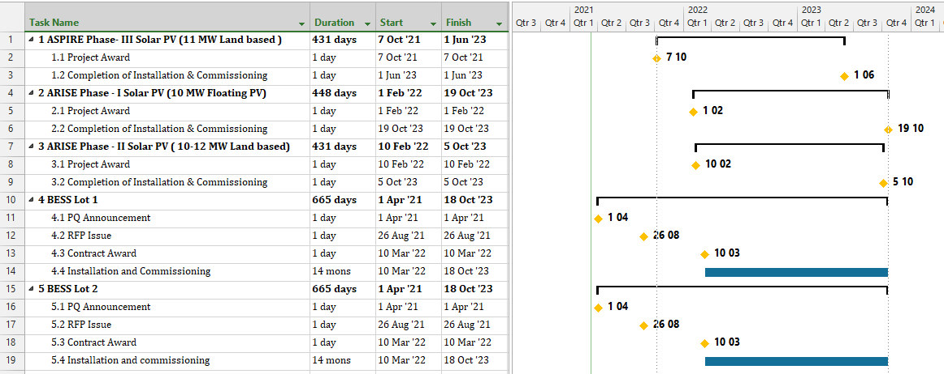
Table 1 Tentative timelines for PV installations under ASPIRE/ARISE and BESS installations

3. Site and Other Data
  - Characteristics of selected island grids for hybridization under the project
There are 22 electrically independent grids for BESS installation in this procurement. The PV and BESS sizing allocations for these grids are summarized below in Table 2 along with current and projected electricity demand for each grid. Interconnection of some of the mini grids; L. Isdhoo, L. Kalaidhoo & L. Dhanbidhoo is anticipated in the course of this project. Also L. Kunahandhoo & L. Hithadhoo will be interconnected though timelines are not certain as of now. This will likely result in consolidation of BESS requirements for those grids.
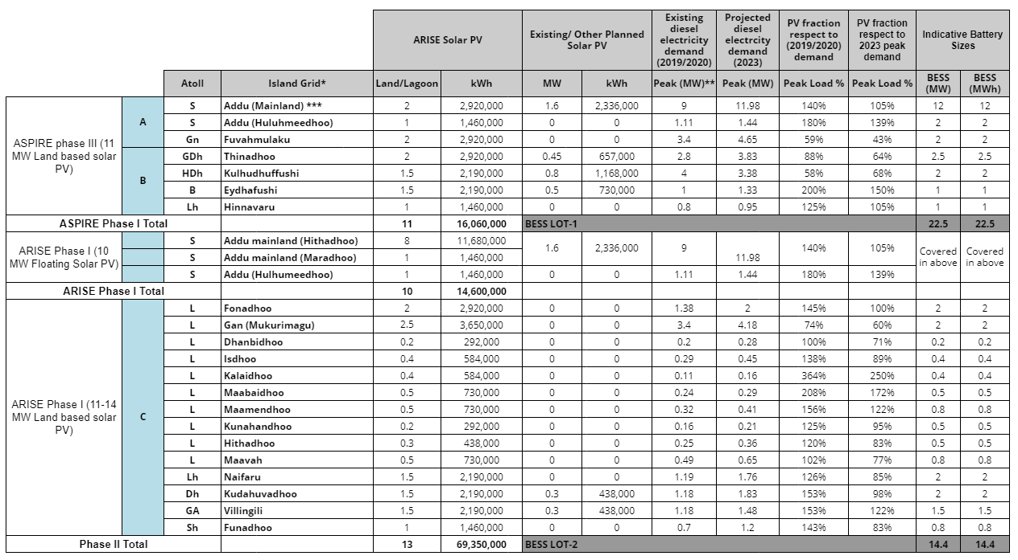
Table 2 Island grids for BESS installation under Lot 1 and Lot 2

  - Geographical locations and logistics for islands covered under the project
The islands selected for BESS installation under this project is distributed throughout the Maldives as shown in Figure 1. The sites identified for installation of PV plants and locations of powerhouses along with key infrastructure are illustrated island by island in the following sections. Overall the islands are well connected with 4 international airports and several domestic airports. Also, in addition to the commercial harbor in capital Male’, Kulhudhuffushi and Hithadhoo ports located in north and south respectively operates as regional ports.
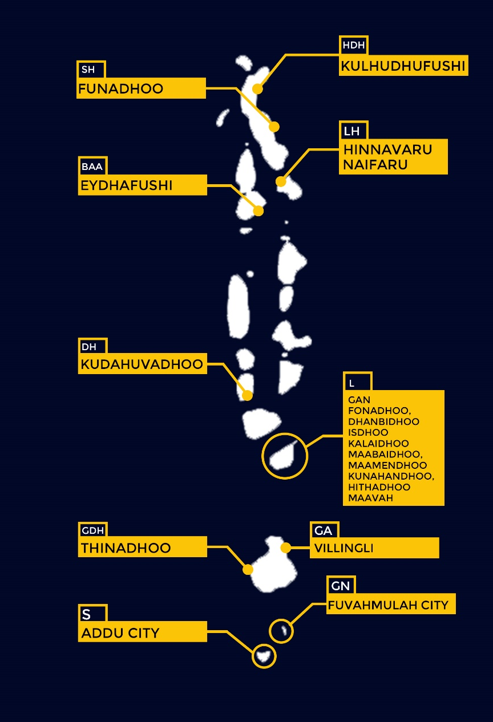
Approx. Scale: 1cm : 45.4 km
Figure 1 Islands for BESS installation under Phase 1 and Phase II of the project

  - Location specific details for BESS Lot I Islands
    - Addu-mainland
Addu mainland refers to the geographically interconnected districts of Addu city at geographical coordinates: 0.6301° S, 73.1586° E, which include Hithadhoo, Maradhoo-Feydhoo, Maradhoo and Feydhoo. Addu city with the local administrative code Seenu is the southernmost atoll in the Maldives and is the largest urban centre apart from Male’ with an approximate registered population over 30,000. The islands are easily accessible by Gan International Airport located on the island of Gan on the same land mass and operates regular flights from domestic routes and some international destinations.
These connected islands have one electricity grid with central power station located in Hithadhoo. The identified sites for PV installation are shown in Figure 2. In general, the BESS under the project is planned to be installed within the powerhouse premises, however considering the dispersed nature of the load centers collocation of the batteries along PV sites is also an option under consideration.

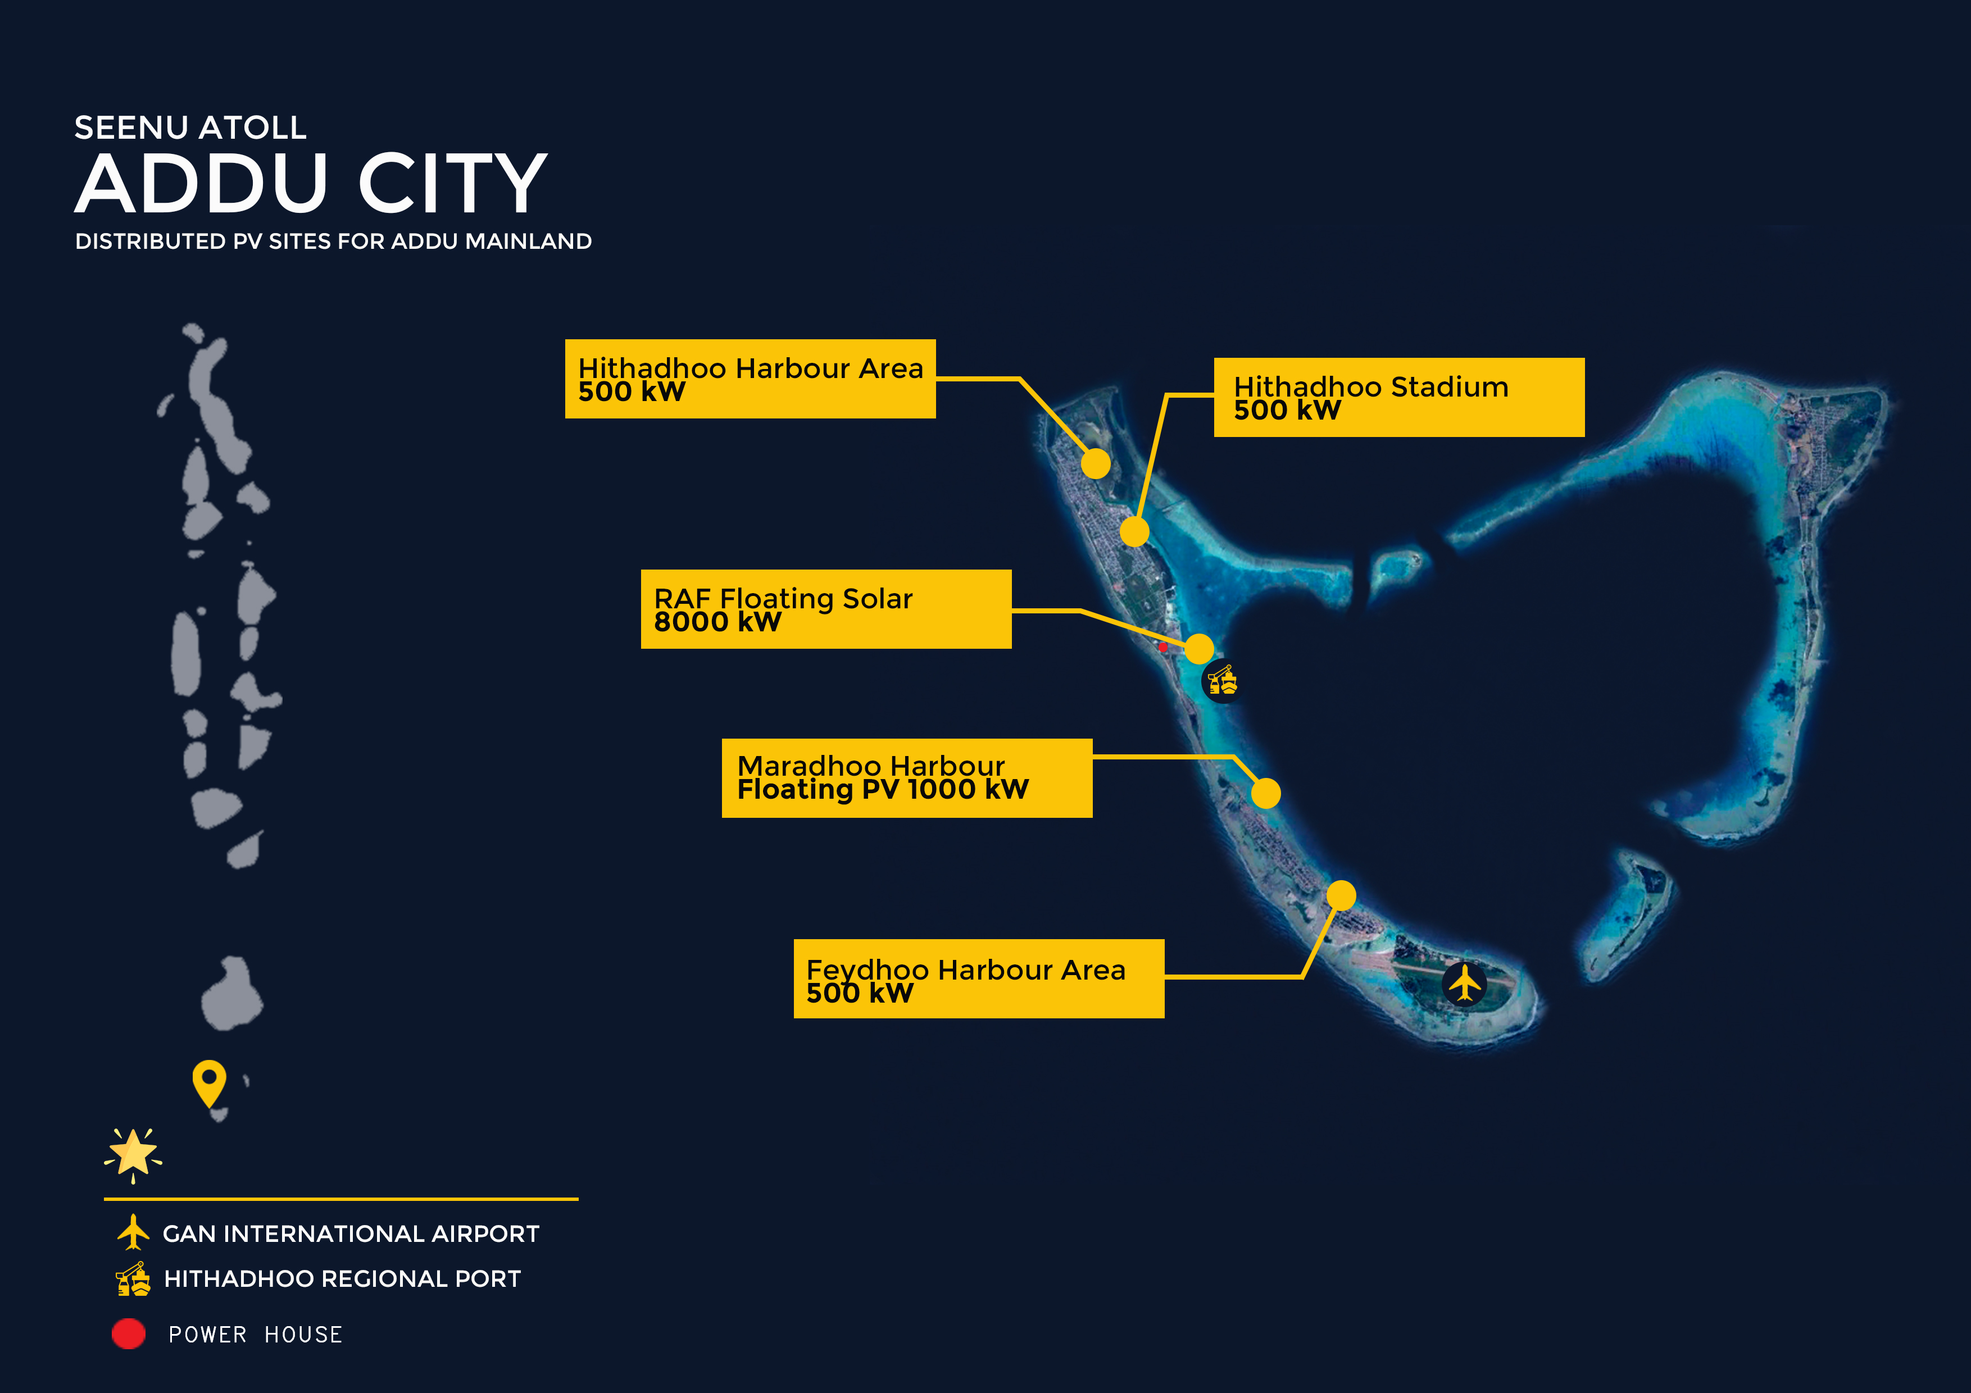
Approx. Scale.: 1cm: 3.2 km
Figure 2 Distributed PV sites and key landmarks for Addu-mainland

    - Hulhudhoomeedoo
Hulhudhoomeedoo is also a geographically connected land comprising of the remaining two districts of Addu city, i.e. Hulhudhoo and Meedhoo and is served by a separate electricity grid from connected mainland. Hulhudhoomeedoo’s approximate registered population is 6500 which is roughly 18% of Addu city’s total resident population. The islands are reachable by a 5-10-minute speed boat ride from Gan International airport. The planned PV installation sites are shown in Figure 3.
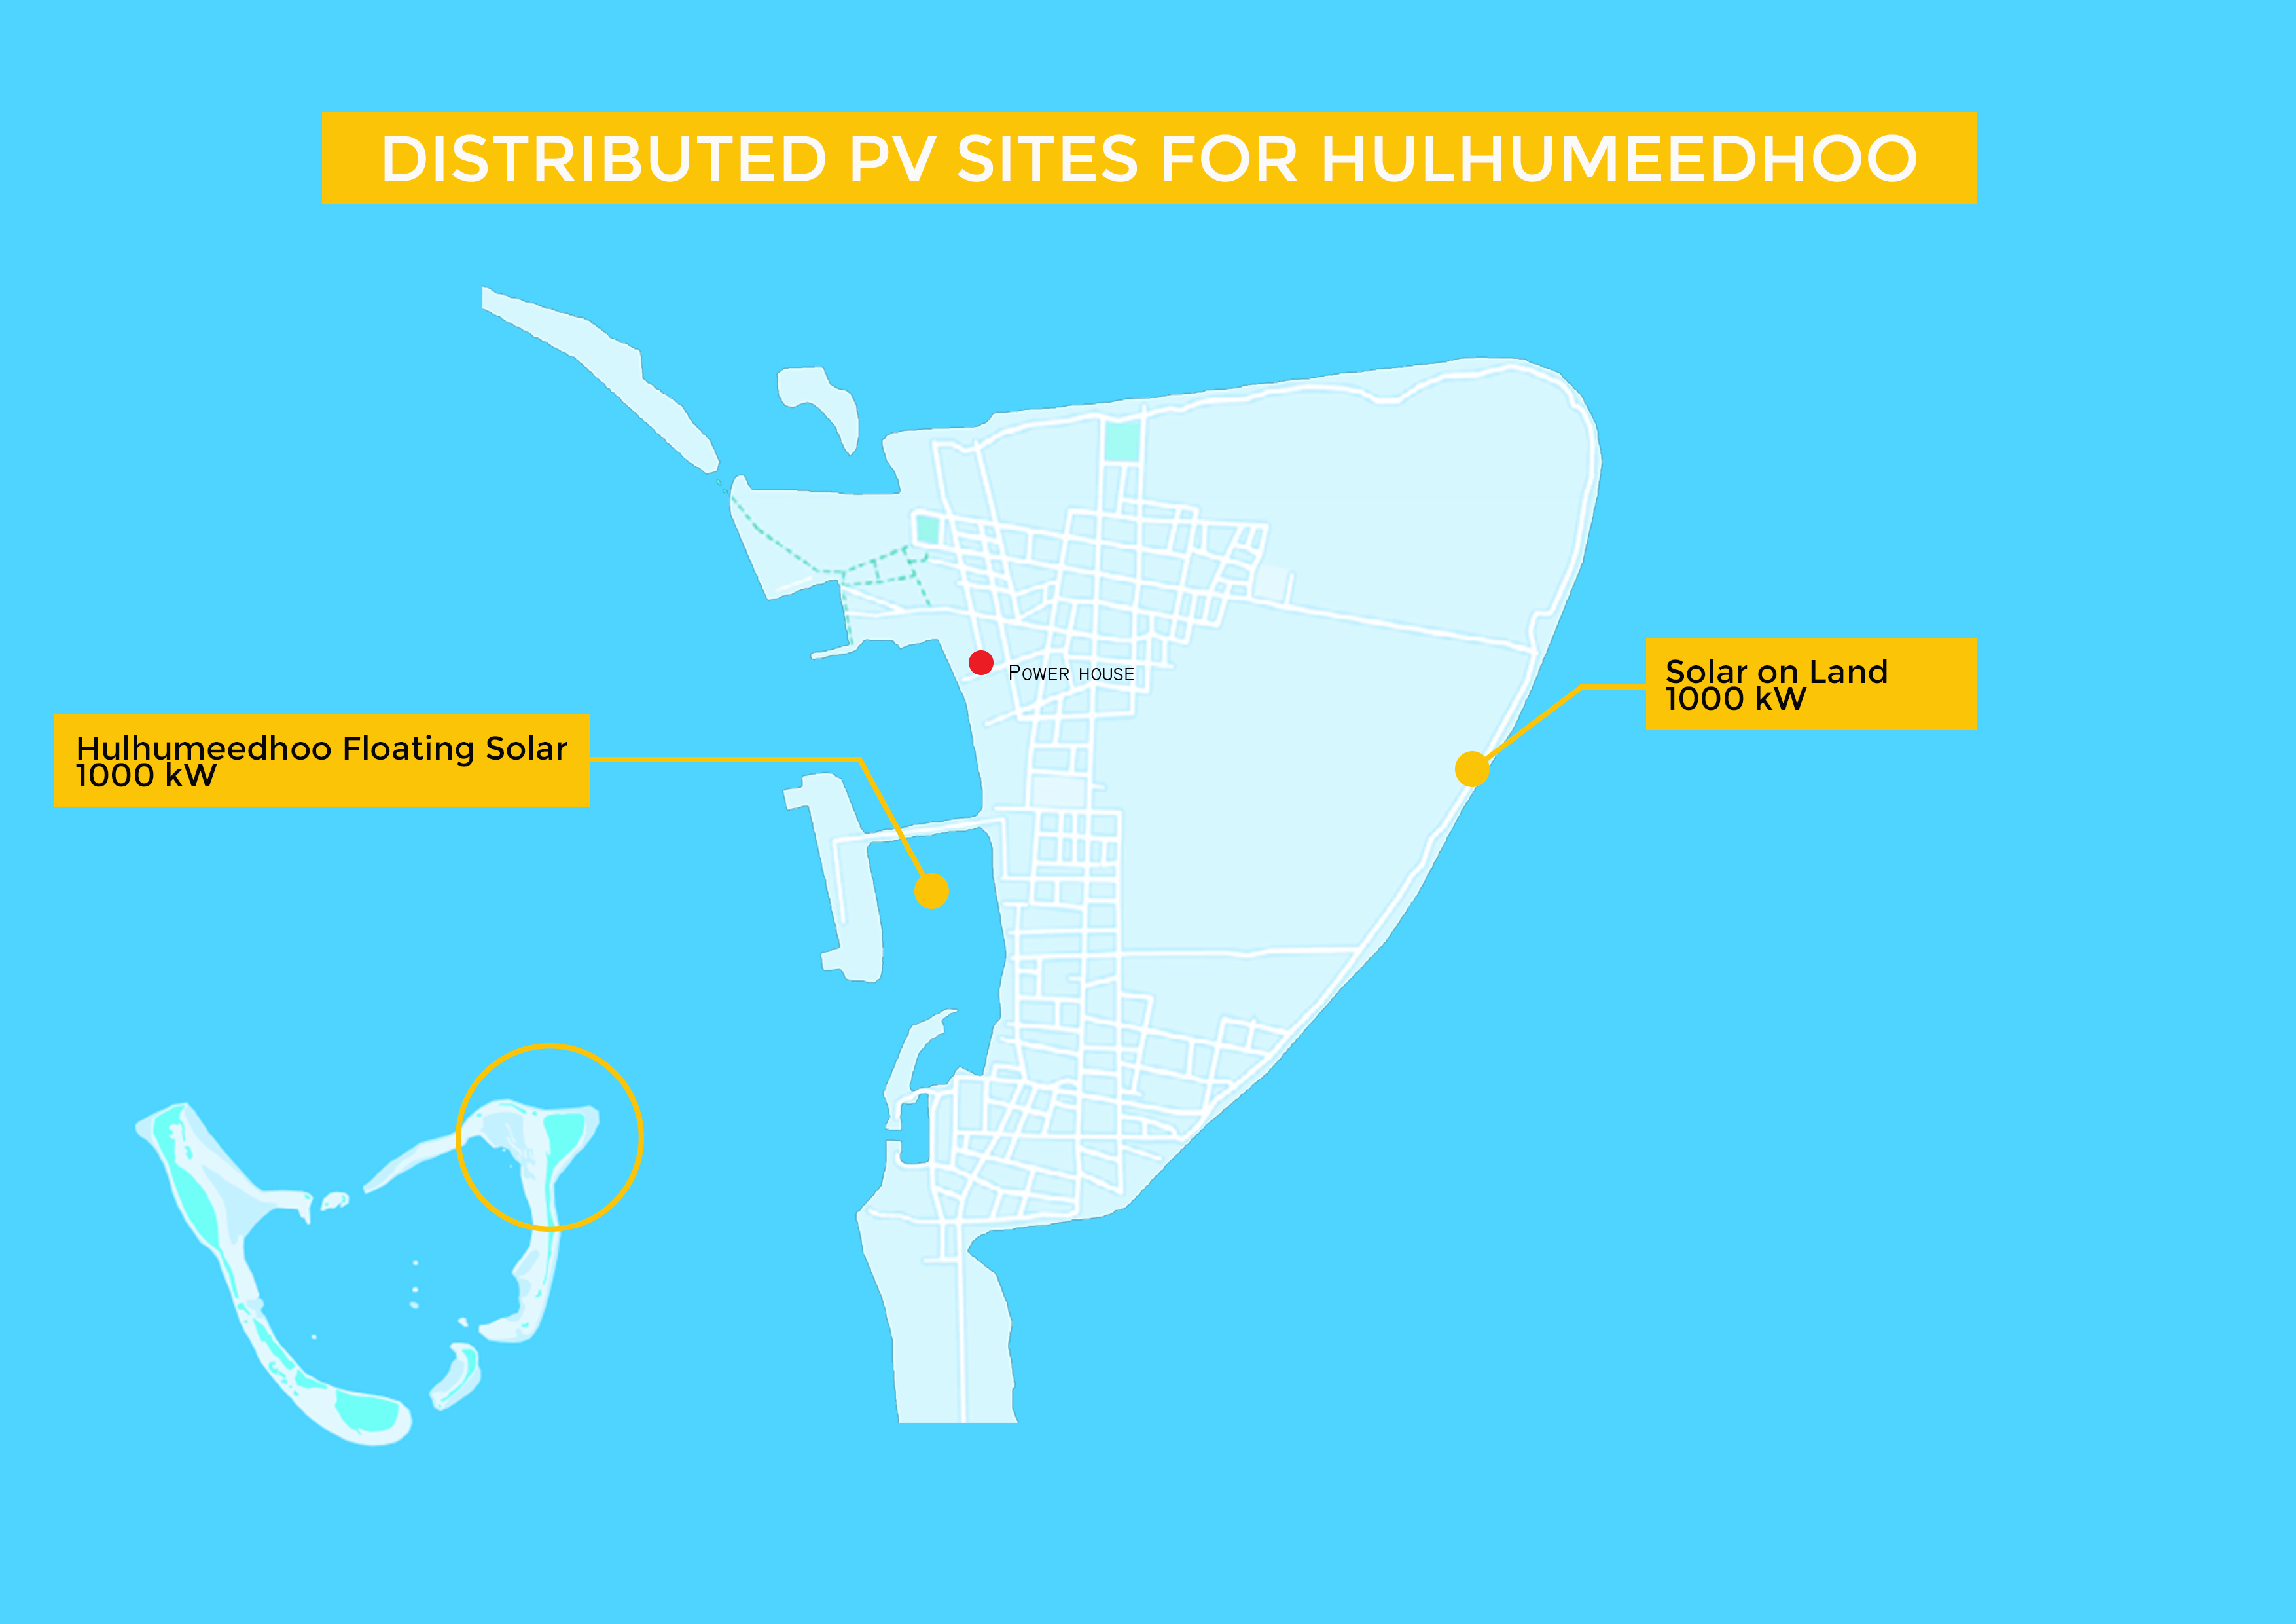
Approx. Scale.: 1cm: 0.43 km
Figure 3 Distributed PV sites and key landmarks for Hulhumeedhoo

    - Fuvahmulah
Fuvahmulah city is an island atoll at geographical coordinates 0.2984° S, 73.4269° E and has an approximate resident population of 13,000. With a domestic airport the city is well connected to other domestic and international airports of the Maldives. PV installations for Fuvahmulah is planned for inside of the airport premises. There are relocation plans for the existing power house and BESS installations will be in the new powerhouse compound. The locations of PV systems and the planned and existing powerhouse locations are marked in Figure 4.
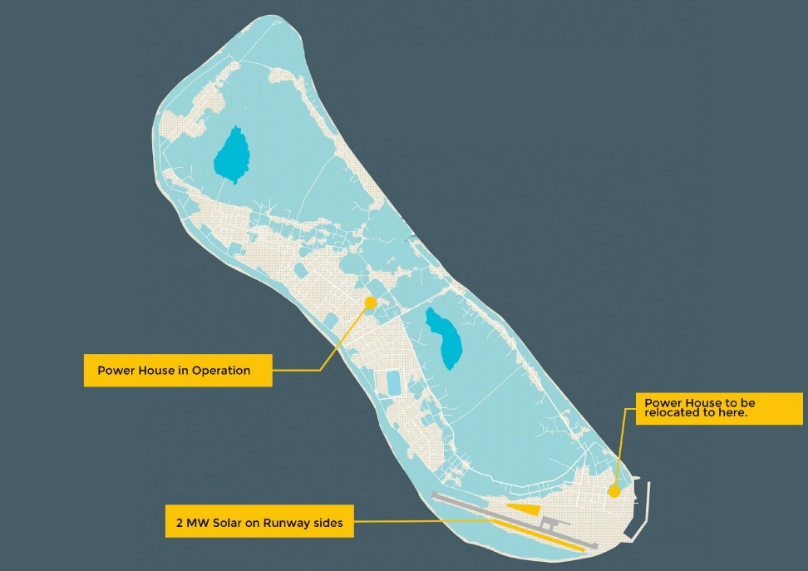
Approx. Scale.: 1cm: 0.45 km
Figure 4 Distributed PV sites and key landmarks for Fuvamulah

    - Thinadhoo
Thinadhoo is the capital of the GDh atoll which is also a Southern atoll and is located at geographical coordinates 0°31′48.83″N 72°59′47.44″E with an approximate resident population of 7,500. The closest airport to Thinadhoo is GDh. Kaadedhoo airport. The planned PV installation areas are marked in Figure 5. BESS installation is anticipated to be located at powerhouse and in case of a distributed installation, BESS will be collocated at PV sites with electrical inter-connection to the closest substations.
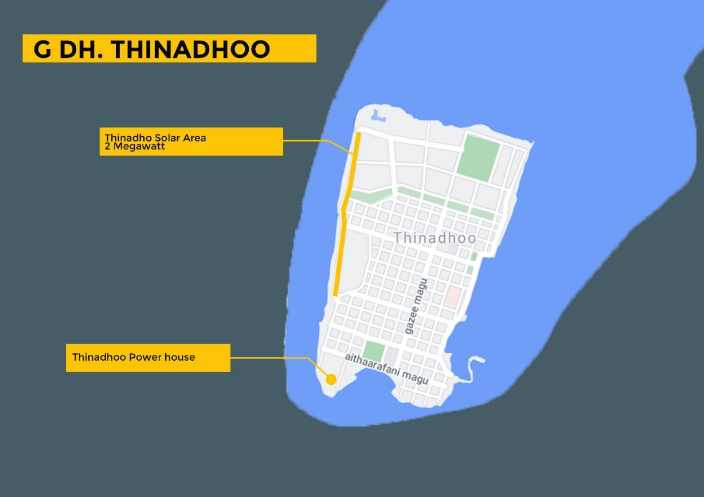
Approx. Scale.: 1cm : 0.20 km
Thinadhoo Power House
Thinadhoo 2MW PV
GDH. THINADHOO
Figure 5 Distributed PV sites and key landmarks for Thinadhoo

    - Eydhafushi
Eydhafushi at geographical coordinates 5.1026° N, 73.0686° E belongs to B atoll which lies in the north-west of the Maldives. The resident population of Eydhafushi is approximately 3000. The closest airport to Eydhafushi is Dharavandhoo airport. The planned PV installation areas for Eydhafushi is shown in Figure 6. BESS installation is anticipated to be located inside the powerhouse and in case of a distributed installation, BESS will be collocated at PV sites with connection to closest substations.
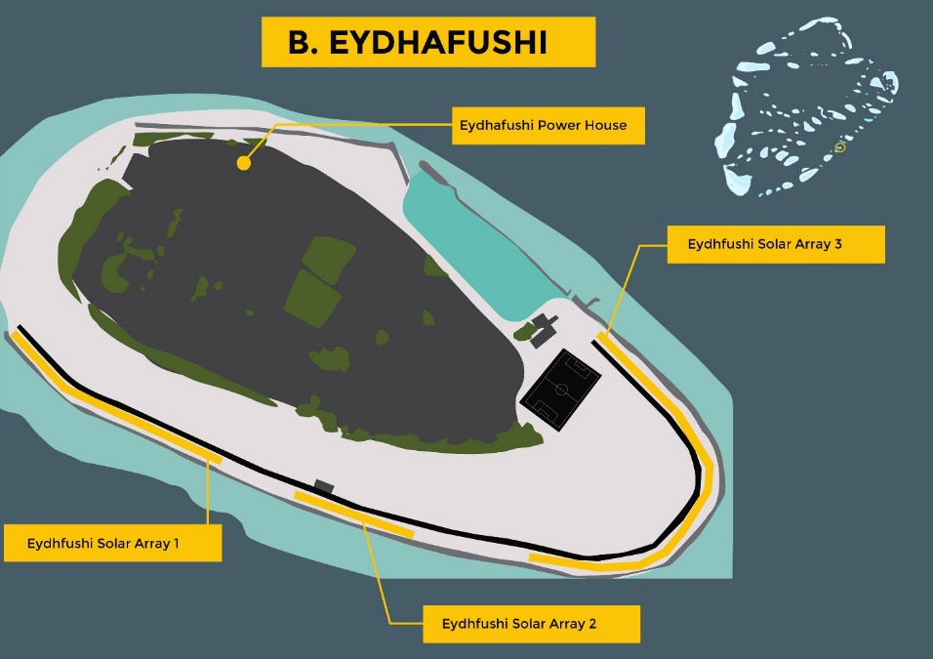
Approx. Scale.: 1cm : 0.09 km
Figure 6 Distributed PV sites and key landmarks for Eydhafushi

    - Hinnavaru
Hinnavaru at geographical coordinates 5.4937° N, 73.4129° E belong to Lh atoll and lies north of the Maldives. The approximate resident population of Hinnavaru is 5000. The areas for PV installation planned for Hinnavaru is shown in Figure 7 and similar to other islands BESS installation is mainly anticipated to be located inside the powerhouse.
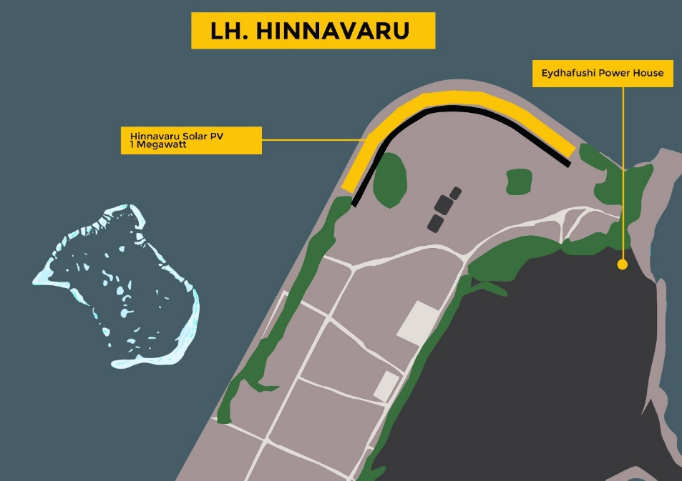
Approx. Scale.: 1cm : 0.06 km
Figure 7 Distributed PV sites and key landmarks for Hinnavaru

    - Hdh. Kulhudhuffushi
Kuldhuffushi at geographical coordinates 6.6266° N, 73.0666° E is the capital of Hdh Atoll. The approximate resident population of Kulhudhufushi is 9,838. The PV installations for Kulhudhufushi is low ground mount installations inside the Kulhudhufushi airport and is shown in Figure 8. Similar to other islands BESS installation is mainly anticipated to be located inside the powerhouse.
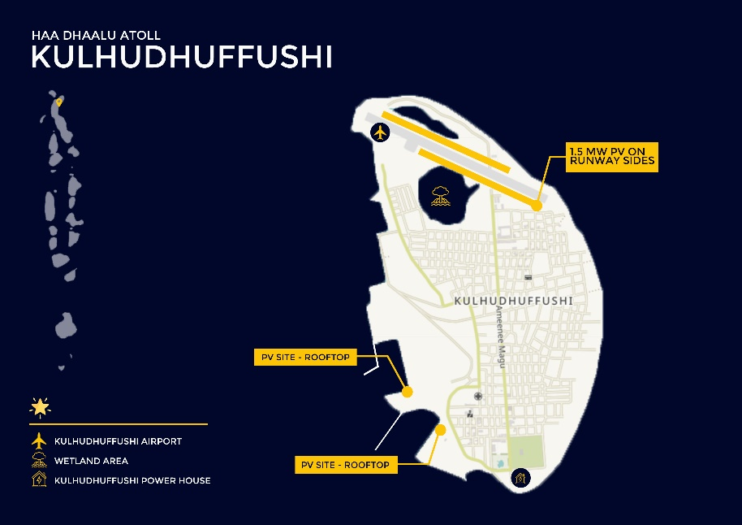
Approx. Scale 1cm : 0.28 km
Figure 8 Distributed PV sites and key landmarks for Hdh Kulhudhuffushi

  - Location specific details for BESS Lot II Islands
The PV installation sites for the islands under this phase of the project is still under identification and full details will be revealed at the RFB stage. The islands which comprise this package are:
    - Selected islands of Laamu Atoll
Fonadhoo, Gan, Dhanbidhoo, Isdhoo, Kalaidhoo, Maabaidhoo, Maamendhoo, Kunahandhoo, Hithadhoo and Maavah include the selected islands from Laamu atoll for the project and is shown in Figure 9. Laamu atoll is in the Southern Maldives and lies at geographical coordinates 1.9431° N, 73.4180° E. The islands of Fonadhoo and Gan are on the same land mass and Kadhoo airport is also located on the same land. Apart from Fonadhoo and Gan, all the other islands of this atoll will need to be accessed via speed boat from Kadhoo airport. The resident population for the entire Laamu atoll is approximately 18,000. Fonadhoo, Maavah and Gan are the most populated islands with respective populations of 2800, 2000 and 4800. The rest of the islands have populations of approximately 1000 each on average.
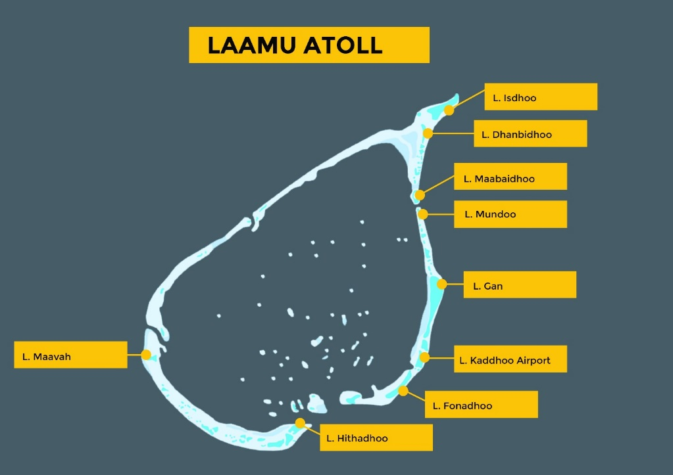
L. Hithadhoo
L. Maavah
L. Fonadhoo
L. Kadhoo airport
L. Gan
L. Mundoo
L. Maabaidhoo
L. Dhanbidhoo
L. Isdhoo, Kalaidhoo
Approx. Scale.: 1cm : 4.8 km
Figure 9 Laamu Atoll islands selected for BESS installations

All the islands of Laamu atoll have its own electricity mini-grids. Interconnection and centralization of power grids of the Laamu atoll is a focus of the utility company, FENAKA. As such interconnection of the mini-grids of Isdhoo, Kalaidhoo and Dhanbidhoo is planned for implementation in 2021 and construction of a central power house for Isdhoo, Dhanbidhoo and Kalaidhoo is also foreseen for a very near future. There were three power houses in operation for Gan, located in the three wards Thundi (Mahinna), Mathimaradhoo and Mukurimagu as shown in below figure. However, Mathimaradhoo and Mukurimagu powerhouses have been phased out in the end of 2019 and Mahinna (Thudi) power is now the central powerhouse for Gan. The powerhouse locations are marked in the following figures.
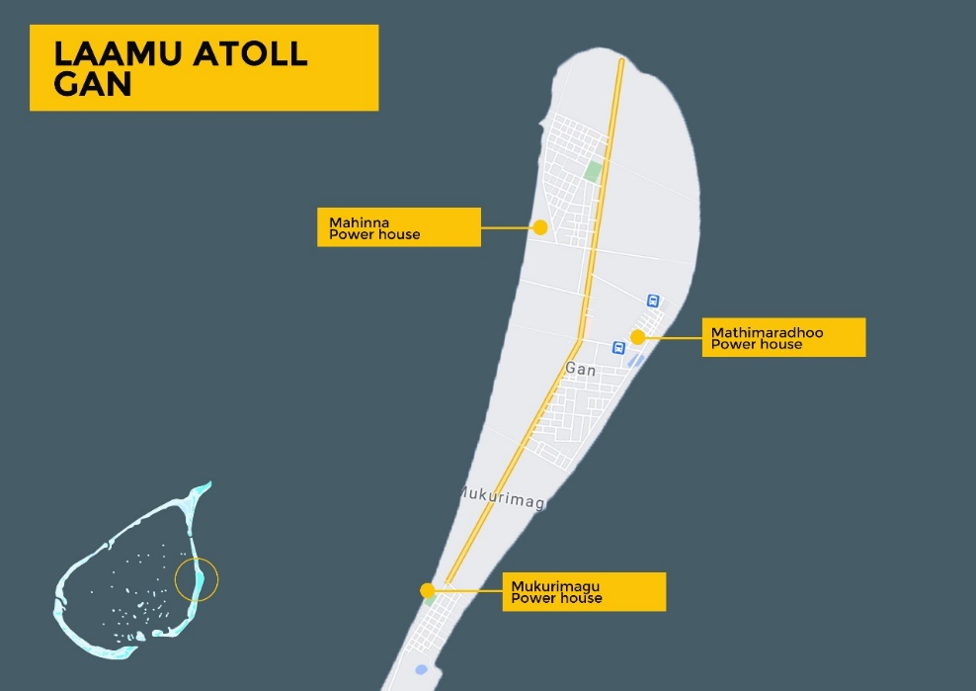
Mahinna Power house
Mathimaradhoo Power house
Mukurimagu Power house
Approx. Scale.: 1cm : 0.52 km
Figure 10 Power house locations for Laamu Gan

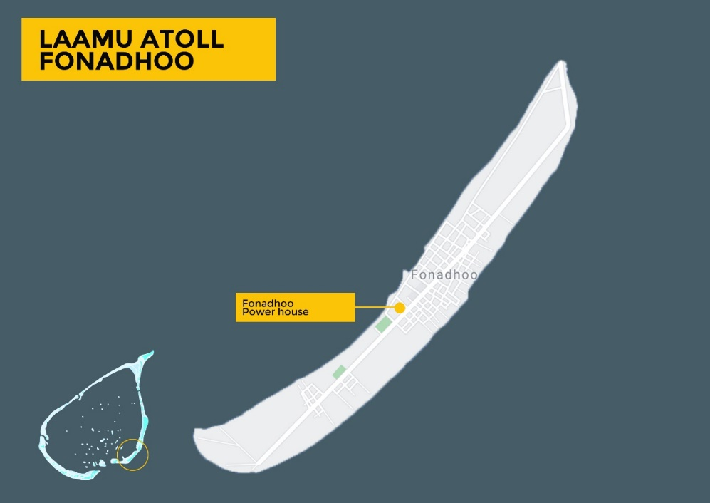
Fonadhoo Power house
Approx. Scale.: 1cm : 0.31 km
Figure 11 Power house locations for Laamu Fonadhoo

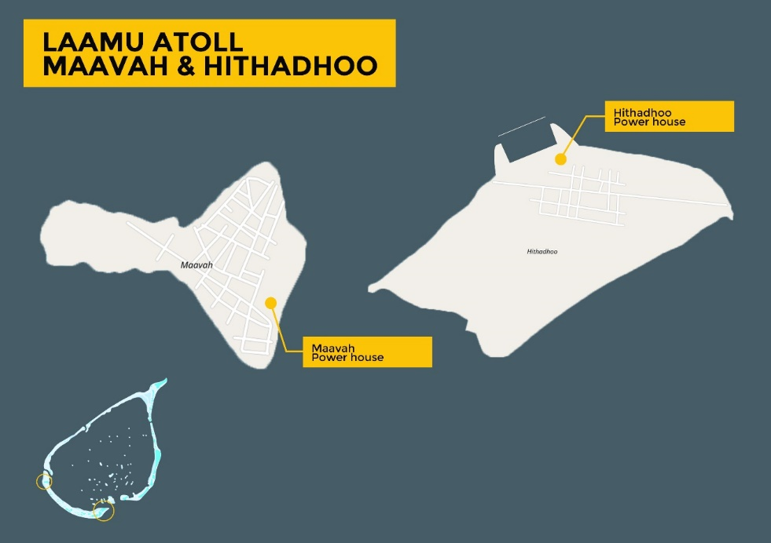
Approx. Scale.: 1cm : 0.2 km
Figure 12 Power house locations for Laamu Maavah and Hithadhoo

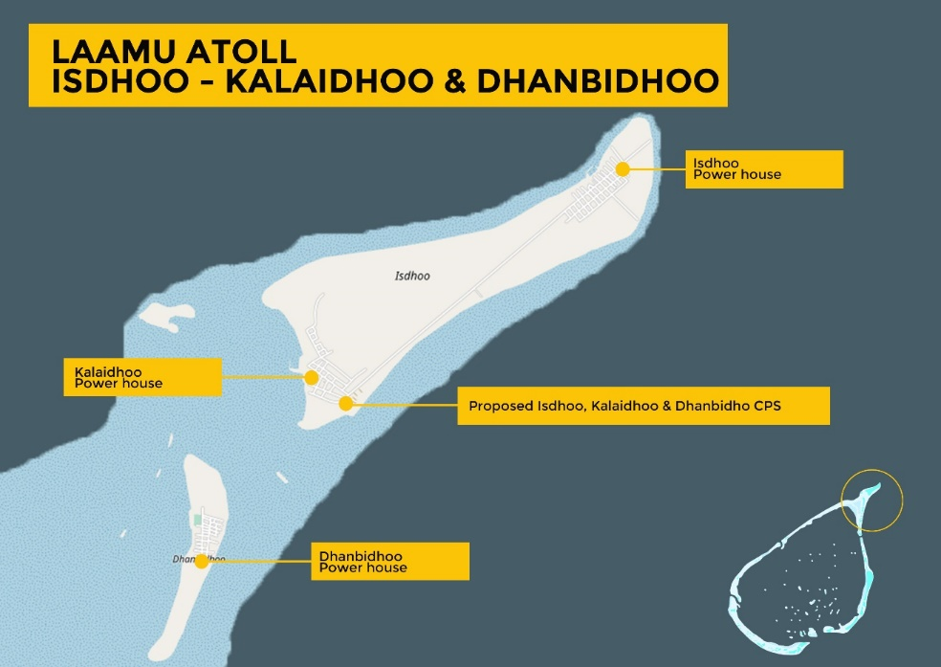
Approx. Scale.: 1cm : 0.5 km
Figure 13 Power house locations for Laamu Isdhoo, Kalaidhoo and Dhanbidhoo

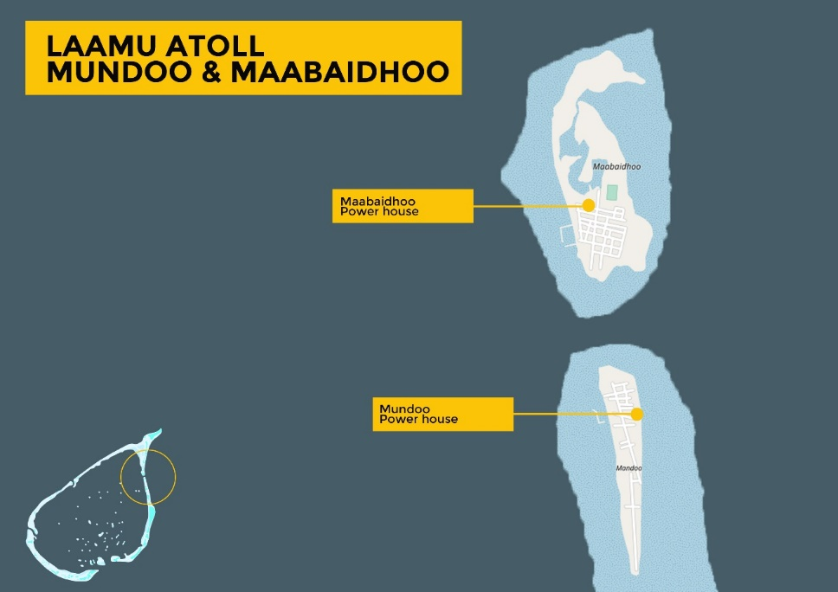
Approx. Scale.: 1cm : 0.35 km
Figure 14 Powerhouse locations for Laamu Mundoo and Maabaidhoo

    - Lh. Naifaru
Naifaru at geographical coordinates 5.4444° N, 73.3657° E, is the capital of Lh atoll and is located about 142km North of Male’, the capital city of Maldives. The closest airport to Naifaru is Velana International airport and the island is accessible from there by ferry or speed boat. The resident population of Naifaru is approximately 5,500.
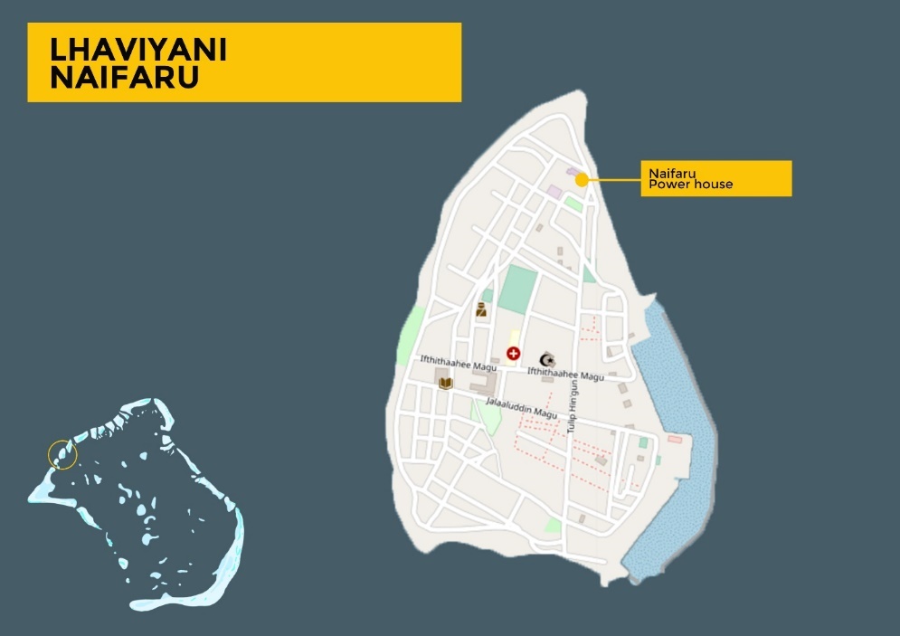
Approx. Scale.: 1cm : 0.14 km
Figure 15 Powerhouse Locations for Naifaru

    - Dh. Kudahuvadhoo
Kudahuvadhoo is the capital of Dh Atoll and is located at geographical coordinates 2.6707° N, 72.8944° E which is 179km south of the capital Male’. Kudahuvadhoo has a regional domestic airport known as Dhaalu airport. The island has a resident population of 3,267.
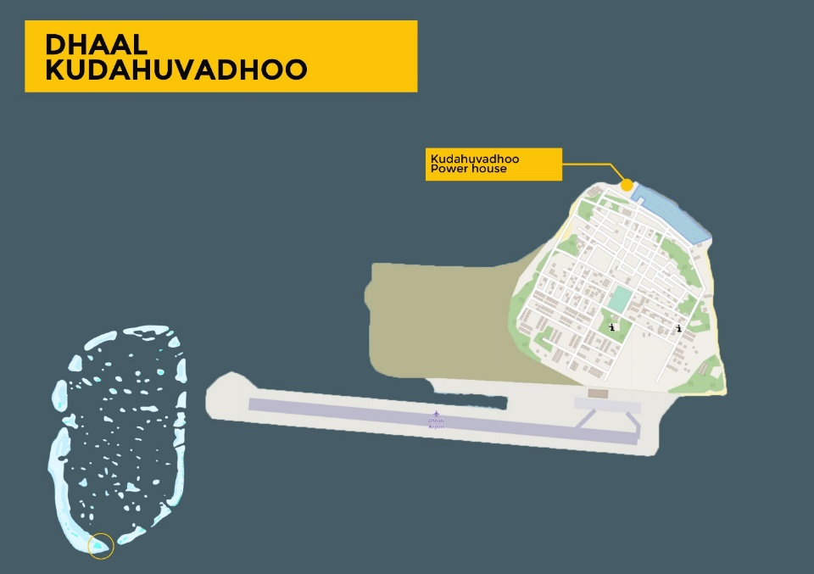
Approx. Scale.: 1cm : 0.23 km
Figure 16 Powerhouse location for Dh. Kudahuvadhoo

    - Sh. Funadhoo
Fonadhoo in the northern Maldives lies at geographical coordinates 6.1448° N, 73.2890° E, and is the capital of Sh atoll with a resident population of 2,553. The island has a very recently built airport which is now operational.
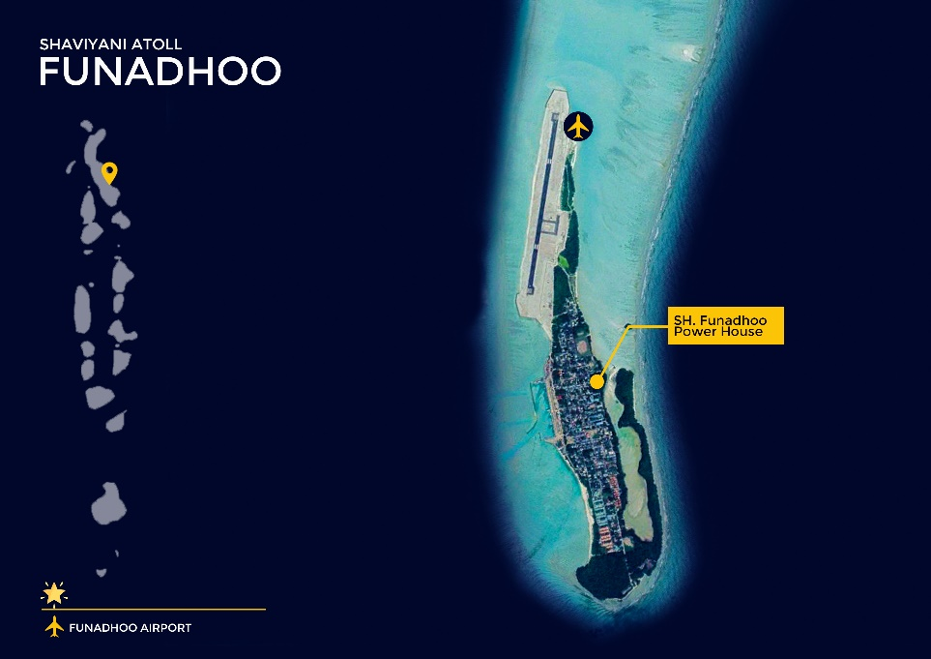
Approx. Scale.: 1cm : 0.37 km
Figure 17 Powerhouse location for Sh. Funadhoo

    - GA. Villingili
Villingili lies in the Southern Maldives at geographical coordinates 0.7539° N, 73.4348° E, and is the capital of GA atoll with a resident population of 3,606. Gdh Koodoo airport connects the island to other airports of Maldives and is only about a half kilo meter away.

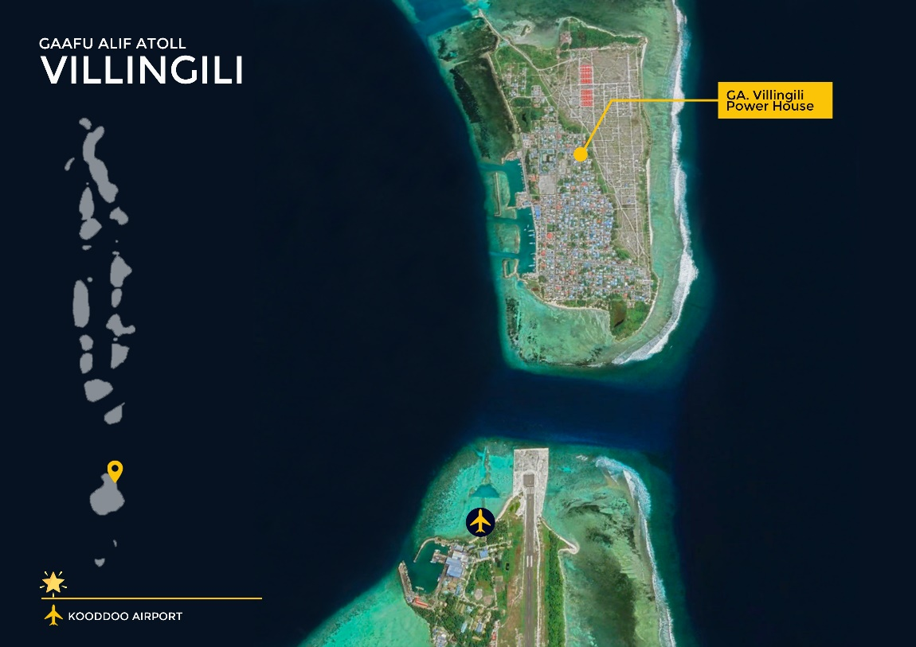
Approx. Scale.: 1cm : 0.13 km
Figure 18 Powerhouse location for GA. Villingili
4. Environmental and Social (ES) Requirement

  - Site Specific Requirements
Prior to issuing Request for Bids (RFB), the Employer will undertake site specific Environmental and Social screening and will complete the required level of Environmental and Social assessment required for the project. The Employer will disclose the draft of the required assessment as part of the RFB and will include the relevant sections of the final document as part of the Contract. The Contractor should bear the costs and implement all mitigation measures highlighted and undertake compile and provide the required monitoring data as per the requirements of the Employer. The costs required for implementation of the mitigation measures shall be provided in the Bill of Quantity/Price Schedule. In addition, as per the requirements of Environmental and Social Management Framework of the project, the following plans shall be developed by the Contractor:
- Occupational Health and Safety Management Plan
- Should cover specific actions, procedures that will be undertaken to ensure Occupational Health and Safety during the contract period in line with the Labor Management Procedure (LMP) developed for the project and the Guidelines for Occupational Health and Safety Management of Workers, Communities and Visitors during Construction Works provided in Annex 12 of the ESMF.
- Hazardous materials management plan
  - Safety Data Sheets (SDS) (prepared in accordance with European Chemicals Agency Guidelines, or equivalent international standard) for all potentially hazardous materials included in the BESS or its spares. This shall include but not be limited to: battery cells (including cathode and anode), fire suppression chemicals, and coolants.
  - Any Original Equipment Manufacturer (OEM) specifications on installation or handling requirements (for example, special electrical protections on surge protection or earthing) that are not covered in the SDS.
  - Any OEM advisories pertaining on incidents or incident investigations pertaining to the particular materials supplied.
  - A project and site-specific detailed description for materials handling and logistics, demonstrating compliance with the above documentation. For example, showing that battery modules’ shipping is planned for refrigerated containers (if required by the SDS).

- Emergency Response plan
  - An Emergency Response Plan (ERP) covering safety of equipment on site, medical treatment of workers, response to external events like floods or cyclone, external fires and evacuation procedure should be proposed. This shall cover both construction and operation phase. In addition a detailed Fire Safety Plan (FSP) should be compiled address both construction and operations stages, covering the following:
    - Fire safety equipment requirements
    - Fire safety signage
    - Procedures in the event of a fire initiated at the container, including shutdown actions, safe distances and evacuation plan, immediate notifications, fire suppression actions (if any) and who is responsible.
    - Procedures following fire event (when is it safe to approach, how to make site safe, who to contact for further clean-up and disposal or investigation).
    - Procedures for an external fire event that may impact the BESS (for example, fire in adjacent equipment).
    - Mitigation to minimize damage to neighboring inhabitants focusing on fire, explosion or toxic gas discharge
    - Mitigations to minimize impacts on health and safety of workers and the public also include electrical, mechanical, chemical, fire, explosion and gas discharge.
    - Considerations made to reduce risk of fire, toxic emissions and explosions to nearby infrastructure, residences and workers determined through a hazard operability study (HAZOP).

- Commissioning Plan
  - The Commissioning plan will document the sequence of steps necessary to transition the BESS from a mechanically and electrically complete state, to a fully operational system. The sequence of operations in the Commissioning plan must be constructed to ensure safe commencement of operation. It must also include the following documentation:
  - Verification that all inspection and test plans under pre-commissioning or site acceptance tests are completed, and that all project documentation requirements are in order (including issued for construction (IFC) design documents, any required third-party certifications such as building permits or electrical safety compliance certificates, factory acceptance test (FAT) reports and Master document registers (MDRs)). The Contractor must confirm that the plant is mechanically and electrically sound and in a fit state to operate.
  - Documentation of completed Control Assurance Plan (CAP). Verification that safety critical control points are within compliance. CAP should include accuracy and delay compliance thresholds, recorded values, and testing interval. Simulated out-of-range inputs should be used to verify appropriate input or signal sanitization. The CAP should also stipulate data recording requirements and how stale data is handled for each point.
  - Documentation of completed Measurement Assurance Plan (MAP). Verification that safety critical measurements are within compliance. The MAP should include accuracy and delay compliance thresholds, recorded values, and testing interval. Simulated out-of-range measurements should be used to verify appropriate alarms and warnings before operation. MAP should also stipulate data recording requirements and how stale data is handled for each point.
  - Internal or External Communication Loss. If there is a loss of safety critical measurement or control, the system should gracefully shut down (e.g. loss of temperature measurement). If measurement or control is not safety critical (As determined in the Failure Module Effect Analysis (FMEA) and System Safety Analysis) then the system can continue to operate (e.g. loss of connection to off-site data backup).
  - OEM verification of installation of BESS modules, or proof that commissioning team is fully trained and authorized by OEM to complete installation to OEM requirements.
  - Ensure comprehensive training of power station staff are provided for emergency situations including simulated emergency drills.

- Operations and Maintenance Plan
Plans for inspecting, servicing, repair and renovation as well as any addition to the system (e.g. installation of additional storage capacity). Procurement specification should require Energy Storage supplier, developer, or integrator to deliver a complete operation and maintenance manual. This manual should provide instructions for all required operating and maintenance activities, the timing for these activities, and who will perform them. This manual should also include conditions under which the system will have met end of warranty, service life, and operational life. The O&M plan should also detail periodic maintenance checks and scheduled replacement of consumables that local operators should perform including checks for corrosion or other degradation of individual cells or larger units that could increase fire or hazardous material risks.

- Decommissioning and Disposal plan
After the system has reached the end of its operational life, system has to be decommissioned, disposed of or materials can be recycled. This plan should explain the procedure for decommissioning, including any hazards that may present, as well as the steps to disconnect the system using external automated control systems. The plan should demonstrate a practical plan for removal of battery modules at end of life (including shipment out of country) and disposal at a facility that meets international standards for environmental management ISO 14000. The plan must show that multiple disposal facilities are readily accessible and offer certification that they will accept the proposed BESS module. It should elaborate what costs this will incur, how articles should be packaged for disposal, and the procedure for shipping the materials to the disposal or recycling site.

The following standards or equivalent will be used to assess that risks have satisfactorily been addressed:
Aspect | Requirement | Required standards
Lithium batteries (cells) | Remain safe (do not release hazardous waste or risk injury) under normal operations of misuse. Standards should ensure battery cells have been subject to testing for a range of normal and adverse conditions without exhibiting runaway thermal behaviour. | IEC 62133, and IEC 62660 (or UL 1642, UL 1973)
Inverters | Electrical safety of equipment, and functionality to support rapid shutdown and related system protection measures | IEC 62909-1 (or UL 1741)
Fire detection and suppression systems | Effectively detect and issue alarms for fire events that may arise in BESS. Ensure safe operation of fire suppression (if included). | ISO 7240, ISO 14520
Battery energy storage systems | Provide overarching safety and environmental requirements for integrated systems. Address personnel safety, electrical hazards, essential grid protection functions, fire and explosion safety, hazardous materials, stand-off distances, installation and operation requirements. Include provisions for system level risk assessment and testing. | IEC 62933 (or UL 9540)  IEC 92902
Transport of battery cells from manufacturer to site | Minimise risk of electrical hazard, fire, or exposure of hazardous material during transport. | IEC 62281
Access, egress and working space | Ensure adequacy of work spaces, including protection from arc flash or exposure to electrical hazards, unrestricted access to emergency exits, and reduce risk of exposure to fire suppression systems. | IEC 61936-1

The Contractor should have ISO14001 certification or equivalent. This certification needs to be submitted at the time of bidding.
The Contractor shall be responsible to ensure all construction material are sourced from approved sites or licensed commercial vendors. All key environmental parameters such as vibration and noise shall not exceed the limitation imposed by the Environmental Protection agency.
If the Contractor fails to adhere to the mitigation and monitoring plan to a level acceptable to the Environmental Social Safeguards Specialist or other monitoring Agencies, the Employer will temporarily suspend the work until such time proper mitigation measures and monitoring are implemented.
The contractor should allocate 2.5 percent of the total contract value as Environmental Social Health Safety (ESHS) Performance Security.
If any of the defects identified by the Environmental and Social Safeguards Specialist are not remedied by the Contractor within the time given by the Employer, the Employer will consider the Contractor’s work is non-compliance towards environmental safeguards and necessary remedial action will be undertaken by the Employer through a third party. Further the cost of the third party and 12% (twelve percent) for supervision charges will be deducted from the Contractors Payment or from the ESHS Performance Security. Any additional cost or time incurred due to above will be at contractors’ expense and will not be subjected to extension of time or claim.
The contractor will be responsible for cleaning up and disposing of all waste materials and rehabilitating (landscaping) all construction sites and work areas so that these can be returned as close as possible to their previous use. This includes the stabilization and landscaping of all of the construction sites. Any borrow pits that were operated by the contractor are to be reshaped and closed. Any contaminated soil must be removed from fuel and oil storage areas. All construction debris is to be removed. Payment will be withheld from the contractor until all of the sites are satisfactorily cleaned, all spoils removed and the sites satisfactorily rehabilitated. The final payment will be released only after confirmation by the Environmental and Social Specialist that the above-mentioned tasks have been completed satisfactorily by the Contractor.
Any legal penalties in relation to environmental and social non-compliance, imposed by any government agency, related to works undertaken by the contractor due to non-compliance of provisions included in the contract should be borne by the contractor.
As a guidance of the type of mitigation measures and safety aspects that will be required from the contractor refer to “Generic Environmental and Social Management Plan (ESMP) for Management of Environmental and Social Impacts During the Construction/Installation of Solar PV and BESS Systems and Grid Infrastructure” provided in Annex 10 of Environmental and Social Management Framework (ESMF) of the project (link: https://www.environment.gov.mv/v2/en/download/10026).
For safety aspects specific to BESS refer to “Standard Guidance on Safety Considerations to be Included in the Implementation of Battery Energy Storage System (BESS) Subprojects as per International Best Practice” provided in Annex 5 of ESMF (link: https://www.environment.gov.mv/v2/en/download/10026).
  - General Safeguards Requirements
In addition to site specific requirements, the Contractor is required to adhere to Environmental and Social Management Framework (ESMF) and Labour management Procedures (LMP) developed for the project in accordance to World Banks Environmental and Social Framework (ESF) and the applicable Environmental Social Standards (ESS) for the project. Specific requirements for Contracted Workers are defined sunder the Labour Management Procedures (LMP).
These documents and translation of executive summary of these documents can be downloaded from the link below:
https://www.environment.gov.mv/v2/en/download/10026
As per the LMP, the following mitigation measures in relation to Contracted Workers need to be followed (page 29 to 31):

    - General Provisions
- List of workers to be utilized in relation to the project, with proof of employment will be required to be submitted to Project Management Unit (PMU) of the Employer by all investors/contractors.
- Construction work can only commence once the following conditions are met:
- Toolbox training completed by all staff employed by the contractor
- All the required Personal Protective Equipment are acquired by the contractor for all workers
- Any newly employed party by the contractor will be required to complete the toolbox prior to commencing any physical work.
- As per the provisions of the employment, all parties employed by any contracted party will be above 16 years of age. For those between 16 to 18 years of age, consent of the parent will be required as per the employment act. In addition, all other provisions of the act highlighted previously regarding employment of a minor will apply. All contractors and investors will be required to provide document evidence (passport, identity card or birth certificate) confirming age of employees to PMU prior to involving them on activities of the project. In addition, for minors consent of the parent will be provided in writing together with evidence of legal guardianship.
- Maximum working hours for staff will not exceed the maximum limit set in the employment act, i.e. 48 hours a week. To confirm this, monthly attendance and duty sheets need to be submitted to PMU during the construction phase.
- An internal transparent and accountable system will be established within the company to tackle issues of sexual harassment, physical and psychological harassment and workplace bullying. Details of this system will be shared with PMU prior to signing any contracts or agreements.
- All contracted staff will be made aware of grievance redress mechanism available for the staff specified under this LMP.
- The leave policy of the company will be shared and confirmed that it is in line with national laws and regulations.
- All foreign parties employed by all contractors/investors will have valid work permit. The work permit details will be shared with PMU.
- All vehicles used by any contractor/investor for the purpose of the project will have valid registration, insurance and road worthiness.

    - Project work Site
- All provisions that are required under Health and Safety Regulation for Construction Industry (2019/R-156) will be strictly adhered to.
- All workers will be provided with Personal Protective Equipment (PPE) by the contractor/Investor. In this regard the following will be observed:
- Hard hats should be used by all workers when undertaking construction and when undertaking inspections at height.
- Enclosed safety shoes should be worn by all construction workers.
- Safety harness should be used by all workers when climbing heights at project sites.
- Electrical Protective gloves should be provided to workers when dealing with electrical components.
- Chemical protective gloves should be provided to all workers when dealing with any chemicals.
- Construction safety goggles should be worn by all construction workers.
- Ear plugs should be worn by all construction workers working in environments with high noise (working above 75 decibels).
- Masks should be worn when dealing with chemicals and when working in dusty environments.
- All chemicals will be stored on hard surfaces and should be covered.
- Portable drinking water will be made available at the construction site during construction phase.
- Adequate safety signs will be installed at the work site giving clear direction. These will be provided in addition to English in the language of the workforce.
- Construction work site will be demarcated & fenced, and warning signs will be displayed both in English and Dhivehi.
- When construction is undertaken, clearly demarcated bins for waste disposal will be placed and emptied daily.
- Open pits will not be left for water to accumulate for a long time.
- Any stockpiled sand will be covered to prevent sand particles from being airborne.
- All vehicles and equipment used for the project will be used by well trained personnel.
- Any scaffolding used will be to British Standard (BS1139).
- When working at night, adequate lighting will be provided.
- A designated toilet facility will be available within 10 minutes of the construction site.
- Breaks will be given to the workforce during mealtimes.
- The site will be cleaned daily following completion of days work.

    - At contractors’ offices and temporary accommodation site(s)
- Constant and reliable electricity supply will be available at project office and accommodation site.
- Shower and toilet facilities will be available at temporary accommodation site.
- Toilet and drainage will be connected to local sewer system, where not available septic tanks will be used for treatment prior to disposal.
- A minimum ratio of 01 toilet/shower per 20 workers will be maintained. Separate facilities will be provided for men and women.
- Individual bedding will be provided to all workers.
- Storage space for individual belongings will be provided for all workers.
- Male and Female workforce will be housed separately.
- Designated locations for waste disposal with clearly marked bins will be established. Bins will be emptied daily.
- Sufficient lighting and cooling systems will be established.
- Portable drinking water will be provided.
- The site will be cleaned daily.
- Monthly inspections to determine pest infestation of the site will be undertaken.
- Meals to the site will be prepared from a Health Protection Agency (HPA) certified facility (whether food prepared on site or off site).

To ensure enforcement of the aspects highlighted for the contracted workers by the contractor, the conditions highlighted under this section will be included in the contracts signed with all contractors.
In addition, general health and safety requirements are highlighted in Annex 12 “Guidelines for Occupational Health and Safety Management of Workers, Communities and Visitors During Construction Works” and Annex 13 “Occupational Health and Safety Plan for Solar PV Installation and BESS Subprojects and Grid Upgradation Works” should be followed by the Contractor (link: https://www.environment.gov.mv/v2/en/download/10026).

  - Grievance Redress Mechanism for Contracted Work Force
As per the LMP the contractor should assign a member of the staff to look into any grievances raised by contracted work force and provide details of how the mechanism will be run as per the established norms of the Contractor. This information should be provided to the Employer prior to signing the contract agreement.
The requirements as per page 33 to 34 of LMP is highlighted below:
Table 4 Grievance Redress Mechanism for contracted workers
Tiers of Grievance Mechanism | Nodal Person for Contact | Contacts, Communication and Other Facilitation by Project | Timeframe to address grievance
First Tier: Contractor/ Investor | Designated person by Contractor/ Investor to specifically look into complaints (if no such person exists within the company can go straight to tier 2) | As per the established system of the investor/contractor | As per established norms of the contractor/investor (not exceeding 30 days).
Second Tier: Labour Relations Authority | Designated Employment Officer for the case | If the aggrieved party is not happy with the response from the Contractor/Investor, the party may upgrade the grievance to second tier (i.e. Labour Relations Authority).  The aggrieved person may submit the complaint through: https://lra.gov.mv/submit-a-complaint-form/ | As per the established norms of the Authority
Third Tier: Judiciary | An individual has the option of going to established judiciary system of the country | The legal system is accessible to all aggrieved persons. | As per established judicial procedures in Maldives

Details of the GRM, with the details of First Tier incorporated need to be communicated to all contracted workers mobilized for the purpose of the project. The information should be given in a language that is understandable to the employed staff. Minutes of meetings held in relation to sharing this information to contracted workers with the required photographic evidence needs to be provided to the Employer.

The grievance redress mechanism for the contracted work force will need to be displayed in the worker accommodation and worker sites in a language which is understandable to the workers employed for the purpose of the project.

  - Grievance Redress Mechanism for the public
The contractor will be required to designate a person to deal with public grievances and the information of the person responsible needs to be provided to Employer prior to signing the contract.
The contractor will be required to print and display the Grievance Redress Mechanism for the project based on the design submitted by the Employer on a whether proof material at all sites where work is undertaken, including any storage and temporary locations utilized for the purpose of the project by the contractor.
The details of the mechanism are highlighted in pages 248 to 258 of the ESMF are provided below. The contractor is responsible to implement the Tier 1 requirements during the construction phase of the project.
Tiers of Grievance Mechanism | Nodal Person for Contact | Contacts, Communication and Other Facilitation by Project | Timeframe to address grievance
First Tier:  Contractor (During Construction phase)  Independent Power Producer (IPP) (for solar) / Electricity Service Provider (ESP) (for battery and grid) (During Operation Phase) | A person designated for the task need to be identified for the purpose by IPP and Electricity Service Provider. | - In the ESP or IPP or Contractor offices and the project site there will be an Information Board providing details of the Grievance redress mechanism listing the names and contact telephones/emails.  - Grievances can be registered by contacting the designated person through phone/email or by submitting a letter of complaint or by filling a Tier-1 complaint form. The Tier-1 form must be available online on the websites of the IPP or ESP or Contractor, Ministry of Environment, Climate Change and Technology (MECT) and from the front office counters of the respective offices. (note PMU of MECT should supply the form to respective parties).  - For those who cannot properly write, a staff should assist in filling the complaint form and get it signed by the aggrieved party.  - A formal receipt of the complaint should be provided to the aggrieved party.  - The IPP/ESP/Contractor will screen the grievance to determine whether the grievance is related to ARISE project or not.  - If it is related to the project the aggrieved party should be informed in writing (copied to MECT) how the case will be processed as per this grievance redress mechanism. This should occur within 03 working days of receiving the complaint. If the aggrieved party is unable to read (for whatever reason) the issued letter should be read to the person in presence of a witness and the witness should declare their witness to this event.  - Alternatively, if it is not related to the project the aggrieved party should be informed that it is not related to the project in writing (copied to MECT) and should inform how the case will be handled. This communication should occur within 03 working days of receiving the complaint. If the aggrieved party is unable to read (for whatever reason) the issued letter should be read to the person in presence of a witness and the witness should declare their witness to this event.  - Where the grievance is related to the project, the IPP/ESP/Contractor should come up with a solution either by (i) discussing internally; (ii) joint problem solving with the aggrieved parties, MECT and Island Council or; (iii) a combination of both options.  - The IPP/ESP/Contractor should communicate the final decision in writing, in terms how the grievance was handled to the aggrieved party within 14 working days of receiving the complaint. If the aggrieved party  is unable to read (for whatever reason) the issued letter should be read to the person in presence of a witness and the witness should declare their witness to this event.  - The aggrieved party must acknowledge the receipt of decision and submit their agreement or disagreement with the decision within 10 days.  - If no acknowledgement is submitted from the aggrieved party then the decision will be considered as accepted.  - If the grievance is not resolved to the satisfaction of the aggrieved party within 14 working days of submission of the grievance to tier 1 then the aggrieved party may notify local council in writing, of the intention to move to tier 2. | 14 working days
Second Tier: Local Council (Island or City Council or any other party which performs such a function) | Local Council will be the second point of contact. Designated contact persons should be established within the Council with a designated contact number. | - Where the aggrieved party is not happy with the outcome of the decision by the IPP/ESP/contractor or where the aggrieved party is of the view that the council is not capable of justly solve the issue or where the grievance is not resolved within 14 working days the grievance can be upgraded to tier 2.  - In the council office and the project site there will be an Information Board providing details of the Grievance redress mechanism listing the names and contact telephones/emails.  - Grievances can be registered by contacting the local council directed contact person(s) or by submitting a letter of complaint addressed to the Mayor or Council president or by filling a Tier 2 Complaint Form. The Tier-2 form must be available online on the websites of the Island Council, Ministry of Environment, Climate Change and Technology (MECT) and from the front office counters of the respective offices. (note PMU of MECT should supply the form to respective parties).  - For those who cannot properly write, a staff should assist in filling the complaint form and get it signed by the aggrieved party.  - A formal receipt of the complaint should be provided to the aggrieved party.  - The aggrieved party must submit a copy of the decision from tier 1 and the letter submitted raising their disagreement to decision where the reason for upgrading to tier 2 is the disagreement with the decision from tier 1.  - The aggrieved party must submit a copy of the grievance form submitted through tier 1 or the grievance letter submitted to council, where the reason for upgrading to tier 2 is due to lack of response from the IPP/ESP/Contractor.  - The council must screen the grievance to determine if the issues and concerns raised in the complaint falls within the mandate of the project.  - If it is related to the project council should inform the aggrieved party in writing (copied to MECT) how the case will be processed as per this grievance redress mechanism. This should occur within 03 working days of receiving the complaint. If the aggrieved party is unable to read (for whatever reason) the issued letter should be read to the person in presence of a witness and the witness should declare their witness to this event.  - Alternatively, if it is not related to the project the council should inform the aggrieved party that it is not related to the project in writing (copied to MECT) and should inform how the case will be handled. This communication should occur within 03 working days of receiving the complaint. If the aggrieved party is unable to read (for whatever reason) the issued letter should be read to the person in presence of a witness and the witness should declare their witness to this event.  - Where the grievance is related to the project, the council should come up with a solution either by (i) discussing within the council; (ii) joint problem solving with the aggrieved parties, MECT, ESP and the contractor/IPP or; (iii) a combination of both options.  - The council should communicate the final decision in writing, in terms how the grievance was handled to the aggrieved party within 14 working days of receiving the complaint. If the aggrieved party  is unable to read (for whatever reason) the issued letter should be read to the person in presence of a witness and the witness should declare their witness to this event.  - The aggrieved party must acknowledge the receipt of decision and submit their agreement or disagreement with the decision within 10 days.  - If no acknowledgement is submitted from the aggrieved party then the decision will be considered as accepted.  - If the grievance is not resolved to the satisfaction of the aggrieved party within 14 working days of submission of the grievance to tier 2 then the aggrieved party may notify MECT, in writing, of the intention to move to tier 3. | 14 working days
Third Tier: Ministry of Environment, Climate Change and Technology | MECT will forward the grievance to the Project Management Unit (PMU) of the Ministry. A dedicated number should be allocated to | - Where the aggrieved party is not happy with the outcome of the decision by the council or where the aggrieved party is of the view that the council is not capable of justly solve the issue or where the grievance is not resolved within 14 working days the grievance can be upgraded to tier 3.  - Grievances can be registered by contacting MECT (directed to the contact person(s) or by submitting a letter of complaint addressed to the Minister of Environment or by filling a Tier 3 complaint form.  - For those who cannot properly write, the MECT staff will fill a complaint form and get it signed by the aggrieved party.  - A formal receipt of the complaint should be provided to the aggrieved party.  - The aggrieved party must submit a copy of the decision from the council and the letter submitted to council raising their disagreement to decision where the reason for upgrading tier 2 is the disagreement with the council decision.  - The aggrieved party must submit a copy of the grievance form submitted to council or the grievance letter submitted to council, where the reason for upgrading to tier 2 is due to lack of response from the council.  - Ministry will forward all the grievances related to the project to the Project Management Unit.  - PMU will screen the grievance to determine if it is related to the project.  - If it is related to the project PMU should inform the aggrieved party in writing how the case will be processed as per this grievance redress mechanism. This should occur within 03 working days of receiving the complaint. If the aggrieved party  is unable to read (for whatever reason) the issued letter should be read to the person in presence of a witness and the witness should declare their witness to this event.  - Alternatively, if it is not related to the project PMU should inform the aggrieved party that it is not related to the project in writing and should inform how the case will be handled. This communication should occur within 03 working days of receiving the complaint. If the aggrieved party  is unable to read (for whatever reason) the issued letter should be read to the person in presence of a witness and the witness should declare their witness to this event.  - Where the grievance is related to the project, the PMU should come up with a solution either by (i) Discussing in the project steering committee; (ii) joint problem solving with the aggrieved parties, the council, Energy Service Provider and the contractor/IPP (iii) undertaking site visits and holding onsite discussions or; (iii) a combination of all these options.  - The PMU will be responsible to ensure that there is no cost imposed on the aggrieved person, due to the grievance mechanism at the third tier.  - MECT should communicate the final decision in writing, in terms how the grievance was handled to the aggrieved party within 14 working days of receiving the complaint. If the aggrieved party  is unable to read (for whatever reason) the issued letter should be read to the person in presence of a witness and the witness should declare their witness to this event.  - The aggrieved party must acknowledge the receipt of decision and submit their agreement or disagreement with the decision within 10 days.  - If no acknowledgement is submitted from the aggrieved party then the decision will be considered as accepted. | 14 Working Days

  - Applicable Laws and Policies
The following labour related laws, regulations and policies as highlighted in pages 15 to 27 of the LMP needs to be followed by the contractor.

    - Employment Act 2008 [2/2008]
Employer/employee relationships are governed under the Employment Act (2/2008) and the subsequent amendments to it. An employer is defined in the Act as, “any person, company, government or association of persons providing employment pursuant to an employment agreement which includes the use of services of non-independent contractors, successors, assigns of such employers, and any person to whom the rights of such employers are transferred in accordance with the law”. An employee is any person seeking to work pursuant to an employment agreement. Maldives National Defense Force and Maldives Police Service are exempted from the Act. The Act prohibits forced employment, and discrimination in granting of employment, increase in remuneration, provision of training, determination of conditions and manner of employment, dismissal and resolution of other employment related issues; based on race, color, social standing, religion, political beliefs or affiliation with any political party, sex, marital status, family obligations, age or disability.
      - Minors
The law considers a minor to be a person under the age of 18. Chapter 3 of the Employment Act allows minors between the ages of 16 and 18 to be engaged in employment, provided consent is obtained from their legal guardian. Minors under the age of 16 are prohibited from engaging in employment, unless it is as part of a training for their education. A minor may also be employed in a family business with the consent of such minor and their family. All children are protected from employment that would have a detrimental effect on their health, education, safety or conduct. These rights are further stipulated in the Rights of the Child Act [19/2019] under which the Labour Relations Authority (LRA), is mandated to enact necessary regulations and monitoring the implementation of the same, for the prevention of child labour.
      - Employment Agreement
All employers are required to enter in to an employment agreement in writing, with their employees. The Act recognizes three types of employment agreements, which are, (a) fixed term contracts or agreements with a definite term, (b) agreements with an indefinite term or permanent employment agreements, and (c) agreements for a specific task or project. Direct workers or project staff in the PMU falls under this latter category. Such agreements are considered neither permanent nor fixed term contract. And they are considered terminated upon the completion of the specific task or project.
All agreements must at minimum have included in them the following details:
- The name of the employee, permanent address, current address, identity card number or passport number, date of birth, nationality, emergency contact person's name, address and phone number;
- Whether employment is permanent or temporary;
- Date of commencement of employment agreement;
- Salary and other benefits;
- Method and guidelines for calculation of salary;
- Pay day;
- Days on which leave may be granted;
- Principles pursuant to which disciplinary measures may be taken against the employee due to his conduct;
- Staff appraisal; and
- Manner of dismissal from employment.
Employers are also obligated to provide employees with a job description.
      - Working Hours
Working hours of employees, under the Employment Act must not exceed 48 hours per week. This however does not cover overtime work.Employees may not work for more than six consecutive days without taking a day off. The employment agreement must stipulate how overtime work can be obtained from an employee. Employees working overtime are entitled to a pay of 1 ¼ times their hourly wage and if working on a public holiday, 1 ½ times their hourly wage.
      - Dismissal
Employees have a right not to be dismissed unfairly, without cause. The Act provides a list of disciplinary measures that can be taken reasonably against an employee due to misconduct and which must ordinarily be exhausted before any dismissal. This includes, cautioning verbally, a written warning, 14-day suspension and demotion, in that order.
Employers must establish procedural fairness and substantive fairness before an employee is dismissed. Procedural fairness is ensuring that due process of the law is followed in any decision to dismiss an employee, including among other things, providing the employee with due notice or money in lieu of such notice and ensuring that the employee is given ample opportunity to defend themselves. Substantive fairness means the actual reason or the misconduct of the employee preceding such dismissal must be one that warrants dismissal. It must be reasonable and fair. The employers must take in to account the circumstances surrounding the case, the previous records of the employee, and actions taken for similar conduct in previous cases.
      - Personal Leaves
Entitled personal leaves for employees under the Act includes, 30 (thirty) days of paid annual leave, 30 (thirty) days of paid sick leave, 60 (sixty) days of paid maternity leave, upon expiry of which either parent may choose to take up to 01 (one) year of unpaid leave, 03 (three) days of paid paternity leave, 10 (ten) days of paid leave for family responsibility, and 05 (five) days of paid leave for a parent of a child undergoing circumcision.
On March 2019, the government decided to grant all government employees with a paid maternity leave and paternity leave of 06 (six) months and 01 (one) month, respectively. This practice has since been taken up by state owned enterprises as well.
      - Training
Employees may be engaged with training, on the job or otherwise, subject to a separate agreement entered in to with the employer, for the purpose. The agreement must have in them at minimum, the details of the employer and the employee along with, details of the type of training, the period it would take to complete the training, costs incurred by the employee in relation to the training and the rights and obligations of each party if the training is not completed.
      - Health and Safety
All employers are obligated under the Act to take measures for the safety and protection of their employees, without any charge. These measures include;
- Providing a safe work place environment and procuring of secure tools and machinery for carrying out work, and ensuring the continued safety of the same;
- provide resources necessary to carry out the work with safety;
- provide protective attire and equipment in the event that the nature of work is such that it is not possible to eliminate or control health hazards arising out of work;
- provide education and training to employees on the use of protective gear and safety equipment, and disseminate information to employees on all issues of related concern;
- conduct regular health checks for employees involved in any work that may cause physical ill health or for employees working with chemical or biological materials that may pose a threat to their health;
- provide or arrange for appropriate medical care for employees injured during the course of their employment
- facilitate first aid to employees who are involved in emergencies or accidents.
Employees are required to;
- maintain safe practices at work to avoid danger to the safety and wellbeing of the employee and co‐workers, which may be caused by inattentiveness to safety and security measures;
- assist the employer and co‐workers in maintenance of measures designed to ensure health and safety in the work place;
- use safety equipment and protective gear as instructed in accordance with the training and education provided for use of such equipment and gear;
- report to the employer any damage, loss of or destruction of protective gear or safety equipment;
- inform the employer or his designated supervisor immediately of the occurrence of any incident which the employee believes may cause danger and which the employee is unable to resolve;
- inform the employer or his designated supervisor of any accidents or damage sustained at work or related to work.
Employees have the right to abstain from work where there is serious threat to health or life.
      - Unionizing, collective bargaining and the right to strike
The Employment Act 2008 is notably silent on the right to strike or the right to form trade unions and is lacking of any provisions on collective bargaining. While these are constitutional rights, and Maldives remain party to the ILO Convention on Right to Organize and Collective Bargaining (No. 98), there is a lack of a specific legislative framework ensuring the right to organize and collectively bargain. Employees can however create clubs and associations, which are governed under the Associations Act (1/2003). Such clubs and association are required under the law to be registered at the ministry with the relevant mandate.
The Regulation on Resolving Disputes between Employers and Employees (2011/R-12), issued by Labour Relations Authority outlines principles for employees to comply with in exercising the right to strike and abstain from work. To strike, under the Regulation is defined as, to abstain from work by peaceful exercise of the employees’ freedom of assembly and speech. Under the Regulation, before any decision is taken to conduct a strike due to a dispute between the employers, the employees are to carry out discussions with their respective employers. The Regulation provides for a three-tier process to be followed in carrying out such discussions. First step involves informal discussion between the parties failing which formal discussions are to be held at a sectional or departmental level. Second tier involves lodging the grievances to a Grievance Committee made up of the head of the respective organization, heads of the relevant departments, and parties representing the aggrieved employee(s). If the Grievance Committee fails to resolve the dispute, the matter is to be forwarded to the Labour Relations Authority. If either party is dissatisfied with the decision of the Authority, the matter can be submitted to the Employment Tribunal for adjudication.
      - Redress, Labour Relation Authority and Employment Tribunal
Labour Relations Authority (LRA) formed under Article 77 of the Employment Act (2008) is mandated with implementing the necessary administrative measures to ensure compliance with the Act. The Authority also issues regulations governing employer/employee relationships. As such employees can lodge complaints to LRA, regarding an employer’s action which they deem is in contravention of the law, and request to enforce compliance.
LRA has the authority to enter in to and inspect workplaces and obtain documents through Employment Officials. Officials have the authority to order an employer to make changes, within a specified time, to the machinery or the manner in which an equipment is set up, to ensure health and safety of the employees as stipulated under law. An official can also order urgent steps to be taken in order to avert a danger where the risk of a danger to the employee’s health and safety exists in the opinion of such official.
If an employer is unhappy with the decision or order of LRA, they can appeal to Employment Tribunal.
The Tribunal established under Article 85 of the Employment Act consists of 07 (seven) members appointed by the President. The members hold office for a tenure of 05 (five) years and should have the educational qualifications and experience to comprehend and resolve employment related issues.
The Tribunal reviews and deliberates at the first instance on matters of employment. Decisions of the Tribunal are appealed at the High Court.
    - Health and Safety Regulation for Construction industry (2019/R-156)
The aim and objective of this regulation is to provide minimum standard for safety and security of the community and labour force. The regulation suggests that if the value of the project exceeds 1.5 million Maldivian Rufiyaa, health and safety aspects regarding the project needs to be defined and training given to the labour force. It states that safety nets need to be installed and other precautionary measures taken such that the neighboring households are not impacted as a result of the project². It also stipulates that Personal Protective Equipment (PPE) that is relevant to the work undertaken should be worn. In this regard, it states that safety helmets, safety shoes, safety goggles, welding mask and gloves need to be used where required. The same article stipulates that, it is the responsibility of the employer to provide PPE to the employee². It also stipulates that steps need to be undertaken during excavation to ensure damage to nearby properties are avoided. It also stipulates that appropriate safety signs need to be installed in construction site.
Furthermore, Emergency Response Plan (ERP) is required for projects that exceeds MVR 1.5 million. The provision requires the emergency response plan to be visible and to undertake drill for emergency response plan at least twice every year. Moreover, a complete first aid kit and a trained first aid person should always be available at the construction site for such projects³. The contractor is also required to assign a site safety supervisor. Such a person should have a minimum five year experience working as a site supervisor.
The regulation also stipulates that for projects above MVR 5 million third party insurance needs to be taken to cover for damages. The regulation also has provisions that highlights that all open pits should be covered or demarcated with fence, to have pedestrian detour if work is undertaken next to a road, If work is undertaken in height safety warning signs or warning flags or lights need to be installed at the site and all idle equipment’s need to be switched off. The regulation also suggest that the construction boundary needs to be hoarded. As per the regulation, the minimum height of the hoarding should be 1800 millimeters.
If working above 03 meters it is stated that a guardrail should be there to prevent falling from height. Moreover, it is stated that safety harness and belt need to be used when working at such heights. The regulation also has special provisions when working on roofs. Use of static line and inertia reel when working on roofs and ensuring that they are installed appropriately. Preassembling the materials required as much as possible prior to lifting to the roof, to minimize work undertaken on the roof. Scaffolding should be installed by a person who has special training and experience for installing scaffolding⁹. The regulation also states that While installing safety net work should be undertaken using a mobile scaffolding or a tower scaffolding⁹. All scaffolding used on site needs to be tested at least once a week.
Specific provisions are also there regarding electricity supply. In this regard one of the following conditions should be met:
- All electric equipment should be connected to a supply that does not exceed 230 V.
- To install an earth circuit monitor on the electricity supply line.
- Use of equipment that have double insulation.
- Utilize earth leakage circuit breaker.
The switchboard installed to provide temporary power should be covered to prevent weather damage.
The regulation stipulates that all electrical equipment used on the site needs to be tested every 03 months to ensure functionality and safety. The regulation also highlights that where chemicals and hazardous materials are used each contractor needs to identify a plan to handle such material and the identified plan needs to be implemented in the work site. It is also suggested when handling hazardous materials, the workers need to be fully covered.
If any flammable materials are on site firefighting equipment should be available and fire protection clothing should be available on site. The regulation suggests that heavy machinery like cranes should not be used in any areas where public could access. Moreover, the same article states that cranes should operate 04 meters away from any overhead electric lines. Moreover, cranes should be inspected every 12 months and the records of the inspection should be kept available in the crane.
To keep log records of any accidents that occur in site and reporting any such incident to police is also specified in the regulation. The regulation also specified non-compliance penalties.
    - Prevention of Sexual Harassment Act (16/2014)
Prevention of Sexual Harassment Act (16/2014) prohibits employers and employees from subjecting those who work under them or their co-workers to any extent any type of sexual harassment. Sexual Harassment is defined in the Act as, any sexual act committed against a person without their consent. A sexual act, for the purposes of the Act, is any action, whether physical, verbal or otherwise, which according to a reasonable person, suggests a sexual intent towards the victim. Any such act is to be proven on the balance of probability. It is the duty of the employer to take reasonable steps to ensure that the work environment is an environment that is free from sexual harassment and one in which such acts does not negatively affect the work of employees. Employers are obliged to establish policies to prevent sexual harassment and have such policies published,
Every government office including the presidents’ office, independent institutions, parliament, the courts and all work places with more than 30 employees must have, under the Act, a Sexual Harassment Prevention Committee, with the function, among other things, of hearing complaints, investigating potential acts of harassment and take proper action against perpetrators in accordance with the Employment Act. The Committee consists of 03 members out of which one must be female. The Committee can, depending on the gravity of the action, take disciplinary actions ranging from cautioning, suspension, demotion and dismissal. Decisions must be taken within 60 days of receiving a complaint. Decisions of the Committee can be appealed at Employment Tribunal.
    - Equality Act 2016 (18/2016)
Employers are further mandated under the Gender Equality Act (18/2016), to ensure non- discrimination based on gender. The Act stipulates that all government offices and private businesses must take appropriate measures to achieve the following goals;
- Abolish gender-based discrimination, including direct and indirect discrimination.
- Abolish all systemic discrimination caused through established systems with unequal practices.
- Promote equal opportunities for men and women.
- Promote notions and ideas of gender equality to eliminate undesired preconceptions against a certain gender.

Providing equal opportunity under the Act includes, (a) eliminating weaknesses or difficulties caused by inequality between men and women, (b) reducing the negative effects of inequality between men and women, (c) facilitating the special needs of a particular gender to achieve ease of attainment of services, and (d) evaluating the degree of participation of each gender in public life and public services and take appropriate steps to balance such participation.
Public and private sector employers are further mandated under the Act to;
- Provide equal opportunity to men and women in the employment, training and advancement of position.
- Provide equal wages to men and women who perform the same responsibilities at the same place of employment.
- Men and women at the same place of employment with work adequately equal in value and weight shall be given equal wages, overtime compensation, benefits and allowances.
- Employment opportunities shall not be offered or advertised to restrict a particular gender, except in circumstances the work is required to be undertaken by a particular gender.
- Announcements and advertisements for work that is likely to attract more men than women must be designed to invite and not to exclude women.
- Take all possible steps to eliminate obstructions to employment of women and to create conducive work environments for women.
- Establish a complaints mechanism.

    - Maldives Pension Act (18/2016)
Employers must enroll their employees in the Maldives Retirement Pension Scheme, and it is obligatory on the employees to participate in the scheme, under Article 12 of the Maldives Pension Act (18/2016). Failure to do so would amount to an offense under the Act. And as such the employment agreement is required to have provisions for deductions for pension contributions by the employee.
Each person who is considered a participant of the Retirement Pension Scheme of the Maldives, is required to pay a minimum of 7% of the employee’s pensionable wage, and the employer must also pay a minimum of 7% of the pensionable wage to the scheme.
    - Migrant Workers
Foreigners are required to obtain an employment approval as per applicable law, and deposit a security with the relevant government agency. This deposit is to be used by the government for costs incurred to remedy an employers’ default of their responsibilities under relevant Regulation on Employment of Expatriates in Maldives (2011/R-22), or as payment for any unpaid fees related to work permit or work visa, or for travel expenses of the worker, where government decides to deport such worker. Article 62 of the Employment Act gives the minister with the relevant government mandate to issue regulations related to the employment of foreigners.
Under the Regulation on Employment of Expatriates in Maldives (2011/R-22), government issues a specific number of “Quotas” for companies, upon request in order to employ expatriates. No foreigner is allowed to work in the Maldives without a valid work permit and a work visa. Employers are required to treat their foreign employees in accordance with the Employment Act and other applicable law. They are responsible for paying any fees related to the work permit or visa accordingly and of returning the worker to their home country once the work permit expires, or if for any reason the government decides that the worker should leave the country. Employers are also required to, upon the death of a worker, to return the body to their family in their home country.
    - International Labour Organization Conventions
Maldives have ratified a number of International Labour Organization Conventions on 04th January 2013. These conventions are described in brief below:
- Forced Labour Convention, 1930 (No. 29): “This fundamental convention prohibits all forms of forced or compulsory labour […] Exceptions are provided for work required by compulsory military service, normal civic obligations, as a consequence of a conviction in a court of law […], in cases of emergency, and for minor communal services performed by the members of a community in the direct interest of the community. The convention also requires that the illegal extraction of forced or compulsory labour be punishable as a penal offence, and that ratifying states ensure that the relevant penalties imposed by law are adequate and strictly enforced.” (See Rules of the game: a brief introduction to international labour standards, p. 35)
- Freedom of Association and Protection of the Right to Organise Convention, 1948 (No. 87): “This fundamental convention sets forth the right for workers and employers to establish and join organizations of their own choosing without previous authorization. Workers' and employers' organizations shall organize freely and not be liable to be dissolved or suspended by administrative authority, and they shall have the right to establish and join federations and confederations, which may in turn affiliate with international organizations of workers and employers.” (See Rules of the game: a brief introduction to international labour standards, p. 28).
- Right to Organise and Collective Bargaining Convention, 1949 (No. 98): “This fundamental convention provides that workers shall enjoy adequate protection against acts of anti-union discrimination […] Workers' and employers' organizations shall enjoy adequate protection against any acts of interference by each other […] The convention also enshrines the right to collective bargaining” (See Rules of the game: a brief introduction to international labour standards, pp. 28-29).
- Equal Remuneration Convention, 1951 (No. 100): “This fundamental convention requires ratifying countries to ensure the application of the principle of equal remuneration for men and women workers for work of equal value. The term ‘remuneration’ is broadly defined to include the ordinary, basic or minimum wage or salary and any additional emoluments payable directly or indirectly, whether in cash or in kind, by the employer to the worker and arising out of the worker’s employment” (See Rules of the game: a brief introduction to international labour standards, p. 40).
- Abolition of Forced Labour Convention, 1957 (No. 105): “This fundamental convention prohibits forced or compulsory labour as a means of political coercion or education or as a punishment for holding or expressing political views or views ideologically opposed to the established political, social or economic system; as a method of mobilizing and using labour for purposes of economic development; as a means of labour discipline; as a punishment for having participated in strikes; and as a means of racial, social, national or religious discrimination” (See Rules of the game: a brief introduction to international labour standards, p. 35).
- Discrimination (Employment and Occupation) Convention, 1958 (No. 111): “This fundamental convention defines discrimination as any distinction, exclusion or preference made on the basis of race, colour, sex, religion, political opinion, national extraction or social origin, which has the effect of nullifying or impairing equality of opportunity or treatment in employment or occupation. [...] It requires ratifying states to declare and pursue a national policy designed to promote, by methods appropriate to national conditions and practice, equality of opportunity and treatment in respect of employment and occupation, with a view to eliminating any discrimination in these fields. The Convention covers discrimination in relation to access to education and vocational training, access to employment and to particular occupations, as well as terms and conditions of employment.” (See Rules of the game: a brief introduction to international labour standards, p. 42).
- Minimum Age Convention, 1973 (No. 138): “This fundamental Convention sets the general minimum age for admission to employment or work at 15 years (13 for light work) and the minimum age for hazardous work at 18 (16 under certain strict conditions). It provides for the possibility of initially setting the general minimum age at 14 (12 for light work) where the economy and educational facilities are insufficiently developed.” (See Rules of the game: a brief introduction to international labour standards, p. 37).
- Worst Forms of Child Labour Convention, 1999 (No. 182): “This fundamental Convention defines as a “child” a person under 18 years of age. It requires ratifying states to eliminate the worst forms of child labour, including: all forms of slavery or practices similar to slavery, such as the sale and trafficking of children, debt bondage and serfdom and forced or compulsory labour, including forced or compulsory recruitment of children for use in armed conflict; child prostitution and pornography; using children for illicit activities, in particular for the production and trafficking of drugs; and work which is likely to harm the health, safety or morals of children. The Convention requires ratifying states to provide the necessary and appropriate direct assistance for the removal of children from the worst forms of child labour and for their rehabilitation and social integration. It also requires states to ensure access to free basic education and, wherever possible and appropriate, vocational training for children removed from the worst forms of child labour.” (See Rules of the game: a brief introduction to international labour standards, p. 37).
In addition, the following environmental laws and policies that are applicable to the project as identified in pages 35 to 39 of the ESMF needs to be followed by the contractor. Including attaining all the required permits where required other than the approvals required through Environmental Impact Assessment Regulations (No. 2012/R-27). As per the requirement of ESMF of the project the approval required through No. 2012/R-27 regulation will be attained by the Employer.
    - The Environment Protection and Preservation Act (4/93)
The basic environment law, Law No.4/93 Environment Protection and Preservation Act (EPPA) was enacted in April 1993 as an umbrella law to protect and preserve the environment of the country. The main elements of the EPPA are as follows:
Introduction: The natural environment and its resources are a national heritage that needs to be protected and preserved for the benefit of future generations. The protection and preservation of the country’s land and water resources, flora and fauna as well as the beaches, reefs and lagoons and all-natural habitats are important for the sustainable development of the country.
Environmental Guidance: The concerned government authority shall provide the necessary guidelines and advise on environmental protection in accordance with the prevailing conditions and needs of the country. All concerned parties shall take due considerations of the guidelines provided by the government authorities.
Environmental Protection and Conservation: The Ministry of Environment, Energy and Water [now the Ministry of Environment, Climate Change and Technology] shall be responsible for formulating policies, as well as rules and regulations regarding the environment in areas that do not already have a designated government authority already carrying out such functions.
Protected Areas and Natural Reserves: The Ministry of Environment, Energy and Water [now the Ministry of Environment, Climate Change and Technology] shall be responsible for identifying protected areas and natural reserves and for drawing up the necessary rules and regulations for their protection and preservation. Anyone wishing to establish any such area as mentioned in (a) of this clause, as a protected area or a reserve shall register as such at the Ministry of Environment, Energy and Water [now the Ministry of Environment, Climate Change and Technology] and abide by the rules and regulations laid by the Ministry.
Environmental Impact Assessment (EIA): An impact assessment study shall be submitted to the Ministry of Environment, Energy and Water [now the Ministry of Environment, Climate Change and Technology] before implementing any development project that may have a potential impact on the environment. The Ministry of Environment, Energy and Water [now the Ministry of Environment, Climate Change and Technology] shall formulate the guidelines for EIA and shall determine the projects that need such assessment as mentioned in paragraph (a) of this clause.
The Termination of Projects: The Ministry of Environment, Energy and Water [now the Ministry of Environment, Climate Change and Technology] has the authority to terminate any project that has any undesirable impact on the environment. A project so terminated shall not receive any compensation.
Waste Disposal, Oil and Poisonous Substances: Any type of waste, oil, poisonous gases or any substance that may have harmful effect on the environment shall not be disposed within the territory of the Maldives. In case where the disposal of the substance stated in paragraph (a) of this clause becomes absolutely necessary, they shall be disposed only within the areas designated for the purpose by the government. If such waster is to be incinerated, appropriate precautions shall be taken to avoid any harm to the health of the population.
Hazardous/ Toxic or Nuclear Wastes: Hazardous/Toxic or Nuclear Wastes that is harmful to human health and the environment shall not be disposed anywhere within the territory of the country. Permission shall be obtained from the relevant government authority at least 3 months in advance for any trans-boundary movement of such wastes through the territory of the Maldives.
The Penalty for Breaking the Law and Damaging the Environment: The penalty for minor offenses in breach of this law or any regulations made under this law shall be a fine ranging between MVR 5.00 (five Rufiyaa) and MVR 500.00 (five hundred Rufiyaa) depending on the actual gravity of the offence. The fine shall be levied by the Ministry of Environment, Energy and Water [now the Ministry of Environment, Climate Change and Technology] or by any other government authority designated by the ministry. Except for those offenses that are stated in (a) of this clause, all major offenses, under this law shall carry a fine of not more than Rf 100,000,000.00 (one hundred million Rufiyaa) depending on the seriousness of the offense. The fine shall be levied by the Ministry of Environment, Energy and Water [now the Ministry of Environment, Climate Change and Technology].
Compensation: The Government of Maldives reserves the right to claim compensation for all the damages that are caused by the activities that are detrimental to the environment. This include all the activities that area mentioned in clause 7 of this law as well as those activities that take place outside the projects that are identified here as environmentally damaging.
Definitions: Under this Law: (a) The “environment” means all the living and non-living things that surround and effects the lives of human beings; and (b) A “project” is any activity that is carried out with the purpose of achieving a certain social or economic objective.
    - The Regulation on Environmental Liabilities (Regulation No. 2011/R-9)
The objective of this regulation is to prevent actions violating the Environmental Protection and Preservation Act 4/93 and to ensure compensations for all the damages that are caused by activities that are detrimental to the environment.
The regulation sets mechanisms and standards for different types of environmental liabilities and equal standards that shall be followed by the implementing agency while implementing the regulation.
According to this regulation the Government of Maldives reserves the right to claim compensation for all the activities which have breached the Environmental Protection and Preservation Act 4/93.
    - Environmental Impact Assessment Regulation (No. 2012/R-27) and Amendments
EPA stipulates under Article 5, any development work or project that have a significant impact on the environment should have an Environmental Impact Assessment consented to by the Ministry of Environment, Energy and Water [now the Ministry of Environment, Climate Change and Technology].
The EIA regulation defines the procedure to follow when attaining environmental approval for development projects. The regulations lists those projects that require EIA (schedule D), those projects that do not require EIA (Schedule T) and those projects that can be undertaken as per the mitigation plan provided by EPA (Schedule U). Roof mounted solar PV projects are listed in Schedule T, thus locally environmental assessments are not required for roof mounted solar PV.
All the other projects need to go through a screening process identified in article 08 of the regulation. Following screening EPA decides the level of assessment required. In this regard, an EIA maybe required, EMP maybe required, project may be undertaken with mitigation plan or project can be undertaken with no assessment. For all other solar projects, ground mounted and floating solar, need to go through the screening process specified in the regulation
For projects that require EIA the regulation details the scoping process that needs to be following in article 11. Following scoping a term of reference will be issued which will guide the level of assessment required.
EIA can be prepared by a consultant who is registered in EPA under article 16 of the regulation. The consultant registration process is administered by a consultant registration board. The functions and composition of this board is detailed in article 17 of the regulations.
Once the EIA report is submitted, EPA sends the review to two independent reviewers as per article 13 of the Regulation. The review period depends on the amount paid by the proponent for review. In this regard the following payment structure is specified in the regulations (article 07 and article 13):
- For a review fee of MVR5000 15 days for review
- For a review fee of MVR 10,000 10, days for review
- For a review fee of MVR 5000 05 days for review
Following review EPA informs the proponent if any addition information is required, or approval can be given for the project, or the EIA report needs to be rejected or the project needs to be rejected due to irreversible damage to the environment.
Article 15 lists procedure for appeal the decision. The appeal decision will be made by Minister of Environment. Article 20 lists fining mechanism for non-compliance.
    - Regulation Governing Reclamation and Dredging of Islands and Lagoons of Maldives 2013/R-15
The Article 22 of the Constitution states that the State shall undertake and promote desire based economic and social goals through ecologically balanced sustainable development and shall take measures necessary to foster conservation, prevention pollution, the extinction of any species and ecological degradation from any such goals and this regulation is constituted for the purpose of pursuing this undertaking. It determines the guidelines that would minimize the damage caused to the environment due to reclamation and dredging pursuant to Article 3 of Environment Protection and Preservation Act. This regulation is enforced by the Environmental Protection Agency.
The aim of this regulation is to minimize environmental damage associated with dredging and reclamation activities. All dredging and reclamation activities requires EPA approval through this regulation. The regulation identifies the following conditions:
- Beach replenishment is restricted to a maximum extent of 10 m from the registered shoreline.
- The following restrictions apply to dredging:
- 500 m from the ocean side reef edge
- 50 m from the shoreline
- An environmentally sensitive site
- Reclamation cannot take place within 200 m of an environmentally sensitive or protected area.
- Reclamation should not exceed 30% of the house reef.

    - Stone, Coral and Sand Mining Regulation
This regulation addresses sand mining from islands and bird nesting sand bars. Sand and aggregate mining from beaches of any island whether inhabited or uninhabited is banned for protection of the islands. Permissions for sand and aggregate mining from other areas shall be obtained from the relevant authorities.
There is another similar regulation named “Regulation on Coral Mining (1990), which is only applicable to coral mining from the ‘house reef’ of islands and the atoll rim reefs.
    - By‐law ‐ Cutting Down, Uprooting, Digging Out and Export of Trees and Palms from One Island to Another
This regulation is enacted under Act 4/93 (environment Protection and Preservation Act). As such, this regulation is a compilation of guidelines to be adhered towards cutting-down, uprooting, removing and transfer between islands, of palms and trees in the Maldives.
Palms and trees may only be cut, uprooted, removed or transferred between islands out of mere necessity. No one shall be exempted from this regulation except the parties/exemptions mentioned in Article 4 of this regulation.
Article 8 of the regulation requires permission to be obtained if more than ten coconut palms that have grown to height of 15ft or if more than 10 plants that have grown to a height of 08ft are to be removed.
Article 2 (d) of the regulation also enforces replacement of the vegetation that is lost as a result of re-plantation. In this regard, 02 palms or trees need to be replanted for every palm or tree removed.
Pursuant to the Environmental Protection and Preservation Act of the Maldives, the Ministry of Environment, Climate Change and Technology has developed this by‐law in order to educate and guide developers about acceptable practices for the management of trees and palms. The by‐law prohibits the cutting down, uprooting, digging out and export of trees and palms from one island to another unless there is no other viable alternative. It also requires that for every tree or palm removed at least 2 should be replanted on the same island. The by‐law also provides particular protection to the following:
- coastal vegetation extending 15 metres into the island;
- all trees and palms growing in mangrove and wetland areas;
- all trees and palms growing in Government protected areas; and
- trees and palms that are abnormal in structure.

    - Waste Management Regulation (No. 2013/R-58)
The Waste Management Regulation of the Maldives was enacted based on Article 22 of the Constitution of the Republic of Maldives and under powers vested in the Ministry of Environment, Climate Change and Technology under the Article 3 of the Environmental Preservation Act 4/93 in relation to Article 7 and 8 of the same Act. The regulation is implemented by the Environmental Protection Agency. This regulation focus on following five areas:
- Waste management standards: Defines standards for waste collection, transfer, treatment, storage, waste site management, landfills and managing hazardous waste;
- Waste management Permits: Defines approval procedures for waste sites;
- Waster transfer: Standards and permits required for waste transport on land and sea, including trans-boundary movements;
- Reporting requirements: Defines reporting and monitoring requirements and procedures; and
- Enforcement: Defines procedures to implement WRM and penalties for non-compliance.

    - Dewatering Regulation (213/R-1697)
This regulation is constituted for the purpose of ensuring that the drainage of water in the islands of The Maldives in the process of dewatering and subsequent dumping of discharge water into the soil or to the sea, is conducted with minimal impact to the environment. Given water is the source of life and one of the essential elements forming the environment, the purpose of this regulation is to avoid contamination of the groundwater table, to mitigate the damage caused to the water table; and to protect the habitat, the environment, the public and all living organisms from the impact of dewatering.
This regulation is enacted from the rights vested on the Ministry from article 3 of Act 4/93(Maldives Environment Protection and Preservation Act). This regulation is enforced by the Environment Protection Agency on behalf of the Ministry.
In addition to the institutions of the state, it is a responsibility of every individual to protect the groundwater table of the islands of the Maldives and to manage it in a sustainable manner. The process of dewatering for any industrial purpose shall be conducted on any island pursuant to the guidelines prescribed in this regulation and after having obtained permission in writing from the implementing agency or from their delegate.
    - Regulation on Protection of Old Trees
The regulation is made under article 04 of EPPA. Article 03 of the regulation lists four categories of trees that can be protected. This includes:
- All trees above 50 years of age
- Unique and threatened species in Maldives in general or in a specific island
- Trees of environmental significance
- Trees of cultural significance

As per article 04 of the regulation all protected trees need to be advertised by the Ministry. The list needs to be updated every 05 years. Article 06 of the regulation states that the boundary of a protected tree is within a 02-meter radius of the tree. Article 05 suggests that trees that are located within a private boundary are exempted from this regulation. Moreover, those trees that are grown for the purpose of agriculture are exempted from this regulation. The regulation also defines responsible parties for maintenance of such trees and also activities like trimming of old branches that can be undertaken for maintenance purpose.
    - Regulation on Migratory Birds (2014/R-126)
The aim of the regulation is to ensure that the migratory birds and their habitat are protected from damage and destruction. Article 06 of the regulation stipulates that it is prohibited to catch, use as pets, trade of birds or any parts and harm the birds or their nests in anyway. Article 07 of the regulation lists all birds except migratory birds found in the Maldives. The regulation also stipulates that exemptions. In this regard as per article 08, research purpose and incase of spread of disease is identified as exemptions.
    - Protected Area Regulation (2018/R-78)
The overall aim of the regulation to specify mechanisms to protect, conserve and manage areas designated as protected areas under article 04 of EPPA. Article 05 of the regulation stipulates that for each of the designated protected areas the following information needs to be announced:
- The name of the protected area
- The boundaries of the protected area with GPS coordinates
- Zonation plan of the area
- Activities that can and cannot be undertaken at a particular location
- The designated level of protection
- The reason for protection and the special significance
- The regulation identifies 07 levels that could be designated to protected areas (article 06)
- Areas of International Significance
- Strict Nature Reserves
- Wilderness Area
- National Park
- National Monument
- Habitat Species Management Area
- Protected Area with Sustainable Use

A list of all protected areas needs to be maintained by EPA and the list needs to be gazette as per article 7. With an agreement in place, as per article 09 management of protected areas can be handed over to any public or private party. As per article 12 each protected area should have a management plan in place for the management of the area.
    - Hazardous Chemical Regulation (2019/ R-1057)
This regulation is implemented by Ministry of Defense. It provides guidance on storage, transport and use of different classes of hazardous chemicals. As per article 03 of the regulation all chemicals other than those listed in Annex 6 of the regulation is considered as hazardous chemicals. As per article 05 of the regulation permit needs to be attained from the Ministry for the purpose of the regulation by submitting completed designated form (https://www.gov.mv/dv/files/chemical-permit-application-form-final.pdf),
Article 09 of the regulation provides labelling guidelines for hazardous chemicals. Article 10 provides safety requirements when transporting hazardous chemicals. Article 11 provides provisions for storage and storage warehouse registration. Article 12 stipulates that any hazardous chemical that is imported to Maldives should be used only for the approved designated purpose. Article 13 stipulates that first aid arrangements should be available at any location where hazardous chemicals are used.
If the hazardous chemical that was imported to Maldives needs to be disposal special permit needs to be attained from the Ministry as per article 14. Article 18 provides details of fines for non-compliance.

  - Contractor Environmental and Social Safeguards Focal Point
The contractor should identify an Environmental and Social safeguards focal point who will be required to report to Environmental and Social Safeguards specialist of the project. The identified focal point can be the same person as the works supervisor, or any other supervisory staff designated by the contractor for the purpose. The person will be responsible to maintain records of any grievances received regarding the project, grievances received from the construction workforce and should ensure that all required safeguards measures as per the various plans developed for the project are implemented. The person will be required to fill a simple checklist pertaining to mitigation measures, grievances and monitoring data and provide it weekly to Environmental and Social Safeguards Specialist of the project. The identified person should have good communication skills and should be able to communicate both in written and spoken English and/or Dhivehi.

  - Procedure for Management of Physical Cultural Resources – Protection and Chance Find procedures
The following procedure as identified in pages 86 to 87 of the ESMF needs to be followed by the Contractor in case of chance find of physical cultural resources.
If any person discovers a physical cultural resource, such as (but not limited to) archeological sites, historical sites, remains and objects, or a cemetery and/or individual graves during excavation or construction, the Contractor shall:
- Stop the construction activities in the area of the chance find;
- Delineate the discovered site or area;
- Secure the site to prevent any damage or loss of removable objects. In cases of removable antiquities or sensitive remains, a night guard shall be arranged until the responsible authorities take over;
- Notify the Supervising Officer who in turn will notify the responsible authorities (island councils and National Center for Cultural Heritage) immediately (within 24 hours or less);
- Responsible authorities are in charge of protecting and preserving the site before deciding on subsequent appropriate procedures. This would require a preliminary evaluation of the findings to be performed by archeologists.
- The significance and importance of the findings should be assessed according to the various criteria relevant to cultural heritage; those include the aesthetic, historic, scientific or research, social and economic values used by the GoM;
- Decisions on how to handle the finding shall be taken by the responsible authorities. This could include changes in the layout (such as when finding an irremovable remain of cultural or archeological importance) conservation, preservation, restoration and salvage;
- Implementation for the authority decision concerning the management of the finding shall be communicated in writing by relevant local authorities; and
- Construction works could resume only after permission is granted from the responsible local authorities concerning safeguard of the physical cultural resource.

End of Document

If this Document is being used to prequalify Applicants for the Procurement of Plant, modify this provision in the PDS to reflect the “One Bid per Bidder” provision in the Bank’s Standard Procurement Document for Plant.
An individual firm is considered a domestic Bidder for purposes of the margin of preference if it is registered in the country of the Employer, has more than 50 percent ownership by nationals of the country of the Employer, and if it does not subcontract more than 10 percent of the contract price, excluding provisional sums, to foreign contractors. JVs are considered as domestic Bidders and eligible for domestic preference only if the individual member firms are registered in the country of the Employer, have more than 50 percent ownership by nationals of the country of the Employer, and the JV shall be registered in the country of the Borrower. The JV shall not subcontract more than 10 percent of the contract price, excluding provisional sums, to foreign firms. JVs between foreign and national firms will not be eligible for domestic preference.
Nonperformance, as decided by the Employer, shall include all contracts where (a) nonperformance was not challenged by the contractor, including through referral to the dispute resolution mechanism under the respective contract, and (b) contracts that were so challenged but fully settled against the contractor. Nonperformance shall not include contracts where Employers decision was overruled by the dispute resolution mechanism. Nonperformance must be based on all information on fully settled disputes or litigation, i.e. dispute or litigation that has been resolved in accordance with the dispute resolution mechanism under the respective contract and where all appeal instances available to the applicant have been exhausted.
This requirement also applies to contracts executed by the Applicant as JV member.
The Applicant shall provide accurate information on the related Application Form about any litigation or arbitration resulting from contracts completed or ongoing under its execution over the last five years. A consistent history of awards against the Applicant or any member of a joint venture may result in rejection of the Application.
The Employer may use this information to seek further information or clarifications during the bidding stage and the associated due diligence.
For contracts under which the Applicant participated as a joint venture member or sub-contractor, only the Applicant’s share, by value, and role and responsibilities shall be considered to meet this requirement.
In the case of JV, the value of contracts completed by its members shall not be aggregated to determine whether the requirement of the minimum value of a single contract has been met. Instead, each contract performed by each member shall satisfy the minimum value of a single contract as required for single entity. In determining whether the JV meets the requirement of total number of contracts, only the number of contracts completed by all members each of value equal or more than the minimum value required shall be aggregated.
For contracts under which the Applicant participated as a joint venture member or sub-contractor, only the Applicant’s share, by value, and role and responsibilities shall be considered to meet this requirement.
In the case of JV, the value of contracts completed by its members shall not be aggregated to determine whether the requirement of the minimum value of a single contract has been met. Instead, each contract performed by each member shall satisfy the minimum value of a single contract as required for single entity. In determining whether the JV meets the requirement of total number of contracts, only the number of contracts completed by all members each of value equal or more than the minimum value required shall be aggregated.
If the most recent set of financial statements is for a period earlier than 12 months from the date of Application, the reason for this should be justified.
For the avoidance of doubt, a sanctioned party’s ineligibility to be awarded a contract shall include, without limitation, (i) applying for pre-qualification, expressing interest in a consultancy, and bidding, either directly or as a nominated sub-contractor, nominated consultant, nominated manufacturer or supplier, or nominated service provider, in respect of such contract, and (ii) entering into an addendum or amendment introducing a material modification to any existing contract.
A nominated sub-contractor, nominated consultant, nominated manufacturer or supplier, or nominated service provider (different names are used depending on the particular bidding document) is one which has been: (i) included by the bidder in its pre-qualification application or bid because it brings specific and critical experience and know-how that allow the bidder to meet the qualification requirements for the particular bid; or (ii) appointed by the Borrower.
Inspections in this context usually are investigative (i.e., forensic) in nature. They involve fact-finding activities undertaken by the Bank or persons appointed by the Bank to address specific matters related to investigations/audits, such as evaluating the veracity of an allegation of possible Fraud and Corruption, through the appropriate mechanisms. Such activity includes but is not limited to: accessing and examining a firm's or individual's financial records and information, and making copies thereof as relevant; accessing and examining any other documents, data and information (whether in hard copy or electronic format) deemed relevant for the investigation/audit, and making copies thereof as relevant; interviewing staff and other relevant individuals; performing physical inspections and site visits; and obtaining third party verification of information.
https://data.adb.org/dashboard/maldives-numbers
- Contracted workers: people employed or engaged through third parties to perform work related to core functions of the project regardless of the location
Article 26, [19/2019]
Article 13, [2/2008]
Article 32, [2/2008] as amended by Article 6 Second Amendment Act to the Employment Act [14/2008]
Article 38, Employment Act [2/2008]
High Court of Maldives case number: 209/HC/2010
Articles 39-49, [2/2008]
Article 70, [2/2008]
Articles 73-76, [2/2008]
Article 2, [2019/R-156]
Article 5, [2019/R-156]
Article 6, [2019/R-156]
Article 7, [2019/R-156]
Article 9, [2019/R-156]
Article 10, [2019/R-156]
Article 12, [2019/R-156]
Article 14, [2019/R-156]
Article 16, [2019/R-156]
Article 18, [2019/R-156]
Article 20, [2019/R-156]
Article 21, [2019/R-156]
Article 22, [2019/R-156]
Article 24, [2019/R-156]
Article 29, [2019/R-156]
Article 32, [2019/R-156]
Article 39, [2019/R-156]
Article 43 & 44, [2019/R-156]
Articles 2, 3 [16/2014]
Article 7, [16/2014]
Article 13, [16/2014]
Articles 17, 18, 19 [16/2014]
Article 22, [16/2014]
Article 26, [16/2014]
Article 18, [18/2016]
Article 19, [18/2016]
Article 20, [18/2016]
Article 14,[18/2016]

