

TERMS OF REFERENCE

Consultancy Services for Ras Male’ Transport Master Plan –
Project Preparation & Feasibility Study

Background

The Maldives is a country comprising of 1192 coral islands formed in a chain of 26 atolls. The total land area is approximately 298 square kilometres in a territory of 90,000 square kilometres. The Maldives one of the most geographically dispersed countries in the world with nearly 47 % of the country’s population concentrated in the Greater Male’ Region. Hence the capital of Male’ is one the most densely populated island cities in the world. In 2023, Malé City's overall population is projected to be 252,750, of which 76,556 are residents for Male’city. With an average of 5.5 persons per home, there are 46,251 households in total. With an area of less than 600 square feet, 17,073 homes, or 37% of the 46,251 households, are classified as living spaces not adequate for living. Additionally, there is still a lot of demand from migratory populations that have spent the most of their life in Male', despite the extensive attempts to meet the needs of registered residents of Male.
One of the major policies of this administration is sustainable development of safe island to resolve the housing issues in the country. Under this policy, Fushidhiggaru Lagoon being the first and largest development in the country. Officially named Rasmale’, Fushidhiggaru Falhu is to be developed as an Eco-sustainable and smart City to address the housing crisis, congestion and ultimately enhancing the living condition of the residents. This proposed development is planned to be developed as climate and disaster resilient city that is to function independently. The dredging and reclamation phase of approximately 1,200 hectares for the development has already begun, and its completion is underway.

Site
The project site is Fushidhiggaru Falhu Lagoon (Figure 1) located on the eastern rim of South Malé Atoll. The site is a lagoon located 10 km from Male’ between nearest points and 20 km to the furthest points.
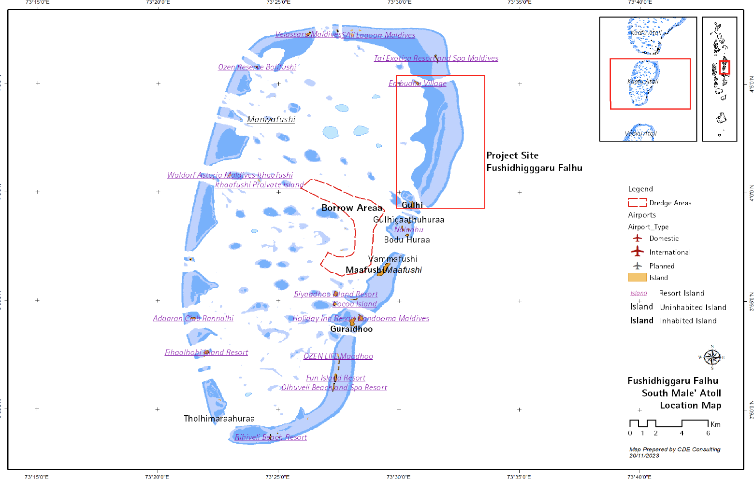

Figure 1. Location of Fushidhiggaru Falhu (EIA 2023, CDE)

Objectives

The primary objective of this feasibility study is to formulate a comprehensive Transport Master Plan for Rasmale, with the overarching goal of establishing safe, reliable, and sustainable connectivity between the capital city and Rasmale. The study shall also evaluate a range of alternative and complementary transport solutions spanning land, sea, and air.
The consultant shall:
  - Assess the technical, environmental, financial, and socio-economic feasibility of all transport connection options between Malé and Rasmale including and not limited to underwater tunnel.
  - Compare and analyze the sustainability, efficiency, resilience, and cost-effectiveness of all identified transport alternatives.

  - Formulate an integrated multimodal transport framework that effectively addresses both passenger and freight mobility requirements.
  - Ensure that the master plan is fully aligned with national urban development strategies, infrastructure investment priorities, and climate resilience objectives.
  - Provide a phased implementation roadmap, with clear recommendations on institutional arrangements, regulatory frameworks, and financing mechanisms.
The consultancy services will support the Government’s vision by delivering a strategic transport framework for Ras Male, encompassing detailed planning, feasibility assessments, and technical documentation for a range of proposed connectivity solutions. The framework will facilitate the efficient and effective implementation of the Ras Male Transport Master Plan in alignment with national infrastructure and urban development priorities.
On behalf of the Government of Maldives, the Ministry of Construction, Housing and Infrastructure (MCHI) will serve as the Implementing Agency for the project. Implementing Agency will be the lead agency in coordinating with the stakeholders and beneficiaries during the pre-construction and construction phase. Implementing Agency shall also provide support in getting any necessary information to achieve compliance to the necessary local laws and regulations.

Scope of Services

The Government of Maldives now seeks a consultancy firm to undertake the Consultancy Services for the Ras Male’ Transport Master Plan – Project Preparation & Feasibility Study (hereinafter collectively referred to as the “Project”). The Project shall include the preparation of a comprehensive strategic framework, technical and financial feasibility assessments, master planning, detailed Employer’s Requirements, technical documentation, and bidding documents to facilitate the engagement of contractors for implementing the selected solutions.
The specific services shall include, but not be limited to, the following:

- Review all existing documentation, studies, and data relevant to transport connectivity between the capital city and Rasmale, and assist the Government in defining the technical, functional, and operational requirements of the Project.
- Conduct a comprehensive feasibility study and economic impact assessment for multiple transport modes.
- Compare and evaluate the sustainability, resilience, efficiency, and cost-effectiveness of each transport option, with a view to recommending the most viable multimodal framework.

- Develop the Rasmale Transport Master Plan, ensuring integration of land, sea, and air transport solutions, and aligning with national infrastructure, urban development, and climate resilience priorities.
- Prepare detailed Employer’s Requirements, including design criteria, technical specifications,
and performance standards for each proposed transport solution.
- Undertake all necessary surveys and studies to support the Project Preparation and Feasibility Study, including, but not limited to, topographic, geotechnical, hydrographic, environmental, marine traffic, and socio-economic assessments, ensuring that data collected informs the technical, financial, and design analyses of the transport master plan.
- Prepare preliminary cost estimates for each transport option and the overall implementation plan.
- Engage with relevant stakeholders, including government agencies, local communities, and private sector operators, and prepare a comprehensive stakeholder engagement assessment.
- Prepare tender and contract documentation in accordance with the FIDIC Silver Book 2017, ensuring that it does not conflict with national laws and regulations. The documentation shall include Instructions to Bidders, General and Specific Conditions of Contract (with preference for FIDIC forms), Technical and Financial Capacity Evaluation Criteria, Employer’s Requirements, Technical Specifications, and any other documents necessary for the procurement of contractors.
- Incorporate any additional requirements of funding agencies, development partners, or financing institutions to ensure compliance with international best practices.
- Explore and recommend the most economically viable and technically feasible development options in collaboration with the Employer and stakeholders, ensuring solutions that optimize connectivity, enhance mobility, and minimize environmental impacts.
- Develop a phased implementation roadmap with recommendations on institutional arrangements, regulatory frameworks, and financing strategies to support the successful execution of the Rasmale Transport Master Plan.

Reporting

Competencies of the Project Team Monthly consultant’s performance report thereinafter describing of key issues, cost status, schedule status with achievements, any other necessary information, as required must be submitted in addition to the following reports for each Phase of the consultancy.
- Inception report within two weeks of contract signing– outline work plan of the consultant, team composition, and updated work schedules with key milestones as per the scope of services.

- Preliminary conceptual design report, feasibility report and economic impact assessment report for government discussion and approval. This report shall be presented to relevant government agencies.
- Design and Build Tender document comprising of the Employer’s requirement and other documents
for bidding.
- Monthly consultant’s performance report thereinafter describing of key issues, cost status, schedule
status with achievements, any other necessary information, as required.
- Tender evaluation report.

Competencies of the Project Team

All technical work shall be performed by experienced personnel, and the Consultant shall employ the necessary expertise and tools to deliver the services in a professional manner and in accordance with accepted international engineering and planning practices.
The scope of services for the Rasmale’ Transport Master Plan broadly requires competencies in transport planning, civil, structural, mechanical, electrical and marine engineering, environmental sciences, surveying, financial analysis, procurement, and stakeholder engagement, spanning pre-construction, construction, and post-construction phases.
As a minimum, the Consultant’s team shall comprise the following experts with the required qualifications and experience. The use of qualified local professionals is highly encouraged where available.
The key expertise required for the consultancy services is as follows:

Team Leader
    - Qualifications;
      - He/She should hold a Master’s or Bachelor’s degree in Civil Engineering, Transport Planning, Architecture, or a related field. Minimum 10–15 years in large scale transport infrastructure, urban development, infrastructure projects, and stakeholder coordination. The Team Leader shall have extensive knowledge and experience in transport master planning, master planning, feasibility studies, detailed design, tendering, and implementation of multi-modal transport systems.
    - Responsibilities shall include but not be limited to:
      - Overall coordination of the Consultant’s team of experts and any other matters
related to the smooth execution of the consulting services contract.

      - Overall responsibility for management and the project liaison with the Employer, and all authorities concerned with matters relevant to the design;
      - Overseeing the entire project, ensures coordination between disciplines, manages stakeholder communication, and ensures project deliverables are met within time and budget. In addition, the following services are expected to be carried out by the Consultants’ team.
      - Management of interdisciplinary integration and stakeholder communication.

Consultant is required to submit their experts with the minimum years of similar work experience for not less than 7 - 10 years and education qualification of the proposed expert required to carry out the services.

1.2. Transport Planner / Transport Systems Expert | - Master’s or Bachelor’s degree in Transport Planning, Civil Engineering, or a related field.  - Leads the transport master planning process, covering tunnel, ferry, high-speed vessels, cable car, and airstrip.  - Ensures multi-modal integration and prepares long-term sustainable mobility strategies.
1.3. Architect / Concept Design Specialist | - Master’s or bachelor’s degree in architecture, with a minimum of 7–10 years’ experience in infrastructure-related architecture, transport hubs, terminals, or large-scale public facilities.  - Lead the architectural concept design for passenger-facing transport facilities, including ferry terminals, seaplane terminals, tunnel portals, cable car stations, and related public spaces.
c. Ensure that terminal and station designs are functional, user-friendly, and accessible, while incorporating cultural identity and aesthetic value.
d. Incorporate climate-responsive and sustainable architectural solutions, and ensure designs comply with planning regulations, building codes, and accessibility standards.
1.4. Civil Engineer / Infrastructure Specialist | - Master’s or Bachelor’s degree in Civil Engineering.  - Designs and evaluates transport-related infrastructure, including tunnels, bridges, and associated utilities, ensuring compliance with standards.
1.5. Transport and Traffic Engineer | - Master’s or Bachelor’s degree in Transportation Engineering,  Civil Engineering, or a related field  - Conducts traffic impact assessments, including marine traffic analysis, and proposes solutions for efficient transport and mobility.
1.6. Transport Planner/ Transport System Expert | - Master’s or Bachelor’s degree in Transport Planning, Civil  Engineering, or a related field.  - Leads the transport master planning process, covering tunnel, ferry, high-speed vessels, cable car, and airstrips  - Ensures multi-modal integration and prepares long-term sustainable mobility strategies.
1.7. Environmental and Sustainability Expert  Registration with the Environmental Regulatory Authority of Maldives is required prior to contract signing | - Master’s or Bachelor’s degree in Environmental Science, or Environmental Engineering.  - Evaluates environmental impacts, integrates sustainability measures, and ensures compliance with environmental regulations.  - Preparation of an environmental and social management plan for the construction works.
1.8. Economist / Financial Expert | - Bachelor’s or Master’s degree in Economics, Finance, or a  related field.  - Conducts cost-benefit analysis, economic impact assessment, and financial viability studies of proposed transport options.
1.9. Marine or Coastal Engineer | - Master’s or Bachelor’s degree in Coastal Engineering, or Civil Engineering specializing in hydraulics/coastal engineering.  - Designs and evaluates waterfront infrastructure, ferry terminals, and ensures proper clearance for marine navigation.
1.10. Surveyor | - Bachelor’s degree in Surveying, Geomatics, Geospatial  Science, or Civil Engineering.  - Conducts topographic and hydrographic surveys to provide accurate site data for planning and design.
1.11. Structural Engineer | - Master’s or Bachelor’s degree in Structural Engineering or  Civil Engineering.  - Ensures the structural integrity and safety of tunnels, terminals, and related facilities.
1.12. Quantity Surveyor | - Bachelor’s degree in Quantity Surveying, Construction  Management, or Civil Engineering.  - Prepares cost estimates, life-cycle cost analyses, and financial feasibility studies for transport solutions.
1.13. Stakeholder Engagement Specialist | - Master’s or Bachelor’s degree in Social Sciences, Public Policy, Urban Planning, or a related field.  - Engages with stakeholders, gathers input, and prepares stakeholder engagement assessments. Having local knowledge would be an added advantage
1.14. Legal and Procurement Specialist | - Bachelor’s or Master’s degree in Law, Procurement Management, or Business Administration.  - Prepares tender documents, ensures regulatory compliance, and advises on legal aspects of land use and development.

Proposing Key Experts for each specified position is a mandatory requirement. Failure to propose the minimum required number of Key Experts for all positions shall be deemed non-responsive. The qualifications and experience of Key Experts will not be evaluated at the shortlisting stage.

Deliverables
All final reports and documents shall be submitted in English, including one (1) hard copy and one (1) electronic copy. Draft reports and documents may be submitted electronically to the Employer.
All reports and documents shall initially be submitted in draft form. The Employer will review these submissions and provide feedback to the Consultant within four (4) weeks of receipt. The review period may be extended as necessary.
Once the draft report has been reviewed by the Employer and the Consultant has addressed all comments related to the reports, drawings, and designs, the final report shall be submitted. Additionally, all relevant data and any information gathered for the project shall be submitted alongside the draft report for the Employer’s consideration.

Duration
The successful party must be available to commence the services in early December 2025, and the maximum duration to complete the services is 5 months.

Services and Facilities Provided by the Employer
- The Employer will furnish all available and related data, maps, and information required for the execution of the services.
- The Employer will assign counterpart personnel for the purpose of liaison with other Government agencies.
- The Employer will make available a focal person to coordinate procurement approvals, and other clearances, approvals as required from the Client (with technical assistance provided by the consultant as necessary).

EOI Evaluation Criteria

To be eligible under this ToR, the Consultant must meet the following criteria. Only those fulfilling the eligibility requirements under Clause 10.1 will be considered for further evaluation under Clause 10.2 (Scoring and Weightage Criteria)
  - Eligibility

    - Financial Capacity

Consultants should have at least three (3) fiscal years’ business and be able to submit Financial Statements (Balance Sheets and Income Statements) for the latest three (3) fiscal years with positive net profit before tax for at least two years in the last three consecutive fiscal years. In the case of a JV, each member is evaluated individually.

    - Availability of Experts

Consultants should have the following number of experts with each of the following areas of expertise.

Post |  | Required Number
1) | Team Leader | 1
2) | Transport Planner/ Transport Systems Expert | 1
3) | Architect/ Concept Design Specialist | 1
4) | Civil Engineer/ Infrastructure Specialist | 1
5) | Transport and Traffic Engineer | 1
6) | Transport Planner/ Transport System Expert | 1
7) | Environmental and Sustainability Expert  (should be a registered consultant at the Environment Protection Agency) | 1
8) | Economist/ Financial Expert | 1
9) | Marine or Coastal Engineer | 1
10) | Surveyor | 1
11) | Structural Engineer | 1
12) | Quantity Surveyor | 1
13) | Stakeholder Engagement Specialist | 1
14) | Legal and Procurement Specialist | 1

Proposing Key Experts for each specified position under 10.1.2 is a mandatory requirement. Failure to propose the minimum required number of Key Experts for all positions under Clause 10.1.2 shall be deemed non-responsive. The qualifications and experience of Key Experts will not be evaluated at the shortlisting stage; however, firms must clearly propose the Key Experts along with their respective positions, ensuring that the minimum required number is met.

In case of a JV, the number of experts of all members is combined for the evaluation.

    - Experience of Consultant

- Experience in a similar nature and technical specialty –
- Successful completion of at least four (4) transport-related master plans of comparable scale and complexity, such as integrated transport, mobility, or multimodal transport master planning assignments, including feasibility studies and strategic planning components.
In the case of a JV, the number of experiences of all members is combined for the evaluation. For a contract under which the Consultant participates as a JV member, only the Consultant's share, by value, shall be considered to meet this requirement.

  - Scoring and Weightage Criteria

Criteria | Weightage
I. Firm’s Relevant Transport Planning Experience | 45%
A. Transport Master Plans Completed/ Approved/ Implemented | 20%
B. Multidisciplinary Transport and Infrastructure Expertise | 10%
C. Technical Quality and Innovation of Transport Solutions | 15%
II. Methodology and Conceptual Approach | 35%
III. Firms’ Technical Capacity | 20%

The minimum technical score (St) required to pass is: 70%

- EOI Submission Requirements

- Letter of Interest: A brief cover letter introducing your company and explaining your interest and approach to the project, along with your capability to deliver this consultancy assignment.
- Company Profile: A concise overview of your company, encompassing its background and expertise, along with any relevant certifications, awards, or industry recognition, along with international exposure related to projects of a similar nature.
- References: Past 10-year references that demonstrate the Consultant’s ability to meet Employer’s specific requirements.
- Brief Concept: Provide a concise description of the proposed concept in accordance with international standards, emphasizing the preferred landing points for the link based on available maps/ data, and the information acquired through a brief study of the site context.

- Methodology: Furnish a brief yet comprehensive overview of the technical approach, methodology, and work plan proposed by your consultancy firm to successfully complete the assignment.
- Project Team: An organizational structure along with a detailed list of key personnel. This should clearly identify the key members of your project team, detailing their roles and relevant experience in similar projects.
- Financial Information: Audited financial statement of the most recent 3 years and any other document(s) proving the financial capacity of the consultancy firm.
- Additional Information: Provide any additional information that you believe would be relevant to this consultancy project.

