SECTION 6

Employer’s Requirement

Section 6 – Employer’s Requirement
This document outlines the requirements for design and construction of the water supply and sanitation system. The document is divided into the following parts:
- Employer’s Requirement: Island Specific Data and Design Requirements
- Employer’s Requirement: Construction Part 1: General Works
- Employer’s Requirement: Construction Part 2: Sewerage Works
- Employer’s Requirement: Construction Part 3: Water Supply System Works
- Employer’s Requirement: Typical Drawings

Note: Preparation of reports, design and construction shall be as per EPA Guidelines:
- Design criteria and technical specifications for conventional gravity sewerage systems
- Design criteria and technical specifications - design and construction of water treatment and supply system
These documents will be available from Environmental protection Agency (EPA).

Island Specific Data

Island Name | Th. Gaadhuffushi
Type of System | Water Supply and Sewerage System
Population (2017 Dec) | 268
Number of Households | 61
Estimated Network Length (m) | 3000
Number of Institutional/Commercial Connections | 35
Provisional connections | 25
RO plant Capacity (CBM per day) | 10
Product water Tank Capacity (2Nos each of CBM) | 50
Minimum Number of Lift Stations (LS)/Pump Stations (PS) | 2

- Estimated Network Lengths area specified for a single network and is considered for the inhabited area.
- Two RO plants should be provided each having the capacity stated above.
- Two product water tanks should be provided each having the capacity stated in above table.
- Number of LS/PS is estimated for the inhabited area which is to be covered in the civil works. However, if the land use plans are available, the design documents for entire island should be produced such that the works in uninhabited zones can be carried at later stage.
- The bidder should verify the estimated quantities of network lengths, and connections by carrying out own estimation and analysis and should check the completeness of the information.

Design Requirements

Below section provides the requirements for the design phase of the project including, Carryout surveys, investigation, Conduction of EIA, Preparation of Concept Design and Detailed Design.
The design phase of the project will encompass the following works detailed below. The contractor should carry out the works as per the requirements set out and in accordance with the technical guidelines from EPA. Where there is a conflict between the stated requirement and EPA guidelines, the higher requirement should be considered.
Below are the expected outcomes from the design phase of the project.
- Survey:
The survey should be carried out in accordance with the guidelines set out from Maldives Land Survey Authority (MLSA). The following aspects should be covered in the survey.
- Three bench mark should be placed as per Control Survey Guideline of MLSA standards and should be registered with MLSA
- The land use plan of the islands
- Topographic survey for the entire island at plot levels should be carried
- Names and details or roads should be properly marked
- Public buildings should be taken with internal layouts to demarcate the exact position of the building and roof areas.
- High tide line, low tide line, and vegetation lines should be taken.
- Harbor basin and any revetment should be mapped in the drawing
- Significant trees, electric distribution boxes, electric light poles should be marked in the survey map.
- Where possible type of vegetation should be provided and any trees falling on immediate network coverage area or on facility locations should be properly mapped in the survey.
- All septic tanks or preferred locations of house inspection chamber by the house owner should be surveyed
- Where septic tanks or existing networks are located, it should be marked in the map.
- The levels on all existing roads should be taken at 10m intervals from the center of the road and at all junctions
- Proposed facility locations and alternative locations should be mapped with existing ground levels.
- Bathymetry for proposed outfall locations and alternatives should be taken.

- Land Allocation Process

- Locations including alternatives for sewerage system facilities should be identified in consultation with island councils and based on approved land use plans of the island
- Locations for Pump stations (PS) /Lift stations (LS) should be selected to maximize the coverage area and to minimize the number of PS/LS.
- The area should be restricted to 5m by 5m or lower.
- Where there is limited land area, the pump station/lift stations can be located at the center of road junctions.
- In locating any PS/LS on roads care should be taken to avoid placement of vent structures near households and to locate the vents next to open lands such as football grounds and cemeteries.
- The outfall locations should be selected to maximize the dispersion of effluent discharge.
- LUP should be updated based on survey carried
- All survey files, including editable copies should be provided to client with the survey report an and land approval request documents.

- Geotechnical Investigations:

- Preliminary Geotechnical survey should be carried and can be restricted to inspection pits or scalar penetrometer tests.
- Inspection pits up to a depth of 1.5m with the log of soil conditions should be provided.
- Inspection pits at all facility locations should be carried and any requirement for ground improvement should be identified

- Social survey

- As part of the community engagement, meetings with all relevant stakeholders and public should be carried
- Meeting minutes for all the community consultation meetings should be provided with survey report.
- Household willingness to pay survey for a minimum of 30% of the households should be carried.
- Locations including alternatives for sewerage system facilities should be identified in consultation with island councils and based on approved land use plans of the island.

- Concept Design:

The Design should be provided for the entire island (where draft or approved LUP is available). However, the civil works as part of the scope will be limited to immediately inhabited areas and to areas where developments are foreseen within the short term. The island specific data provided reflects some of these developments.

The Overall Concept of the System should be based on the Typical Concept layout provided.

- Sewerage System
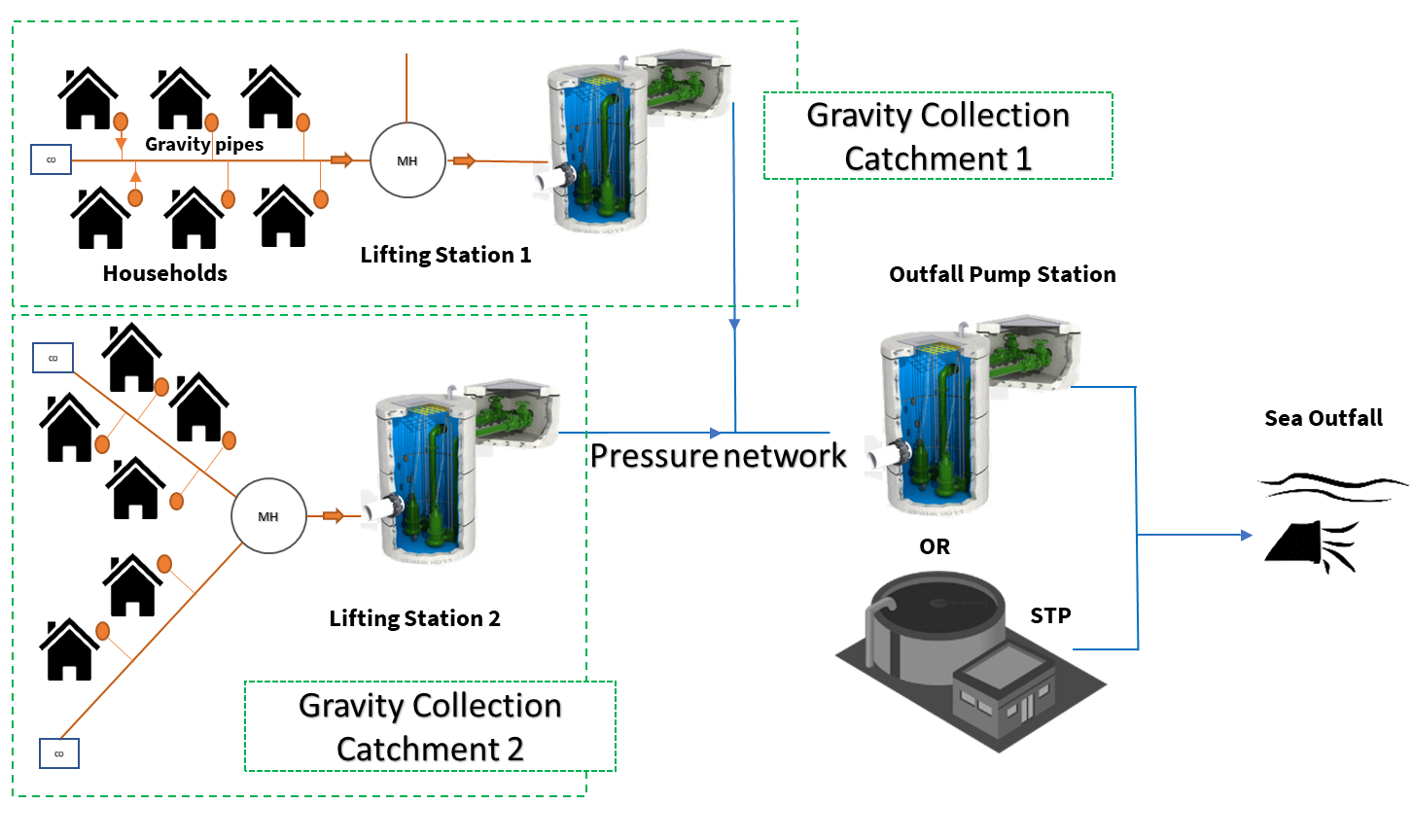
- The Gravity Sewer System should be provided with the following components
- Gravity Network/Catchment:

- Each Household should be provided with 315-400mm dia Household catch pit, which will transfer the sewage through lateral connections (110mm dia) leading to sewer mains (160mm dia). Typical Drawings are provided as attachment.
- At starting point of each sewer main section Maintenance shaft (MS) or cleanouts (CO) can be used
- The sewer main should have a minimum cover of 600mm (From ground level to the top/crown of the pipe) at all starting MS
- The minimum slope for the sewer mains is 1:250 and is preferred to be maintained between 1:250 to 1:200.
- The maximum excavation depth for the sewer main is 2.5m.
- The network should have 600mm manholes at all junctions or at maximum intervals of 60m. The last manhole or the final manhole leading up to PS/LS could be provided as 1000mm dia.
- The gravity network should cover the entire island (if approved or draft land use plans are available) and should facilitate the immediate implementation of selected catchments for the inhabited area of the island. The additional catchments required to cover the entire island should be designed to facilitate the phasing out of the works.

- Pump Stations (PS)/Lift Stations (LS):
- The Sewer mains will discharge sewage into lift Stations (LS)
- The PS/LS should include, sump, valve chamber, vent structures and control panel
- PS/LS should be provided for each gravity catchment with TWO submersible pumps controlled based on the level sensors/Float switches.
- Based on the sewage levels within the PS/ LS sump, the pumps should operate automatically to discharge the sewer into pressure network.
- Sewage Pumped into pressure network from lift stations located at each catchment should be discharged into outfall pump station or Sewage treatment Plants.
- If there is no STP the sewage should be directly discharge to sea via sea outfall
- The discharge will be directly into sea away from the reef edge and into a minimum depth of 6m.
- The sea outfall should be protected with ballast block and diffusers at the discharge point should be provided.

- Water Supply System
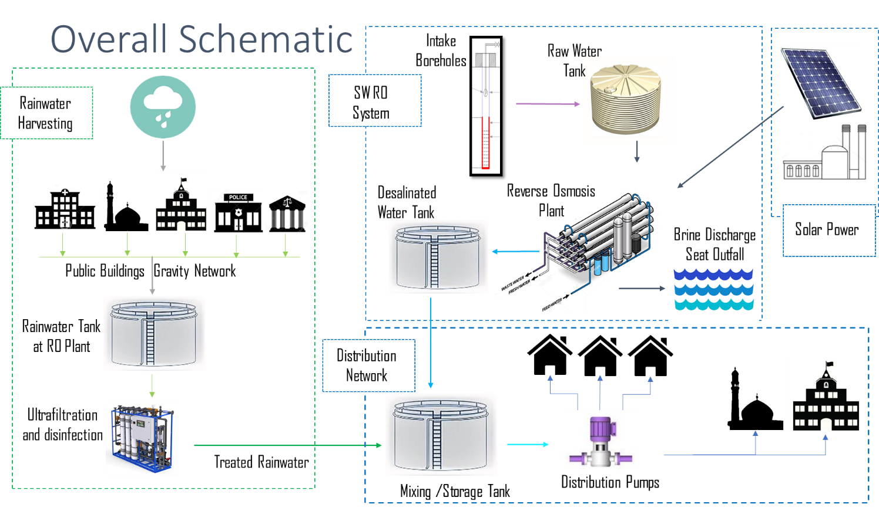
The Water Supply System design should be based on IWRM systems which include the following components (Where one of these components are available in the island the system should be designed to incorporate the other components)
- Sea Water Intake: From borewells placed at Treatment Plant Plot Area. A minimum of two borewells to be placed.
- Desalination System: Sea Water RO treatment with pretreatment and post treatments. The RO plant should be compact and sized based on the island specific data provided.
- Solar power: Photovoltaic modules in plant building roof top should be used to either provide a grid connection or it should be provided with inverters and a standalone system where energy can be utilized for RO plant operation
- Storage Tanks, Feed Water Tanks and Brine Tanks
- Distribution Network: The network should cover the entire island
- Household Connections: each household will be provided with a metered connection.

The concept design documents presented should include the following documents along with the requirements stated in the EPA technical guidelines.
- Background of the project: Geographical setting, Existing facilities, all surveys carried
- Demographic data: Detailed assessment of existing population and housing including future projections
- Waste water loadings, design criteria and projected connections: The waste water loadings should be calculated based on EPA technical guidelines. 120 lpcd can be taken use as the waste water generated and loadings can be calculated. The population for 15 year and 35 years should be projected and electromechanical components should be sized based on this demand. The civil structures (Gravity Mains and PS and STP) should be sized for 35-year demand).
- For Water supply systems: The water demand should be calculated based on 50 lpcd for the first 15 years and 75 lpcd for 35 years. The RO plant and Storage tanks are sized based on this and provided in island specific data. The design of distribution network should consider the demand based on the 35 year demand (75 lpcd) or by using the loadings provided in the EPA technical guidelines.
- Proposed System including Pump stations/Lift Stations, Network and Components and facility buildings (If the island has an existing plant building the locations
- Design Considerations of Pump stations and Pumping Main.
- Design Considerations for Gravity Network
- Design considerations for treatment plant: Sewage Treatment Plant (STP) should be designed to be installed at a later stage and hence land allocating required for STP should be reserved. The concept and detail design of treatment to secondary level should be included and any proposed technology for treatment plant should be compact. Package treatment plants such as SBR are preferred.

- Detailed Design
The detailed design should provide all the hydraulic calculations required for gravity network and PS/LS. Administration building if required should be considered
- Preparation of Detailed Design of civil, electrical, mechanical and miscellaneous works of Sewerage System i.e. Sewer Pipes, Manholes, Cleanouts, Lifting Stations and Sewage Conveyance, Sea Outfall Pumping Station and Sea Outfall/Sewage Sea Outfall Conveyance System into the Deep Sea etc.
- Preparation of Construction Drawings of Civil, Electrical, Mechanical and Miscellaneous works of the Sewerage System i.e. Sewer Pipes, Manholes, Cleanouts, Lifting Stations and Sewage Conveyance, Sea Outfall Pumping Station and Sea Outfall/Sewage Sea Outfall Conveyance System into the Deep Sea etc.
- All Electrical drawings should be approved from Maldives Energy Authority.
- All the gravity profiles should be provided.
- Approval of Survey and Investigations, Concept Designs, EIA, Detailed Design and Construction Drawings from EPA.
- Follow International Design Standards/Engineering Practices for the design and construction of sewerage system of the Islands of the Contract Package in case EPA Design Standards / Guidelines/Technical Specifications are missing or silent for the item/component of the sewerage system.
- Preparation of Design of civil, electrical and mechanical works of Water Supply System i.e. Borehole, RO Plant including Brine Disposal, Sea Outfall, Ground Storage Tank, and Water Distribution System etc.
- Preparation of Construction Drawings
- Construction of civil, electrical and mechanical works of Sewerage System i.e. Borehole, RO Plant including Brine Disposal, Sea Outfall, Ground Storage Tank and Water Distribution System etc.

- EIA
After completion of the Concept, EIA works should be commenced based on the approved concept and should be carried according the EIA regulation.

Land Use Plan Map of the Island

