

**Ministry of Finance and Treasury**

**Republic of Maldives**

TERMS OF REFERENCE

**Design of Water Supply Facilities in N.Holhudhoo, R.Inguraidhoo, B.Kendhoo, K.Gaafaru, R.Maakurath, K.Dhiffushi and N.Maafaru, Maldives**

# Introduction

The Government of the Republic of Maldives has allocated funds for the development of Water Supply Facilities in the Islands of N.Holhudhoo, R.Inguraidhoo, B.Kendhoo, K.Gaafaru, R.Maakurath, K.Dhiffushi and N.Maafaru and intends to apply part of the proceeds for the following services: Design of water supply facilities in N.Holhudhoo, R.Inguraidhoo, B.Kendhoo, K.Gaafaru, R.Maakurath, K.Dhiffushi and N.Maafaru, Maldives. The services include preparation of Preliminary Designs, Detailed Design and Bill of Quantities (BoQ) of the water supply facilities.

The proposed water supply facility for the islands is designed to bring an effective solution towards the islands where consequent supply of emergency water had been provided during the dry period. The project would install a desalination plant with a storage tank and provide access by means of the community tap bay.

# Background

The Maldives consist of 1190 low-lying coral islands spread over an area of 90,000km2 in the Indian Ocean. Nearly 200 islands are inhabited, around 90 islands are resorts, and the rest are uninhabited. There are 26 geographical atolls which are grouped into 20 administrative atolls.

Water is a precious resource in Maldives as freshwater is limited Surface freshwater is generally lacking throughout the country with the exception of a limited number of brackish water swampy areas in some of the islands. The freshwater in the islands is developed as a thin lens just a meter or two below ground. The sandy porous soil is highly vulnerable to saline intrusion, contamination from waste disposal and inappropriate sanitation practices causing groundwater unsuitable for human consumption in many of the islands. The provision of safe drinking water supply and adequate sanitation facilities is regarded as a basic right for all Maldivians in the new constitution of the country.

The only conventional water resources available in the Maldives are shallow groundwater aquifers and rainwater. Non-conventional water resources include desalinated water and bottled water from mainly local production and to a lesser amount from importation. The main sources of freshwater water across Maldives are rainwater and desalinated water. Desalinated water through distribution network with household connections are available in Male’ city where desalinated water is available on 24 hour basis and accounts to 25% coverage of safe water provision in overall country vise. In the atolls by contrast only about 8% of the atoll population uses desalinated water through piped network. There is urgency to improve access to services, as well as the quality of the services provided, given the vulnerability of existing systems and the population growth.

The common types of water used in the households in the outer atolls are groundwater and rainwater. Groundwater is used mainly in bathing, washing and toilet flushing but only occasionally used for drinking. Rainwater is harvested in all households and used for drinking and cooking purposes. Most of the people in the atolls use rainwater for drinking. However, due to limited storage capacity within house plots, householders can collect and store only a small quantity of water. The average household storage capacity on islands across Maldives is 2500L. In dry periods, many households experience shortage of drinking water, which is due to shifting weather patterns and prolonged dry periods. In such instances, the government is called upon to transport potable water to the affected islands. Over the last few years the National Disaster Management Centre (NDMC) has transported potable water to many islands facing acute water shortages due to prolonged dry periods costing over US$ 250,000 every year.

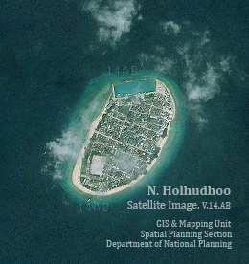

**N.Holhudhoo**

The island of Holhudhoo is situated in the South Miladhunmadulu Atoll. The island has an area of 20 hectare. The island has a population of 2135 people with a density of more than 107 people per hectare

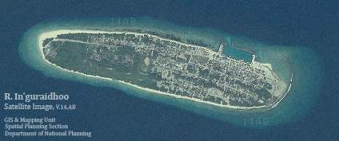

**R.Inguraidhoo**

The island of Inguraidhoo is situated in the North Maalhosmadulu Atoll. The island has an area of 48 hectare. The island has a population of 1793 people with a density of more than 37 people per hectare.

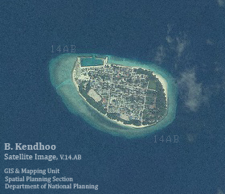

**B.Kendhoo**

The island of Kendhoo is situated in the South Maalhosmadulu Atoll. The island has an area of 20 hectare. The island has a population of 1160 people with a density of more than 58 people per hectare.

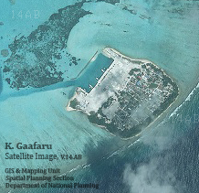

**K.Gaafaru**

The island of Gaafaru is situated in the Male’ Atoll. The island has an area of 22 hectare. The island has a population of 1291 people with a density of more than 59 people per hectare.

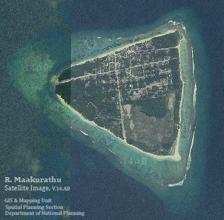

**R.Maakurath**

The island of Maakurath is situated in the North Maalhosmadulu Atoll. The island has an area of 51 hectare. The island has a population of 1208 people with a density of more than 24 people per hectare.

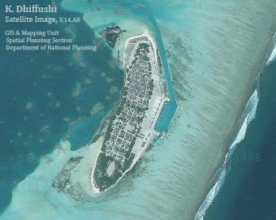

**K.Dhiffushi**

The island of Dhiffushi is situated in the Male’ Atoll. The island has an area of 29 hectare. The island has a population of 1196 people with a density of more than 41 people per hectare.

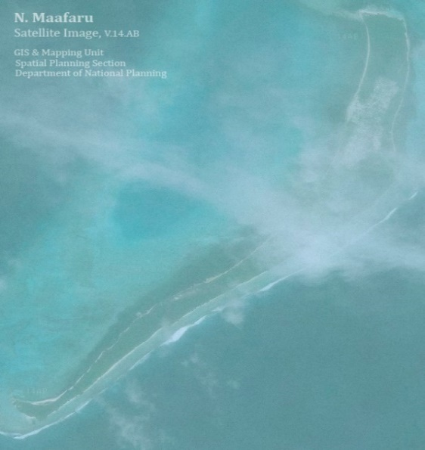

**N.Maafaru**

The island of Maafaru is situated in the South Miladhunmadulu Atoll. The island has an area of 132 hectare. The island has a population of 1113 people with a density of more than 8 people per hectare.

# Scope of Works

**General**

The scope of services required under this assignment includes carrying out surveys and investigation, Environmental Impact Assessment (EIA), preparation of water supply system design which consists of raw water intake (borehole), RO plant including brine disposal, storage tanks and RO building and water distribution points (Community Tap-Bays) at selected points in the Islands. Apart from this, the consultant is also required to prepare the tender documents.

**Phase IA: Data collection – Complementary Diagnosis**

First of all, it is necessary to carry out investigations to adjust the works program on the different islands. This means:

* Information pertaining to population, number of households, Per capita water demand of the Islands. Institutional/commercial/industrial demands. etc.
* Current water situation of the Islands: Existing water supply systems, water shortage issues, per capita water consumptions patterns, water requirements in the islands, available water storage capacity (both public and private), conditions of roof catchments etc
* Information of available public and private roof catchment areas and conditions of roof catchments.
* Available water storage capacity (Public and Private)
* Determine number of Community tap-bay points required for each Island in Consultation with the respective Island Councils
* Willingness to pay & affordability Survey
* Performing marine investigations for the siting of the Brine outfall structures so that the final location is acceptable in environmental terms.
* Carrying out the geotechnical investigations pertaining to detailed design of the facilities, if required.

The Consultants will collect existing data and carry out the necessary investigations to ensure that sufficient information is available to clarify uncertainty regarding the technical choices to be made. In his methodology, the consultant will precise his data acquisition methods:

* area covered by the investigations;
* duration and degree of accuracy of the measurements to be carried out;
* members of staff in charge of interpreting the data collected.

|  |
| --- |
| **Outputs of Phase IA**  Inception Report will include at least :   1. List of data collected and summary of relevant items enabling the solutions for the collection and treatment of water 2. Description of measurements / investigations / analysis carried out in order to define the technical solutions and compare them 3. Technical and economic comparison of solutions technically based at feasibility level; 4. Topographic and geotechnical limiting factors affecting the construction of the planned facilities. 5. Potential Constraints. |

**Phase IB: Preliminary Design**

The consultant will prepare preliminary design and submit to MEE for approval. The report shall address the following, but not limited to:

* evaluation and comparison of different proposed options for water supply system for each island taking into consideration the following aspects:
* treatment efficiency
* durability
* capital costs
* operation and maintenance Costs
* required land area
* expertise required for Operation and Maintenance/Ease of Operation and maintenance
* environmental and social aspects
* potential for integrating rainwater (it is recommended that minimum 25% of the water demand should be catered from rainwater)

|  |
| --- |
| **Output of Phase IB**  Preliminary Design Report will include at least :  a. Preliminary Design Report (including the list of data collected and summary of relevant items enabling the solutions for choosing the initial component to be established (Determine whether Rainwater Harvesting component is enough to cater the demand for the dry period for each island or Reverse Osmosis plant is required.) |

**Phase IC: Environmental Impact Assessment (EIA)**

The consultants shall undertake an environmental impact appraisal of all solutions to the satisfaction of EPA, including but not necessarily limited to the following tasks:

* Discussions in association with MEE and EPA to confirm the scope of the environmental issues and studies for this package.
* Environmental studies (desk and new field investigations and community consultation as required) to identify anticipated environmental impacts of the project.
* identification of potential mitigation measures and discussion of these with MEE,
* finalization of recommended mitigation measures required during design, construction and operation of the project,
* developing cost estimates of the mitigation measures
* preparing a project-specific Environment Management Plan / mitigation management action

This task will lead to a specific report to be submitted to EPA.

The other phases of this consultancy shall account for the recommended mitigation.

Without prejudging the full scope of issues, the EIA for this project shall address at least the following issues:

* effects of construction on terrestrial and marine environment;
* effects of water treatment plant sludge management;
* effects of land disturbance associated with any earthworks, pipelines, landslip protection.

To prepare the work, the Consultants will use the EIA guidelines. The analysis of the environmental aspects of the various solutions will be integrated in the technical and economic comparison so that MEE is able to select works programmes that are suitable for each island.

|  |
| --- |
| **Output of Phase IC** :Report on Environmental Impact Appraisal (EIA) acceptable to EPA |

**Phase II: Detailed Design**

The second stage will concern detailed design of the selected solution for each island

The Consultants will take into account the Environmental Impact Study in his detailed design and will plan for the implementation of the mitigation measures as stated in the EIA and recommended by EPA.

The Detailed Design Report will contain three parts:

**Part 1 (Main report)** will include:

* basic data and interpretation of these data regarding the detailed design;
* Brief Description of the formulae, methods and models used for any calculations
* general justification and description of the proposed rehabilitated or new structures;
* Calculation notes section including all hydraulic and structural calculations
* Identification of different construction lots (civil works, electromechanical works etc.);
* works schedule (indication of the timing of each task, links with other tasks, key dates, contractual dates), introduction to nature and quality of materials quality and construction methods (including for maintaining the water production service)

**Part 2 (Bill of Quantities and Cost Estimate)** will include a Bill of Quantities for each structure and then by type of works (earth, concrete, mechanical, electrical). The Consultants will here explain the unit costs as well as the percentage considered for miscellaneous and contingencies. Finally, cost estimation will be carried out on the basis of quantities and unit costs. The Consultants will keep this cost estimate confidential.

The capital costs shall be derived from the Bill of Quantities and unit rates developed from recent tender for works in the MEE, using either unit prices or cost curves and indexed to inflation. The minor items will be estimated using historic current rates and prices prevailing in the Maldives islands.

For the mechanical and electrical equipment, cost estimates will be prepared based on recent experience of the cost of similar work and / or quotations from internationally recognized manufacturers and suppliers. The cost estimates will allow for transportation and erection on site, all out-site costs and off-site overheads.

Bill of Quantities will be established separately for each island.

**Part 3 (Technical Report)** will include:

A drawings section that will include a first sub-section related to the existing structures (‘reference drawings’) and a second sub-section related to rehabilitate or new structures (including general layouts, civil structures and electromechanical equipment’s).

|  |
| --- |
| **Outputs of Phase II:**  Report II will include the detailed design of the ‘selected solution for each island including:   * the Main Report; * the Bill of Quantities and Cost Estimate; * Technical Report (Detailed Drawings) |

Final version of the Detailed Design will support preparation of the Tender Documents for the selection of contractors.

**Phase III: Tender Documents & Selection of Contractors**

***Tender Documents***

The Consultants will prepare tender documents accordingly including the following. The Consultant shall also prepare Prequalification Documents if required by the Client

**Volume 1: Tender and Administrative Documents**

**Volume 2: Technical Specifications and Schedules**

**Volume 3: Drawings and Layouts**

**Volume 1** will include at least the following:

* **Invitation to Tender;**
* **Description of the Works and Quantities;**
* **Instructions to Bidders;**
* **Conditions of Contract, Form of Tender (and Appendix);**
* **Bill of Quantities and Schedules;**
* **Form of Contract Agreement, Form of Tender Security, Form of Performance Security, Form of Guarantee for advance payment**

**Conditions of Contract** will be incorporated as the final legal agreement to be drawn up between the Contractor and the Client. The Conditions of Contract would be drawn up in close co-operation with the Client and would incorporate such special clauses as may be required.

Typically the Conditions of Contract will be based on the following:

* For Civil Engineering works: FIDIC Conditions of Contract for Construction (MDB Harmonized Edition), For Building and Engineering Works Designed by the Employer.

The **Bill of Quantities and Schedules** will be prepared for all the tender packages as a basis for tendering and for payment under the Contract. Civil Engineering Standard method of measurement shall be recommended wherever possible.

**Volume 2** will include Technical Specifications and Schedules. Technical Specification will be prepared for all items to be constructed, supplied or erected. Materials and work specifications will cover all aspects of materials and equipment to be provided.

The Consultants will use local or national standards where possible. Where no suitable local or national standards exist then international standards such as BS, ASTM, ISO etc. will be used.

Where possible, the specification of materials (locally produced or imported) will be specified. Construction Schedules will be issued in details.

**Volume 3** will be based on part 3 of the detailed design. All drawings will show clearly defined contract limits relating to the various divisions of works. Drawings will include general arrangement drawings, sections, elevation, typical details and typical reinforcement detailed. In addition detailed reinforcement drawings and bar schedules will be included in the tender documents. Drawings for mechanical and electrical equipment will show main outlines and leading dimensions in sufficient details for the manufacturers to design the adequate equipment.

|  |
| --- |
| **Outputs of Phase III:**  Report III including the tender documents including:   * Volume 1: Administrative and tender documents; * Volume 2: Technical specifications and schedule; * Volume 3: Construction Drawings and layouts |

# Project Team

The project team must consist of members as specified in the table.

|  |  |  |
| --- | --- | --- |
| # | **Post** | **No** |
| 1 | Project Manager (Team leader) | 1 |
| 2 | Civil engineer | 2 |
| 3 | Electro-Mechanical Engineer | 1 |
| 4 | EIA Consultant | 1 |
| 5 | Surveyor | 3 |

## Similar Assignments

To be eligible for this assignment, the consultancy firm must demonstrate past experience in performing the services (description of similar assignments, Value of such assignments). The Firm shall have carried out a minimum of three (03) similar assignments with a minimum contract value of MVR 1,000,000.00 each.

## Qualifications of the Design and Consultancy team

The Consultant should submit full CV’s for each of the proposed staff members highlighting the criteria given below.

1. ***Project Manager***

Bachelor’s degree in Project Management or Environmental Management/Science or in a related field with minimum 05 years’ experience in project management, along with specific experience in the field of Sewerage projects. Tertiary certification will be an added advantage.

1. ***Civil Engineer***

Bachelor’s degree in Civil Engineering with minimum 03 years’ experience along with Specific experiences in designing Water Supply systems. Tertiary certification will be an added advantage.

1. ***Electro-Mechanical Engineer***

Bachelor’s Degree in Electrical/Mechanical Engineering with minimum 03 years’ experience along with specific experience in designing Electro-Mechanical components of Water/Sewerage Facilities. Tertiary certification will be an added advantage.

1. ***EIA Consultant***

Experience in conducting EIA for water supply systems will be given preference. EIA specialist approved by EPA

1. ***Surveyor***

Diploma in Surveying/civil engineering with minimum 03 years’ experience in conducting land surveys

# Reporting Requirements

The consultants should submit a Monthly report at the end of each month in a format agreed with the MEE representative. At the end of each quarter a consolidated report summarizing the events of the months preceding shall be submitted in place of the monthly report.

|  |  |
| --- | --- |
| **Details** | **No. of Copies** |
| Detail Map showing all survey results in AutoCAD format | - |
| Inception Report | 2 hard copies + Soft copy |
| Preliminary Design Report as per Guidelines of MEE | 2 hard copies + Soft copy |
| EIA report | Hard copies + Soft copy as EPA requirement |
| Detailed Design Report as per Design guidelines of EPA | 3 hard Copies + 1 soft copy |
| Bill of quantities and Technical specifications | 3 hard copies + 1 soft copy |
| Complete Bid document | 3 hard copies + 1 soft copy |

# Equipment, logistics and facilities

The Consultants shall ensure that experts are adequately supported and equipped. In particular he/she shall ensure that there are sufficient administrative, computing and secretarial provision to enable experts to concentrate on their primary responsibilities. The Consultant shall meet the full costs for the supply of the teams including all travels, remuneration, insurance, emergency medical aid, facilities and all else necessary for the competent operation of the teams. The Consultants will provide their own office space for the Project team.

# Payment schedule

Payment schedule will be in accordance with the schedule specified below:

|  |  |  |
| --- | --- | --- |
| **DESCRIPTION** | **ALLOCATION** | **AMOUNT (MRF)** |
| Advance Payment | 10% |  |
| Payment upon approval of Inception Report | 30% |  |
| Payment upon approval of EIA report and approval of Detailed Design Reports | 40% |  |
| Payment upon finalization of Tender Documents | 30% |  |
| **Total** | 100% |  |
| Amortization of 20% will be deducted from each monthly invoice to recoup the advance payment  Advance Payment will be paid upon Submission of Advance Payment Bank Guarantee | | |

# Deliverables

The consultants shall submit the following reports

* Detail map showing all survey results in AutoCAD format (if not available)
* Inception report (2 hard copies + Soft copy)
* Preliminary Design report (2 hard copies + Soft copy)
* EIA report (Hard copies + Soft copy as per EPA requirement)
* Detailed Design report (3 hard Copies + 1 soft copy) as per Design guidelines of EPA.
* Bill of quantities and Technical specifications
* Complete bid document

# Technology Transfer

The Consultant shall consider the technology transfer as an important aspect of this project. The Consultant shall provide the opportunity to the staffs of the client to be involved in the working team of Consultants during the design phase of the project for their capacity development wherever possible. If requested by Clients staff, the Consultant shall brief and demonstrate the survey and design procedures.

# Duration of the Assignment

All surveying, preparation and submission of design documents should be completed within 04 months. Tender assistance should be given to Client and NTB during tender, evaluation and award stage.